AN ECONOMIC ASSESSMENT OF BIOLOGICAL NITROGEN
FIXATION IN A FARMING SYSTEM OF SOUTHEAST MINNESOTA

A THESIS
SUBMITTED TO THE FACULTY OF THE GRADUATE SCHOOL
OF THE UNIVERSITY OF MINNESOTA

BY

Maureen Ruth Kilkenny
IN PARTIAL FULFILLMENT OF THE REQUIREMENTS
FOR THE DEGREE OF
MASTER OF SCIENCE
in
AGRICULTURAL ECONOMICS
March, 1984
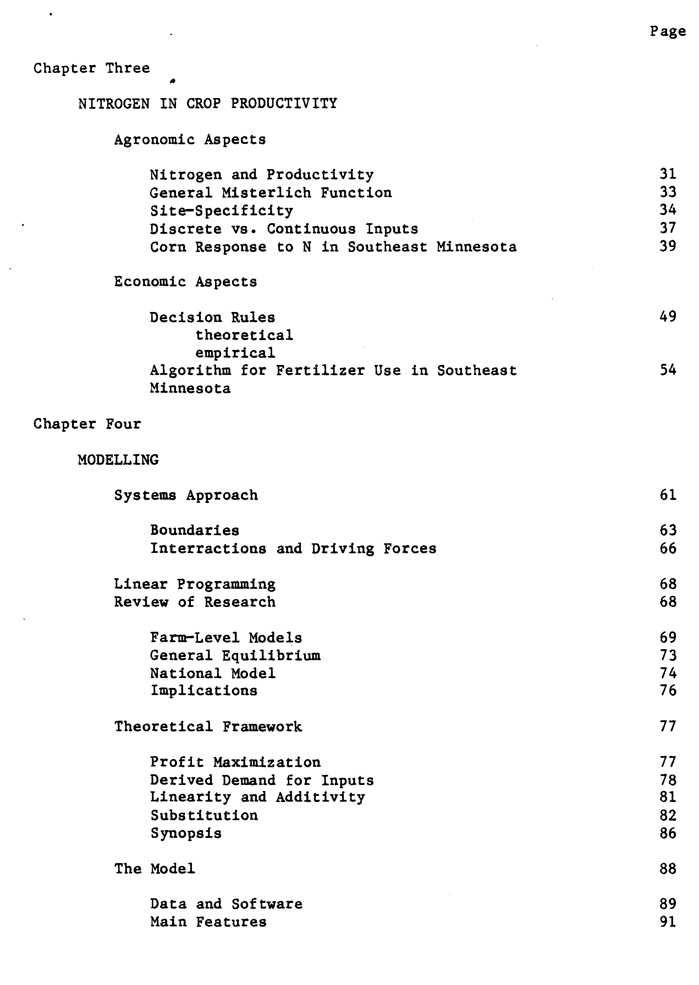
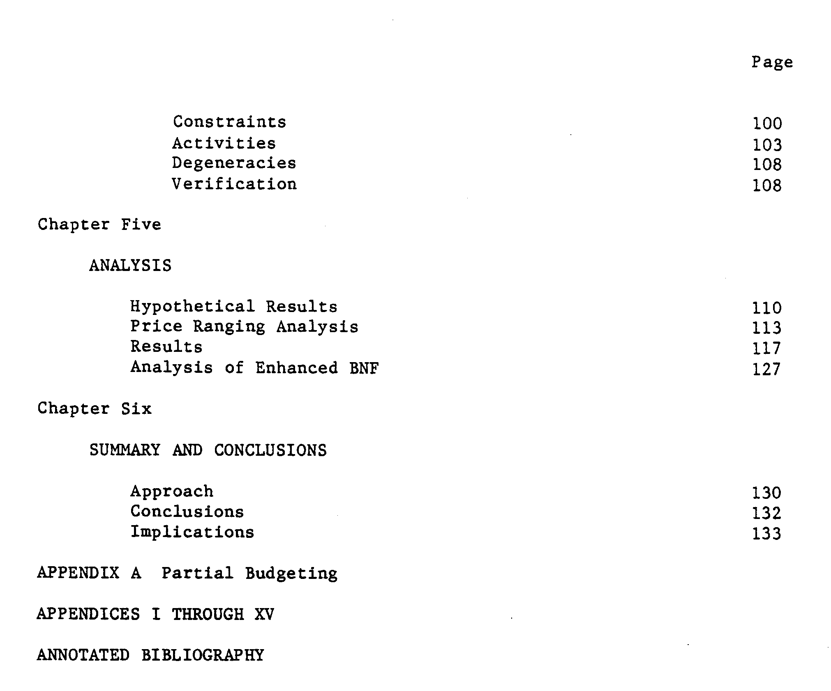

ABSTRACT

Biological Nitrogen Fixation is investigated as a technical and economic substitute for fertilizer nitrogen using a systems approach.
Recent agronomic and farm management data from southeast Minnesota is analyzed to formulate models of corn yield as a function of nitrogen, in different rotations; and nitrogen fertilizer purchase and use by farmers as a function of fertilizer price. These are incorporated into a goal-oriented, time-disaggregated linear mathematical programming model. The economic relationship between BNF and N_{f} is investigated by simulating integrated farm (crop and livestock) adjustments in both fertilizer use and the exploitation of the BNF of legumes, to increases in the price of fertilizer nitrogen. The results of the analysis indicate that the direct use or sale value of the legume which supports BNF is more economically significant than the value of the residual nitrogen that can be recovered by corn in rotation. Legume derived nitrogen does substitute for fertilizer nitrogen when a use value exists, particularly at high fertilizer prices.

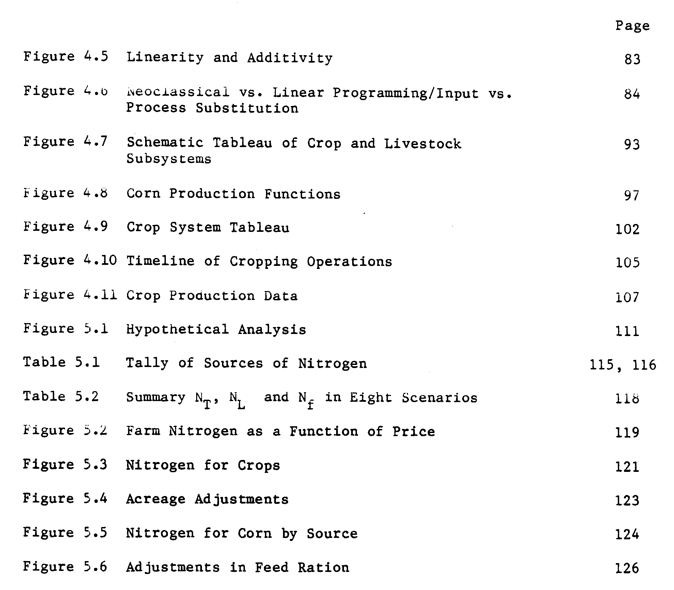
Chapter One

INTRODUCTION

Nitrogen fertility is the single most limiting factor in crop production worldwide (Subba Rao, 1978). In advanced agricultural economies, more than twenty centuries of reliance on biological sources of nitrogen maintained by crop rotation among grains and legumes, recently became redundant due to inexpensive industrially produced nitrogen fertilizers.
Dependence on fertilizers (manufactured from natural gas) is now being questioned from several standpoints. Rising energy costs jeopardize the cost-efficiency of fertilizer nitrogen in crop production for advanced agriculture (C.A.S.T. no. 5, 1977). Second, developing country agriculturalists are questioning whether the costly fertilizer technology is the only alternative to raise grain cultivation productivity (Sanders, 1980). Third, for some of these areas, acquiring the large amounts of fertilizers indicated is not physically nor economically feasible (Hughes and Pearson, 1974). Interest in local sources, especially biologically fixed nitrogen (BNF) by legumes, is increasing (Ahmed, 1982). New knowledge about the potential of BNF as a modern alternative to nitrogen fertilizers has encouraged applied researchers on BNF to develop legumes for greater agricultural productivity and intensity (Heichel, 1978b).
Very little economic research has been done on BNF per se. Legume based rotations were a common principle and farm management topic since the heyday of soil fertility research in the 1920's. Heady (1948) illustrated a product-product model using the BNF ability of legumes. Heady and Jensen devoted a paper (1951) and a large part of their farm management text (1954) to crop rotations and legume residual nitrogen.
2
In recent years, two trends of economic analyses of BNF have appeared. Both fall short of describing the true economic significance of BNF by legumes. Agronomists have used a sort of partial-budget analysis to find a dollar value for fixed nitrogen. Partial budgeting is criticized in the Appendix A.
On the other hand, economists interested in agricultural adjustments to energy constraints have prepared sophisticated math programming models which include some specification of the BNF alternative to nitrogen fertilizers. (Miranowski, 1979; Walker and Swanson, 1974; Heady, et. al., 1975, 1976 and 1977). These specifications of the BNF alternative are considered by this author to be flawed. At this point it is sufficient to suggest that the linear programming models noted above were constructed without a clear formulation of the BNF alternative. Therefore, the conclusions and implications about BNF are probably not valid.
Buttel, et. al (1980) have reported-that a surprising number of studies concerning agricultural adjustments to increases in energy and fertilizer nitrogen costs do not include crop rotation-based exploitation of BNF as a substitute for nitrogen fertilizer. For example, CAST publication no. 68 (1977) rejects the option of grain legume rotations contending that grain acreage would necessarily be diverted from production. And, there are other arguments.
Doering (1977) argues that the relative price of fertilizer will determine the adjustments in use, and proposes that by the year 2000, despite higher prices, fertilizer use will not decline because it will

3
remain cost-effective. He believes that legume nitrogen complements commercial fertilizer use. Doering and Peart (1977) deduce that biologically fixed nitrogen recovered through rotations does now and will continue to provide a portion of the nitrogen required by grains. But even if nitrogen fertilizer becomes much more expensive, a high rate of fertilizer application will regain optimal. .
OBJECTIVES
Given the inadequacies of economic research on this topic, this thesis is an attempt to refine a method to formulate the relationship between BNF and the commercial fertilizer alternative in a specific farming system. The results of this research and analysis are intended
to support decision-makers dealing with issues requiring the identification of cost-efficient farming systems despite availability or price constraints on nitrogen fertilizer use.
The overall objective of this research is to estimate the economic status of BNF in a specific farming system. Specific objectives are to:
1. construct an empirical model of the physical substitution between fertilizer and legume N

2. measure the economic substitution between fertilizer Y and legume N at various levels of fertilizer N price

3. initiate an analysis of the economic effect of enhancement of BNF ability of alfalfa with no direct use or sale value.

PROCEDURE
Objective one will be met in three steps. Biological nitrogen fixation will be described and quantified. Crop rotation will be defined in terms of integrated farming systems. Corn yield response to nitrogen
4

for different rotations will be estimated using functional analysis of variance and Ordinary Least Square regression techniques.
To approach Objective Two, a decision rule for nitrogen fertilizer use will be proposed. The decision rule is a variant of profit maximization with a cash constraint. A farming system approach will be applied to the development of a goal-oriented, time-disaggregated linear programming computer model of an integrated crop and dairy farm. This model is then verified according to the criterion of mimicking specific farmer practice. Then the nitrogen price parameter will be ranged. The resulting solutions will be analyzed by calculating the level of recovery of legume nitrogen relative to the purchase and use of commercial nitrogen.
For Objective Three, enhancement will be assumed to consist of increasing the level of residual nitrogen available for crops in successive years after alfalfa and soybeans. The livestock enterprise will be excluded.
SOURCE OF DATA
To provide an empirical base and testing ground for the study, a local area was chosen because of the availability of relevant data. Southeast Minnesota has an agricultural experiment station in Waseca, and many of the farmers are members of a record-keeping association. Crop rotation experiments were recently conducted at Waseca Ag. Exp. Station. The Agronomy Department at the University of Minnesota is deeply involved in BNF research.
5
Southeast Minnesota; Appendix 1 (Map); is an area of crop and livestock farming. Dairy herds are managed on family farms. Corn and soybeans are the main cash crops. Alfalfa is cultivated mainly to feed the livestock.
The Southeast Minnesota Farm Management Association members submit farm records which are summarized in their Annual Reports. These reports have been maintained for over fifty years in the area. Therefore, a sizeable body of detailed information exists about the production activities, inputs, and associated costs and revenues on these farms.
ORGANIZATION
The thesis is organized into six chapters, of which this is the first. Chapter Two covers the physical and agronomic aspects of biological nitrogen fixation and crop production. In Chapter Three, the corn response to nitrogen function is estimated and the decision rule for fertilizer application is formulated. The fourth chapter covers the conceptual system model, the theoretical framework and incorporates a review of previous analytical efforts. The model is described and verified. Chapter Five provides the results of the price-ranging and enhancement analysis. The exercise is summarized in Chapter Six and the implications are presented. Appendix A is a critique of Partial Budgeting.
The text is accompanied by an annotated bibliography. The citation style follows a journal-article format, thus footnotes have been replaced by the annotations.
Chapter 2
BIOLOGICAL NITROGEN FIXATION
AND CROP ROTATION

Nitrogen is 80% of our air and the key building block of both animal and vegetable proteins. The supply of nitrogen in the earth's soil is continually being used, depleted, lost and restored. The annual loss of nitrogen from cultivated soils in the United States is estimated at 23 million tons. This loss is due to harvest/removal of crops, erosion, leaching, grazing of animals, and denitrification. The natural rate of replacement in continental United States is about 16 million tons-leaving a seven million ton deficit per year (Welch, 1979).
The natural replacement processes include 1) the return to the soil of ammonia compounds by precipitation, 2) the incorporation of green manures, and 3) the activities of nitrogen fixing bacteria. The third activity, known as "biological nitrogen fixation" restores about 200 million tons of nitrogen to the soil per year, worldwide (Burns and Hardy, 1975).
The process of nitrogen fixation is a critical step in the recycling process of nitrogen. This process is illustrated in Figure 2.1. The term "fixation" refers to the splitting of the dinitrogen (N₂) molecule that characterizes gaseous nitrogen, and affixing either hydrogen or oxygen atoms to form N0₃ – or NH4, known as nitrate and ammonium respectively. Only in these forms can nitrogen be utilized by plants and animals to build proteins, which are 18% nitrogen.
Symbiotic biological nitrogen fixation is accomplished by bacteria that infect the root hairs of legume plants (beans, clovers, alfalfa,
- 8
etc.). These bacteria are members of the genus Rhizobium, where "rhiza" is derived from the Greek word for root and "bins" means "life". These microbes colonize the root hairs in swellings called "nodules". There they convert atmospheric dinitrogen into ammonia. This ammonia is quickly circulated in the plant, building proteins for growth, seed filling or photosynthesis activity. The rhizobia tap into the legume's own sugar supply to meet their metabolic requirements. Due to the interdependence and mutually beneficial characteristics of the association of the legume with rhizobium this system is symbiotic.
Legumes thrive on much more fixed nitrogen than other crops. They utilize more nitrogen than the typical un-augmented soil can provide, if they host the rhizobia. Due to symbiotic fixation legumes have evolved to be the most protein-rich crops cultivated today. Compare a ton of soybeans containing 63 pounds of protein nitrogen to a ton of corn grain which contains 16 pounds. One ton of alfalfa hay contains 45 pounds of protein nitrogen (Appendix II). Soybean plants generally derive 40 to 60% of their total nitrogen needs from the soil, while alfalfa plants derive approximately 50% of their needs, and the remainder for both species is provided through symbiosis.
The majority of the total nitrogen content of legumes is removed from the soil in harvest. How then can these crops contribute to soil fertility?
It was once believed that during fixation, ammonium leaked into the - soil. This notion is contrary to the laws of nature. In fact, it does not generally happen (Vance, 1981). As mentioned above, the legume must
9
share its energy compounds (sugars) with the rhizobia. The legume plant will provide sugars to the rhizobia as long as it needs nitrogen above the quantity of nitrogen available in the soil. Absorbing soil nitrogen requires much less energy than supporting the actively-fixing rhizobia colony. That's why legumes preferentially absorb nitrogen from the soil. If there is enough sugar energy to go around, the legume will provide sugars to the rhizobia to provide more nitrogen. When the nitrogen fixed satisfies the legumes' needs, this process stops. Thus, the nitrogen from legumes does not leak into the soil. But the decomposition of legume roots does release organic nitrogen to be recycled by companion crops.
Legume-derived nitrogen is released in the soil by turning under the legume residue. The nitrogen-rich organic matter is subsequently decomposed by other soil bacteria. Free-living bacteria and fungi re-transform the nitrogen locked in decaying plant proteins into nitrate (NO₃) or ammonia (NH₃). These organisms also consume ammonia to proliferate. If the organic matter (leaves, roots, etc.) being decomposed is high in protein nitrogen, a surplus of ammonia accrues in the soil. Thus, decomposition of alfalfa roots and crowns results in a greater addition of nitrogen to the soil than decomposition of wheat straw--which is so low in nitrogen content that the decomposition of wheat straw actually depletes the soil nitrogen (Giddens, Arsjad, and Rogers, 1965).
In the United States, rhizobia bacteria are widely prevalent in nonacid soils. If not, simple innoculation--introduction of the appropriate rhizobium bacteria in the root area either by coating the seed or inserting a culture directly into the soil--suffices to establish a rhizobium population. The bacteria can persist in the soil for over five years
10
without a legume crop. During the periods while a legume crop is cultivated, the strain that is preferred by the legume will thrive. Specific chemical surface characteristics of the rhizobia strain aid in host-symbiont recognition. Some strains of rhizobia are more competitive in establishing the symbiotic infection and forming nodules. A strain which establishes the legume roots and which fixes nitrogen without requiring too much of the legume's sugar energy is considered effective and efficient.
Environmental factors have considerable impact on the persistence, competitiveness, effectiveness and efficiency of the symbiotic association (Gibson, in Hardy and Gibson, 1977). Soil moisture (not too dry) and temperature (not too hot) and soil pH (not acid) affect persistence. The timing and intensity of daylight (photoperiodicity) also affects efficiency. Toxicities such as excessive salinity or aluminum toxicity which occurs in acid soils also constrains symbiotic fixation by harming the legume plant. Good soil moisture and appropriate maintenance of soil nutrients, using lime to correct acidity, promotes optimal conditions for both nitrogen fixation and legume crop growth (Hera, 1979).
In-summary, biological nitrogen fixation is a major part of the natural nitrogen cycle. The symbiotic mode of biological nitrogen fixation accomplished by rhizobium bacteria in the roots of legumes can play a critical role in the provision of nitrogen in modern agriculture. There are two ways to capture the biologically fixed nitrogen from the symbiotic system of legumes and rhizobia common in the United States. The nitrogen in the legumes can be harvested directly and used as a
11
protein-rich food or feed. Or the legumes can be managed as a green manure crop and the incorporation of the residues into the soil will provide additional soil nitrogen to a subsequent crop. This is one way to practice crop rotation. It is important to consider whether or not these methods are mutually exclusive and to quantify value of each approach. The following pages present some estimates of BNF of alfalfa and the potential of alfalfa in rotation to supply nitrogen to corn.
ENERGY AUDITS OF U.S. AGRICULTURE
Over 40% of the energy consumed in U.S. agriculture is embodied in use of fertilizers alone (USDA, 1977). Fuel and oil for farm machinery, pesticides, and liquid propane (used for drying corn) account for the other energy demands.
In the United States, 25% of the anhydrous ammonia capacity is used to produce fertilizers (CAST, 1974; Welch, 1976). Forty percent of all nitrogen fertilizer consumed in the U.S. is used on corn. Of the total crop acreage devoted to corn, 95% is fertilized at an average level of 100 pounds per acre of corn harvested in the Corn Belt. (Schienbien 1977; Swanson, et al, 1978). Each pound of nitrogen fertilizer produced embodies 38,000 BTUs of energy (Dovring and McDowell, 1980). Corn production in the United States is energy-intensive. In light of the uncertainty concerning energy availability, alternative methods for producing corn are being sought.
In contrast with U.S. corn production, Heichel (1978a) reported that: ..."alfalfa production in Minnesota is the most energy efficient modern cropping system heretofore reported."
12
He calculated the energy required for crop production and expressed the values in an "energy audit." Minnesota alfalfa production requires an energy input of 22.4 gallons of crude oil equivalents per acre. A parallel study by Vance (1978) expressed the energy savings implied by the biological nitrogen fixation by alfalfa in terms of natural gas equivalents. Alfalfa which fixes 58% of its nitrogen requirements generates 199 kg. N₂/hectare/year. This is equivalent to 11,144 cubic feet of natural gas. The saving in comprehensive energy consumption according to Dovring and McDowell (1980) is 8,562 million BTU's. Thus, as stated by Heichel:
"This symbiotically fixed nitrogen might be viewed as energy credit because it lessens the need to purchase the usual quantity of manufactured fertilizer for a succeeding grain crop. Thus, rotation incorporating alfalfa holds promise for increasing the energy efficiency of grain production systems and may have a hitherto unappreciated role in reducing the vulnerability of agriculture to increased energy prices."

In a related study, Heichel (1978b) showed that a 36 percent reduction in fossil energy flux could be achieved when corn is grown in an annual rotation with alfalfa, with only a 14 percent yield loss.
An energy-balance approach was applied to compare corn grown continuously with various rotations in an Iowa study (Mosterjeran, 1979). The efficiency of energy production in terms of calories produced per calories used in production was highest for meadow crops and lowest for corn. Corn produced in rotation produced 16.8 calories per calorie consumed in production. Conversely, the least efficient sequence was continuous high fertility corn. He further found that little difference existed in the total amount of crop energy produced among the various
13
rotation sequences and continuous corn. Crop rotation, therefore, appears to be the most energy efficient approach to producing crops in the Corn Belt.
Crop rotation is only one of many possible adjustments of the farm enterprise to constrained energy availability. Other possible adjustments include reduced tillage, in-field corn drying, use of livestock manure, switch to lower yields at lower fertilizer application rates, or increased continuous cropping of soybeans. Of these alternatives, only crop rotation and continuous soybean cropping embody direct substitution of biological nitrogen fixation for energy-intensive commercial nitrogen fixation. The following pages describe crop rotation with legumes and provide estimates of the nitrogen and non-nitrogen benefits to the farm associated with grain-legume crop rotations.
CROP ROTATION
Crop rotation, as defined by Yates (1954), is "a definite cycle (repetitive sequence of crops) grown in successive years on the same land.," The separate crops in a rotation (the crop grown each season) are called "courses". Rotation of crops has been a common practice to maintain soil fertility since the dawn of modern agriculture. Ancient Greeks rotated grain crops with fava beans, as described by Theophrastus in 300 B.C., and according to Pliny, Romans turned lupins and alfalfa under as green manure. During the Middle Ages, tilled land was rotated among grains, legumes, and fallow. Crop rotation similar to modern versions was practiced by farmers in England in the 1700's (Encyclopedia Brittanica, 1981).
14
In the United States, soil fertility research began in the 1870's. Crop rotation, manuring, and eventually fertilizer use experiments were conducted on the Morrow Plots in Illinois. By 1903, two "facts" were established: (1) cropping did deplete the fertile prairie soils and (2) the depletion could be postponed by rotating legume crops with the grain crops (Welch, 1976).
Despite the availability of commercially-produced nitrogen after the opening of a Haber-Bosch plant in the U.S. in 1921, nitrogen fertilizer was expensive, and not a popular substitute for crop rotation. Perhaps the low analysis (not concentrated) and the small proportion of nitrogen in the potash-nitrogen-phosphorus mix obscured its value in crop production (Ewald, 1956). Thus, farmers continued to depend on rotations with legumes to maintain soil fertility.
Lyon and Bizzell (1933) showed that the more often alfalfa occurred in the rotation, the more nitrogen was secured by subsequent crops. They documented a net benefit of 192 lbs. of nitrogen per acre after nine years of continual alfalfa cropping. They also showed that the natural accretion of nitrogen in soils without legume cultivation amounted to 25 lbs./acre/year. Haynes and Thatcher (1955) reported their conclusions about rotations and fertility over time. With no nitrogen fertilizer additions, crop rotations maintained the productivity of soil, but could not improve soil quality beyond an upper limit. Continuous unfertilized corn cropping seriously diminished soil productivity. Graphic illustrations of these results are reproduced in Figure 2.2.
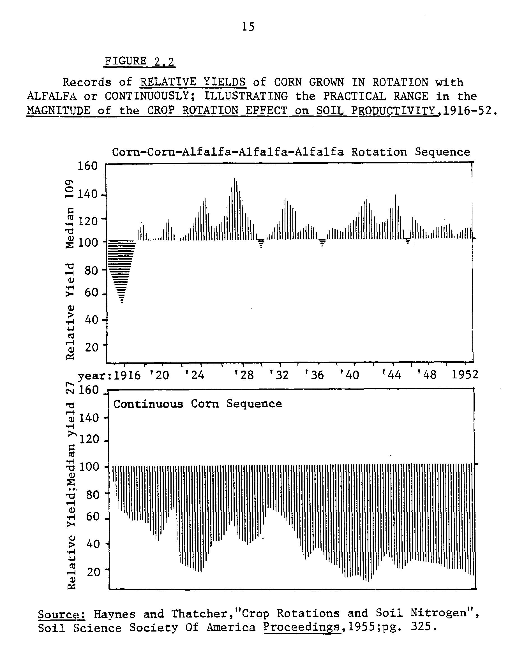
16
Experiments to quantify the importance of crop rotations originally focused on identifying the types of crops, typically legumes, that would provide the maximum crop yield benefit. Alfalfa was recognized as the most effective rotation crop. It was assumed that yield benefits were due to both nitrogen and "something else". As the use of nitrogen fertilizers spread, more scientific attention was focused on specifying the nature and magnitude of these effects known as the "nitrogen effect" and the "rotation effect", respectively.
The Nitrogen Effect
As late as 1955, experiments commenced on the Morrow Plots to compare nitrogen fertilizer with manure and/or crop rotation treatments for corn. The two results found were (1) that fertilizer treatments most quickly reinstated soil fertility but (2) that fertilizer did not entirely substitute for rotations. The following paragraphs present evidence of the extent to which fertilizer and nitrogen recovered from rotations substitute for each other.
Nitrogen contained in the residues of legumes is available to plants over time, at the rate established by the microbial action decomposition process. Also, as mineralization of these nitrates occurs, some is lost to denitrification, some leaches out of the soil profile, and some is metabolized by the decomposition organisms themselves. Voss and Pesek (1962) estimated actual first-year legume nitrogen availability from alfalfa at 123 to 200 lbs. per acre, and second-year nitrogen at 54 to 83 lbs. per acre. Fribourg and Bartholomew (1956) estimated legume nitrogen from a good stand of alfalfa at 100 lbs./acre.
17
These estimates resulted from two different types of tests. Voss and Pesek chemically analyzed the soil. Fribourg and Bartholomew compared yields of fertilized corn at known nitrogen soil levels with rotation corn yields. The range in available nitrogen estimates was attributed to variations in initial soil fertility, cultivars, weather/soil moisture and other confounding effects, the most important of which are the relative "efficiency" of nitrogen from legumes or fertilizer, and the non-nitrogen "rotation effects".
The concept of efficiency refers to the rate at which nitrogen is recovered by crops from various sources. If legume-derived nitrogen was utilized by a crop at the same rate as fertilizer nitrogen, pound for pound; it would be considered to be 100% efficient. Shrader and Johnson (1959), Sutherland, Shrader and Pesek (1961), Boawn, Nelson and Crawford (1960) and Voss and Pesek (1962) estimated the efficiency of legume nitrogen at between 16 percent and 92 percent of fertilizer nitrogen. The conclusions that use of commercial fertilizer was more efficient "pound for pound" than reliance on BNF of alfalfa or other legumes only further confounded the comparisons between crop rotations and fertilizer use.
Mooers (1930), Schmid (1959) and Shrader, Fuller and Cady (1966 established that corn yield data could be fit on one common function relating yield to nitrogen from either manure, legume residue, or fertilizer. Thus, the "common response curve" as illustrated in Figure 2.3 became a tool to compare the productivity of different forms of nitrogen inputs without having an exact measure of efficiency. For example, the nitrogen from symbiosis in legume residue is quantified in terms of "fertilizer nitrogen equivalents." A fertilizer nitrogen equivalent is:
18
19
“the quantity of nitrogen from whatever source such as soil, manure or legumes which was needed to obtain the same yield as was obtained with a pound of nitrogen supplied as ammonium nitrate.” Shrader, Fuller, and Cady (1966).
In figure 2.3, observe that the nitrogen equivalent of the crop rotation CCOM₁ is between 120 and 160 pounds of nitrogen.
The Rotation Effect
Experimental evidence of the non-nitrogen effect of rotations was concurrently piling up. Corn grown in rotations with legumes yielded more than continuously grown corn even at excessive levels of nitrogen fertilization (Welch, 1976). The concept of fertilizer nitrogen equivalent therefore also incorporates the non-nitrogen yield enhancing "rotation effect". This rotation effect is a separate consequence of crop rotation alone.
Up to a point, an equivalent yield of corn can be obtained using fertilizers as with crop rotation. But if both rotated corn and continuous corn are fertilized, the rotated corn can yield significantly more than fertilized corn, no matter how much nitrogen fertilizer is applied. This is the consequence of the "rotation effect". Baldock, et. al. (1981), reported a rotation effect as 15 percent of the total yield-enhancing effect of alfalfa in a CCCOA rotation. To date, the cause of the rotation effect has not been satisfactorily explained. Here are some propositions that have been positively tested: The "rotation" effect is due to:
1) effects of plant growth regulators that stimulate growth (auxins and cytokinins) left in legume residue (Baldock, et. al. 1981).
2) beneficial effect of deep root structure of legumes on soil tilth. (Barber, 1972).
20
3) avoiding autotoxicity: continual cropping of the same species of crop depresses its own yield (Hicks, 1981). Crop rotation interrupts continuous cropping.

4) relative buildup of phytotoxic substances is reduced due to increased soil aeration under alfalfa (Barber, 1972).

5) reduced soil-borne disease infestation; (Curl, 1963); (Litsinger, 1976).
6) reduced concentration of denitrifying bacteria that may interfere with efficiency of fertilizer nitrogen, (Walker, 1975). 7) moisture X fertilizer nitrogen efficiency lower than moisture X legume nitrogen efficiency, (Bolton, et. al., 1976; Higgs, et. al., 1976).

The yield benefit associated with rotations is a combination of the nitrogen effect and the rotation effect. This varies among crops. Sundquist, Menz, and Neumeyer (1982) propose that the yield response of corn after soybeans is characterized almost entirely as a rotation effect. In contrast, the main effect on corn in an alfalfa rotation is a nitrogen effect. For the remainder of this thesis, the focus will be on the corn/alfalfa rotation as an alternative to nitrogen fertilized continuous corn.
MANAGING ALFALFA FOR BNF
The preceding discussion leads to the conclusion that alfalfa provides the greatest crop rotation benefits of the Corn Belt crops. Indeed, alfalfa hosts greater levels of nitrogen fixation than any other legume per season (Vance, 1978). Can alfalfa be cultivated for direct use as a livestock feed and also provide high levels of organic nitrogen? The following evidence concludes "affirmative". The issues are (1) the relationship between dry matter production and symbiotic activity; (2)
21
how symbiotic activity nitrogen carry-over are affected by repeated harvesting; (3) how the timing of harvest, vis-à-vis the nitrogen nutrition of alfalfa affects its winter hardiness; and (4) how symbiotic activity varies over a typical four-five year perennial stand of alfalfa. Can alfalfa be also managed as an annual and still provide comparable nitrogen carry-over. benefits to corn as does perennial alfalfa?
Alfalfa has been cultivated as a perennial for four to six years and exploited as livestock feed, then plowed down and followed by corn with consistent success for decades. Boawn, et. al. (1963) reported that over half of the nitrogen taken up by fertilized corn following harvested perennial alfalfa was from the decayed roots or from the pool in the soil. But recent: research suggests that other management alternatives with shorter time-horizons exist.
Over the decades, yields of alfalfa have improved as a result of proper liming and improved soil phosphorous and potassium management. Recent studies reported by Higgs (1976) and others relate the quantity of nitrogen that can be available after the alfalfa course to the yield of alfalfa in terms of total dry matter production. A healthier stand of alfalfa can also fix more nitrogen, so the relationship is positive: more alfalfa implies larger quantities of organic nitrogen, to a maximum level. Consequently, first and second-year yields of corn following alfalfa have increased as alfalfa yields have increased.
In addition, Vance and Heichel, et. al. (1978) have found that although repeated harvesting impairs symbiotic nitrogen fixation temporarily, this does not force alfalfa back to reliance on soil nitrogen.

22
Results show that the quantity of soil nitrogen remaining after an un-harvested alfalfa crop and a repeatedly harvested one (in a year) are roughly the same.
Thirdly, Heichel (1981) has suggested that through genetic selection, nitrogen fixation of alfalfa could be some positive multiple of the current level without a significant impairment of the production of hay.
The largest quantity of nitrogen from legume cultivation can be captured if a full re-growth is plowed-down in fall, but the quantity contained in the roots and crowns alone is quite substantial. (Jokela (1981) conservatively estimates it at 90 lbs/acre.) Currently, research is underway to identify the differences in nitrogen available from plowed-down crowns of heights from 5 to 12 inches.
In perennial alfalfa management, the timing of the last harvest and the level of regrowth affects winter-hardiness. Some studies suggest that the last cutting of alfalfa be done early in the fall to allow time for re-growth and fixation before the dormancy period. Others suggest a very late cutting, so that the cold weather will suppress growth and the nitrogen in the roots will not be drawn into the vegetative parts. It is not clear which technique eventually maximizes both yields and available nitrogen after the perennial stand. But for an annual stand, Heichel, Barnes and Vance (1981) recommend an early September, late summer final cut and then immediate plow-down. That way both the seeding-year and second year of alfalfa can contribute significant quantities of nitrogen.
23
ROTATIONS IN THE FARMING SYSTEM
In addition to the yield-enhancing effects of crop rotation with legumes, and the supply of livestock feed, crop rotation provides a range of benefits to the farming system as a whole. Heady and Jensen (1954) listed twelve ways in which rotations built stronger farms:
1. prevent soil erosion
2. maintain soil productivity
3. control weeds, diseases and pests 4. help soil drainage
5. spread labor and machinery and power (use) over the season 6. provide livestock feed
7. lessen risks and uncertainties 8. provide cash income
9. adjust to rainfall limitations and (crop) moisture needs 10. use land in most profitable crops
11. allow soil-building crops frequently on each field
12. select the crops best adapted to each soil.

The following is an overview of current evidence supporting the above postulates that have not been previously discussed. These are points (1), (3), (4), (6), (7), (9). Points (5) and (10) concern the allocation of farm resources over time to maximize farm earnings. These issues will be investigated in detail later, in the modeling analysis.
Erosion Control
Evidence supporting the first assertion in the list above is institutionalized in the formulation of the Universal Soil Loss Equation. The USLE is documented in USDA Handbook 537. Soil erosion can be calculated from knowledge of land slope, soil characteristics, rainfall and crop management practices. Continuous alfalfa cultivation is least prone to erosion and therefore serves as the reference erosion index. Reduced tillage employed with crop rotation is an effective means of
24
maintaining soil fertility concurrent with erosion control, (Holt, 1979). Sixty percent of the commercial nitrogen fertilizers applied on Minnesota crops remain in the field in crop residues. Although the turning under non-leguminous crop residue will retain these nutrients in the soil, they remain relatively immobilized, releasing over a few years to subsequent crops, (Giddens, Arsjad, and Rogers, 1965). If both legume and non-legume residues are returned to the soil concurrently, the organic nitrogen will be made available at a higher rate than from either crop separately. But turning under crop residue is not necessary. Even if no-till methods are used (the hay crop is killed with herbicides and the residue is left on the surface) the meadow can supply all of the nitrogen required for a subsequent corn crop, (Triplett, Haghiri and Van Doren, Jr., 1979). This result is not surprising in light of research reported earlier that showed that plowing and cultivation stimulates mineralization. Mineralization is the immobilization of organic nitrogen after decomposition, making it unavailable to plants.
Cultivation of alfalfa can therefore reduce erosion potential two ways: (1) by providing excellent ground cover against rain-erosion, and (2) by serving as a green manure crop, even with no-till techniques.
Pest Control
"Monoculture is a convenient cropping practice for growers, but it is also convenient for insects."
Gordon Barnes, "Insect Control" (1980)

Continuous cropping allows pathogenic organisms to continue their life cycles uninterrupted. Many pathogens attack only a limited range of crops, and cannot survive when the host plant is absent. Inserting a
25
botanically unrelated crop into the cultivation sequence can be an effective measure of control. The following discussion of the role of alfalfa in crop rotation for pest reduction is summarized from the excellent survey by Curl (1963).
Rotating grain with alfalfa is a successful method for controlling fungal diseases. The organic residue from alfalfa decomposition produces fungi-toxic substances. Soil which is high in organic matter favors predatory fungi that destroy nematodes. These are forms of "biological control"--the promotion of antagonistic or predacious interferences among soil organisms. Rotation also is beneficial for the alfalfa because it interrupts the alfalfa root-rot infestation.
Soil micro-flora have a variety of nutritional requirements. Since living plant roots and crop residues qualitatively alter the soil, this regulates the activity of microbes and plant pathogens in the environment. Nutrient deficiencies affect a plant's susceptibility to disease. Crops on land previously in alfalfa may have sufficient nitrogen, which helps reduce the damage of a fungal attack. But alfalfa depletes soil potash (K) and phosphorous (P). Subsequent crops could suffer deficiencies in these nutrients and fall prey to a pathogenic attack.
Litsinger and Moody (1976) describe how crop rotation controls corn rootworm, the most severe pest in the local corn belt. Ninety percent of the dollar value of pesticides applied to corn is to control corn rootworm (Sundquist, Menz, Neumeyer, 1982). Seven percent of the total cash cost in corn production could be saved if crop rotation is practiced, since applying corn rootworm pesticides would be unnecessary.
26
An empirical study by Klepper, et. al. (1977), in the corn belt area found that crop rotation was the most popular technique of pest control on organic farms. Yield and profit pictures from these farms were comparable to those of local conventional farms.
In summary, crop rotation is a fundamental and widespread practice of pest control for soil-borne diseases. Where chemicals or disease-resistant varieties are employed, crop rotation is an important supplementary measure. If pathogens develop immunities, or persistent strains occur, crop rotation provides the best method to control these soil-borne diseases.
Environmental Consequences
Alfalfa's very deep tap root system facilitates greater aeration of the soil and improves the soil tilth, (Blake, 1980). These are important factors promoting drainage. Water-logged soils promote the process of denitrification, a reversal of the fixation processes. Good drainage precludes water-logging, but it brings other problems. Nitrate is highly soluble and subject to leaching out of the soil profile. Fertilizers applied as nitrates are largely leached out of the soil during a rain. Ammonia is far less soluble, but the action of soil microorganisms converts ammonia into nitrate (nitrification) and then it too can be leached away. Leaching interferes with nitrogen uptake by the intended crop and causes downstream nitrate pollution. Rates of recovery by the crop and retention of nitrogen fertilizer in the soil, even without leaching, are commonly around 60% of the quantity applied (Swanson, et. al, 1978). Thus, particularly under rainy conditions, the use of
27
nitrogen fertilizers can be both inefficient and environmentally destructive.
Two studies which considered the value of crop rotation with legumes toward reducing nitrate pollution are Walker and Swanson (1974), and Olson, Heady, Chen and Meister (1977). In the first study about reducing nitrate pollution potential to zero (called an "on farm nitrogen balance") crop rotation was the optimal strategy modeled. The second study did not account for legume nitrogen carry-over, but found that under nitrogen fertilizer-use constraints rotation of corn and soybeans is optimal. Seasonal Moisture and Yield Stability
Legume nitrogen becomes available to a subsequent crop as the microbial action on the legume residue releases it. This method of nitrogen nutrient provision has been shown to be more reliable than use of fertilizer nitrates under both excessively wet or drier-than-average conditions. While heavy rain will leach fertilizer nitrates out of the soil profile, the timed release of mineralizing legume nitrogen is merely postponed. The organic nitrogen is not lost. On the other hand, during seasons of lower than average precipitation, the corn rotated with alfalfa displayed a positive yield effect; whereas, fertilized corn suffered a yield loss according to studies by Barber (1972). Research by Higgs, et. al. (1976) and Bolton (1976) concur:
"Consistent response of rotations over years despite variation in seasonal suitability for corn production indicates the significance of the use of rotation in a management program aimed at high yields." (p. 24, Bolton, 1976).
28
Diversification against Risk
Crop rotation reduces risk in two ways. First, the relatively more consistent high yields of corn grown in rotation despite weather variation is discussed above. Second, crop rotation implies diversification during any one cropping season. Cropland is allocated to the various courses of different crops with different management requirements. Parcels of the farm will be in different stages of the rotation sequences at any one time. Diversification not only provides insurance despite adverse weather, but also against variation in crop revenues. The farm operator can be assured of a harvest of the types of crops that survived the bad pests or weather. Of if the price of one crop falls, his other crop revenues serve to maintain at least a minimum income (Kim, 1981).
Livestock Feed
Jacobs and Stricker (1976) argue that BNF is best exploited by growing legumes for livestock feed. Alfalfa hay has long been prized as a feed for livestock, but its popularity was constrained by the high fiber-to-nutrient proportion in mature alfalfa. Although mature alfalfa is difficult for livestock to digest, young pre-bud alfalfa is ideal. Improved understanding of both ruminant digestion mechanisms and alfalfa management has stimulated interest in pre-bud alfalfa as feed (Conrad, VanKeuren and Hibbs, 1978; and Rohweder and Baylor, 1980).
As suggested earlier, management of alfalfa for both high yields and the provision of nitrogen carry-over is possible following guidelines of Martin (1979) and Heichel, Barnes and Vance (1981). Pre-bud
29
alfalfa supplies high levels of protein and a good proportion of fiber to the ruminant animal. It compares favorably with all other feeds (Appendix III). With proper cutting management, it also supplies significant nitrogen to the subsequent corn crop.
NET BENEFITS OF CROP ROTATION
The term "crop rotation" does not by definition imply alternating cultivation of grains and legumes. Nevertheless, it is obvious that crop rotation has become synonymous with the practice of grain-legume rotation because of the superiority of legumes in rotations to improve the quality of the soil and to provide fixed nitrogen.
In section one of this chapter two methods of exploiting BNF, not mutually exclusive, in a corn belt farming system were presented. One is to capture the organic nitrogen of the legume crop residue for a subsequent grain crop. The other is to directly utilize the nitrogen protein rich legume crop as feed. The question of the economic value of BNF for Minnesota can be stated equivalently as the economics of crop rotation for grain/livestock farming systems.
The investigation of the economics of the crop rotation as a means of providing nitrogen starts with the identification of the input and a description of alternative sources. By describing BNF and crop rotation, some clues about the implicit and explicit costs of symbiotic or legume nitrogen are exposed. First, the soil must be prepared to support the microbial population. Then a microbe population must be established if it does not already exist. Then a legume must be cultivated. All of the expenses associated with these activities are explicit

30
costs. Coincidentally, the farm operator must forego the cultivation of the target grain or cash crop if he chooses to cultivate the legume alfalfa. This is an implicit cost.
The operator must weigh these costs against the benefits of crop rotation, harvest and use of legumes. The benefits of crop rotation have been enumerated above. Many of these benefits are not derived in terms
of saleable output, as in the case of improved soil tilth or reduced erosion. Some benefits are elements of alternative sets of farm inputs, such as the biological pest control due to crop rotation instead of insecticides; and alfalfa hay as a high-quality livestock feed instead of protein supplements.
These outputs of crop rotation/legume cultivation are inputs for other farm activities. To a certain extent, allocating farm resources to legume cultivation activities will actually increase the productivity of corn cultivation as it increases the fertility of the soil, etc. Thus there is a level of crop rotation, given a target farm income, up to which the cultivation of the two crops would not be competitive for farm resources, but actually "complementary" (Heady, 1954).
This proposition is the basis for the modeling and analytical effort of this thesis. In order to proceed, some generalizations of the .local specific agronomic and economic relationships fundamental to the question must be formulated on the basis of the information contained in this chapter. This is the substance of the following chapter.
Chapter Three
NITROGEN IN CROP PRODUCTION
Nitrogen and Productivity
Nitrogen is the most limiting factor in corn production since the adoption of high-yielding varieties of corn and the technique of high plant density (Englestad and Terman, 1966). With the advent of corn hybrids, which by 1939 were cultivated on over half the acreage in the corn belt, (NFDC, 1970), nutrients were more rapidly depleted from the soils than ever before. Therefore, high soil fertility became a prerequisite for maximum yields.
Figure 3.1 illustrates the importance of high nitrogen fertility today. The two response curves compare the nitrogen response of the native corn varieties with the nitrogen response of hybrids. The location of the intercept of the hybrid corn nitrogen response curve indicates that the hybridization alone accounts for at least one-third of the total productivity increase. The accelerated slope of the curve displays evidence of the greater response of hybrids to nitrogen.
Therefore, while crop rotation was sufficient to maintain adequate fertility for high yields of non-hybridized corn through the 30's and fertilizers were used to complement rotations; after WWII the roles of rotations and fertilizers reversed.
Nitrogen fertilizer use had an unprecedented impact on (1) crop productivity through the development of the hybrid corn (TVA, 1971); (2) land productivity by allowing more dense corn populations per acre
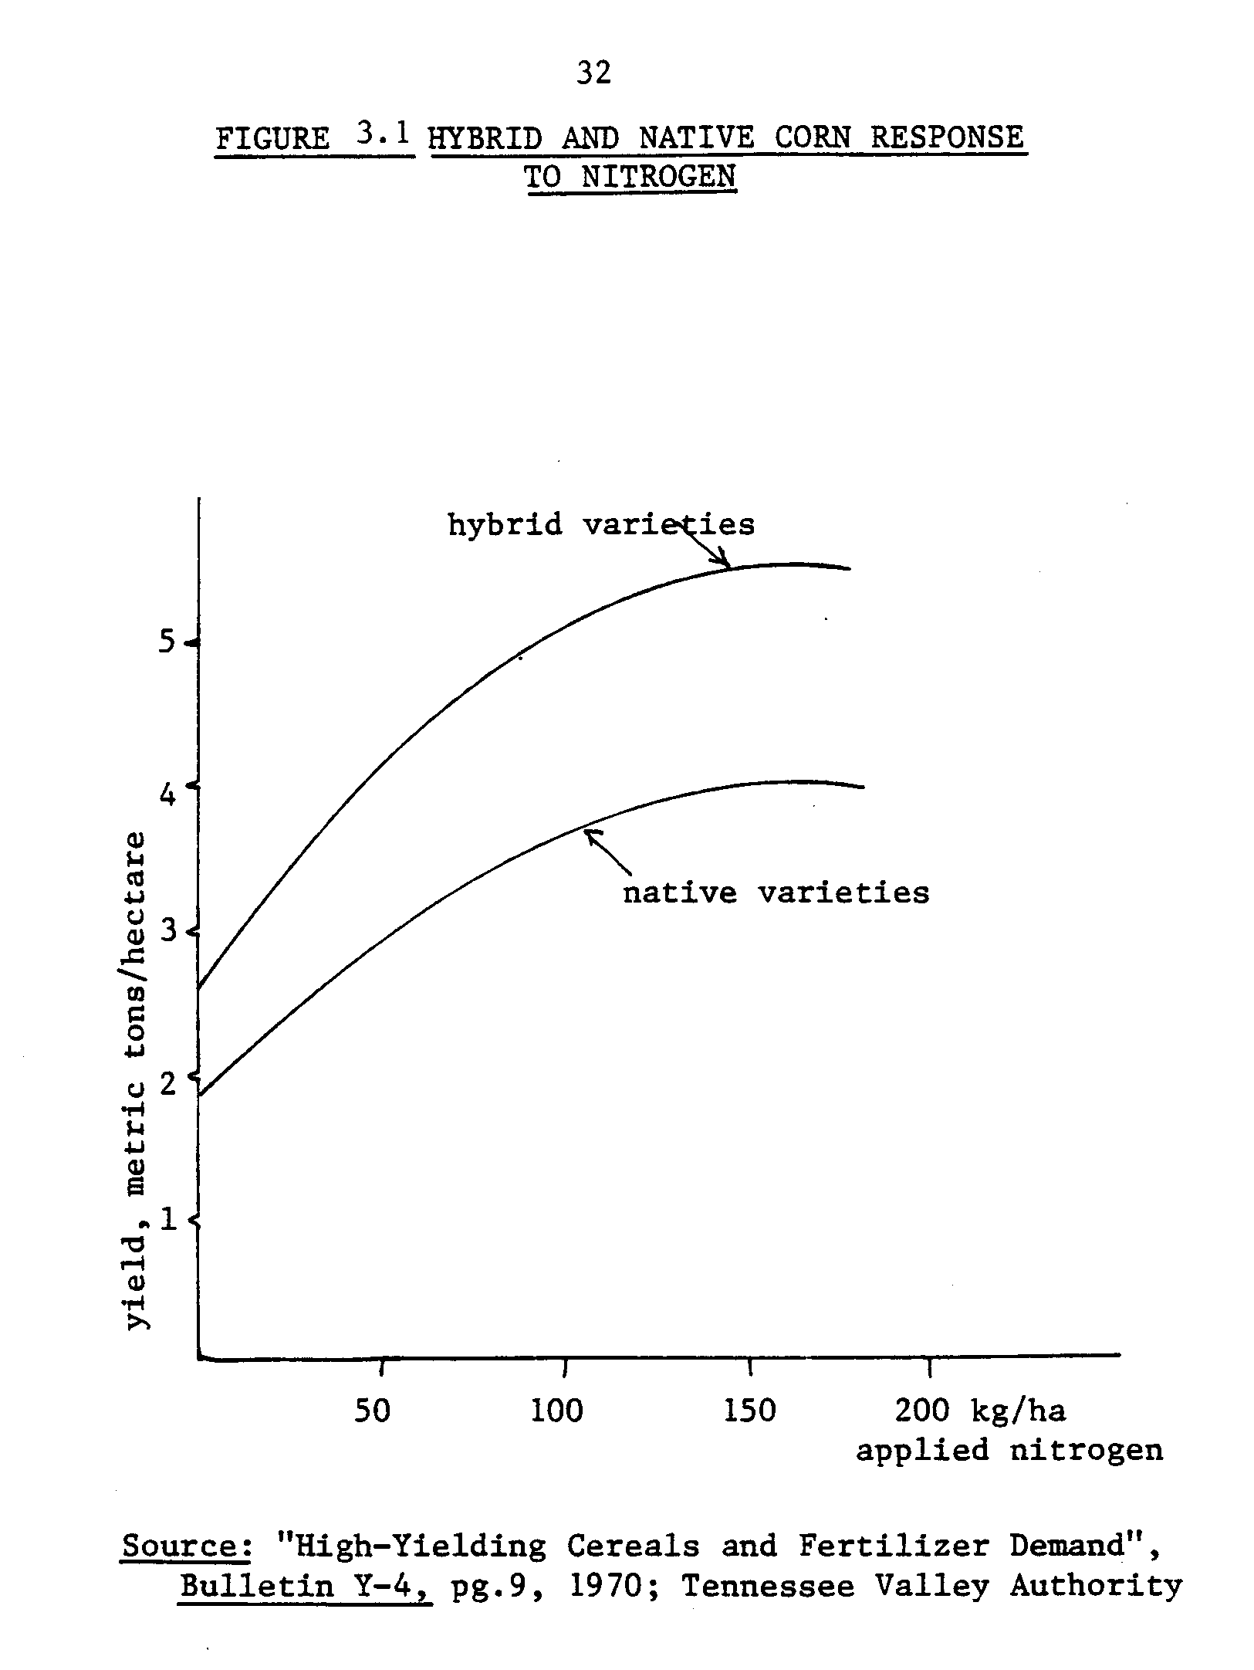
33
and enhanced yields (BLS, U.S. Dept. of Labor, 1952). Coupled with the steady N-fertilizer price decline (Loomis, 1957; Tennessee Valley Authority 1979; Fertilizer Institute 1980), these factors exerted incredible influence supporting a switch from rotation to continuous cropping relying on nitrogen fertilizers instead of BNF to maintain soil fertility.
THE GENERALIZED MISTERLICH-SPILLMAN FUNCTION
The response curves in Figure 3.1 are examples of the functional form that could potentially be used to model corn response to nitrogen. They are quadratic curves. Other functional forms include parabolic (G. W.
Cooke, 1982) and the "LRP", Linear Response and Yield Plateau (Lanzer and Paris, 1981), and the Misterlich function.
The Misterlich form is commonly employed because it is an elegant formula that reflects the main characteristics of the response of corn to nitrogen. Misterlich interpreted the famous nineteenth century scientist von Leibig's "Law of the Minimum" for asympotic regression. The Law of the Minimum contains two assertions: (1) that crop growth is proportional to the availability of the most. limiting essential nutrient and (2) that nutrient substitution is extremely limited.
Spillman reformulated the expression for asymptotic regression as an exponential response curve. The formula employed today (Baldock, et. al., 1981), known as the Misterlich-Spillman functional form is:
y = y* - d(e^{-EN})
34
where y denotes estimated corn yield
y* is the maximum yield attainable with added nitrogen
d is the difference between the highest and lowest yields, *
i.e., when N = 0, y* - d = y minimum.
N is the level of added nitrogen
e denotes natural.log
E is a curvature parameter specific to nitrogen, given the other factors.
Figure 3.2 is an illustration of the Misterlich-Spillman function. The features of corn response modeled so clearly are (1) the yield plateau is easily read from the equation at y* , the asymptotic maximum (2) the minimum, unfertilized yield is also easy to identify as the intercept, and (3) the curavature, indicated by - E shows how intense the local response to nitrogen is.
SITE-SPECIFICITY
In fact, environmental conditions, soil type, and climate determine whether the response increases at a steady high rate or a low rate; (i.e., the curve is steep or gently-rounded) and also establish the level of the maximum yield. Therefore, the appropriate functional form may vary among agro-climatic regions.
An example of the variations in response to nitrogen of the same cultivar of corn among five locations in Illinois are the response curves calculated by Swanson, Taylor and Welch, (1973) in Figure 3.3. Note that the nitrogen applied to achieve the maximum yield of corn varies from location to location by as much as 90 lbs/acre. Most economic decision
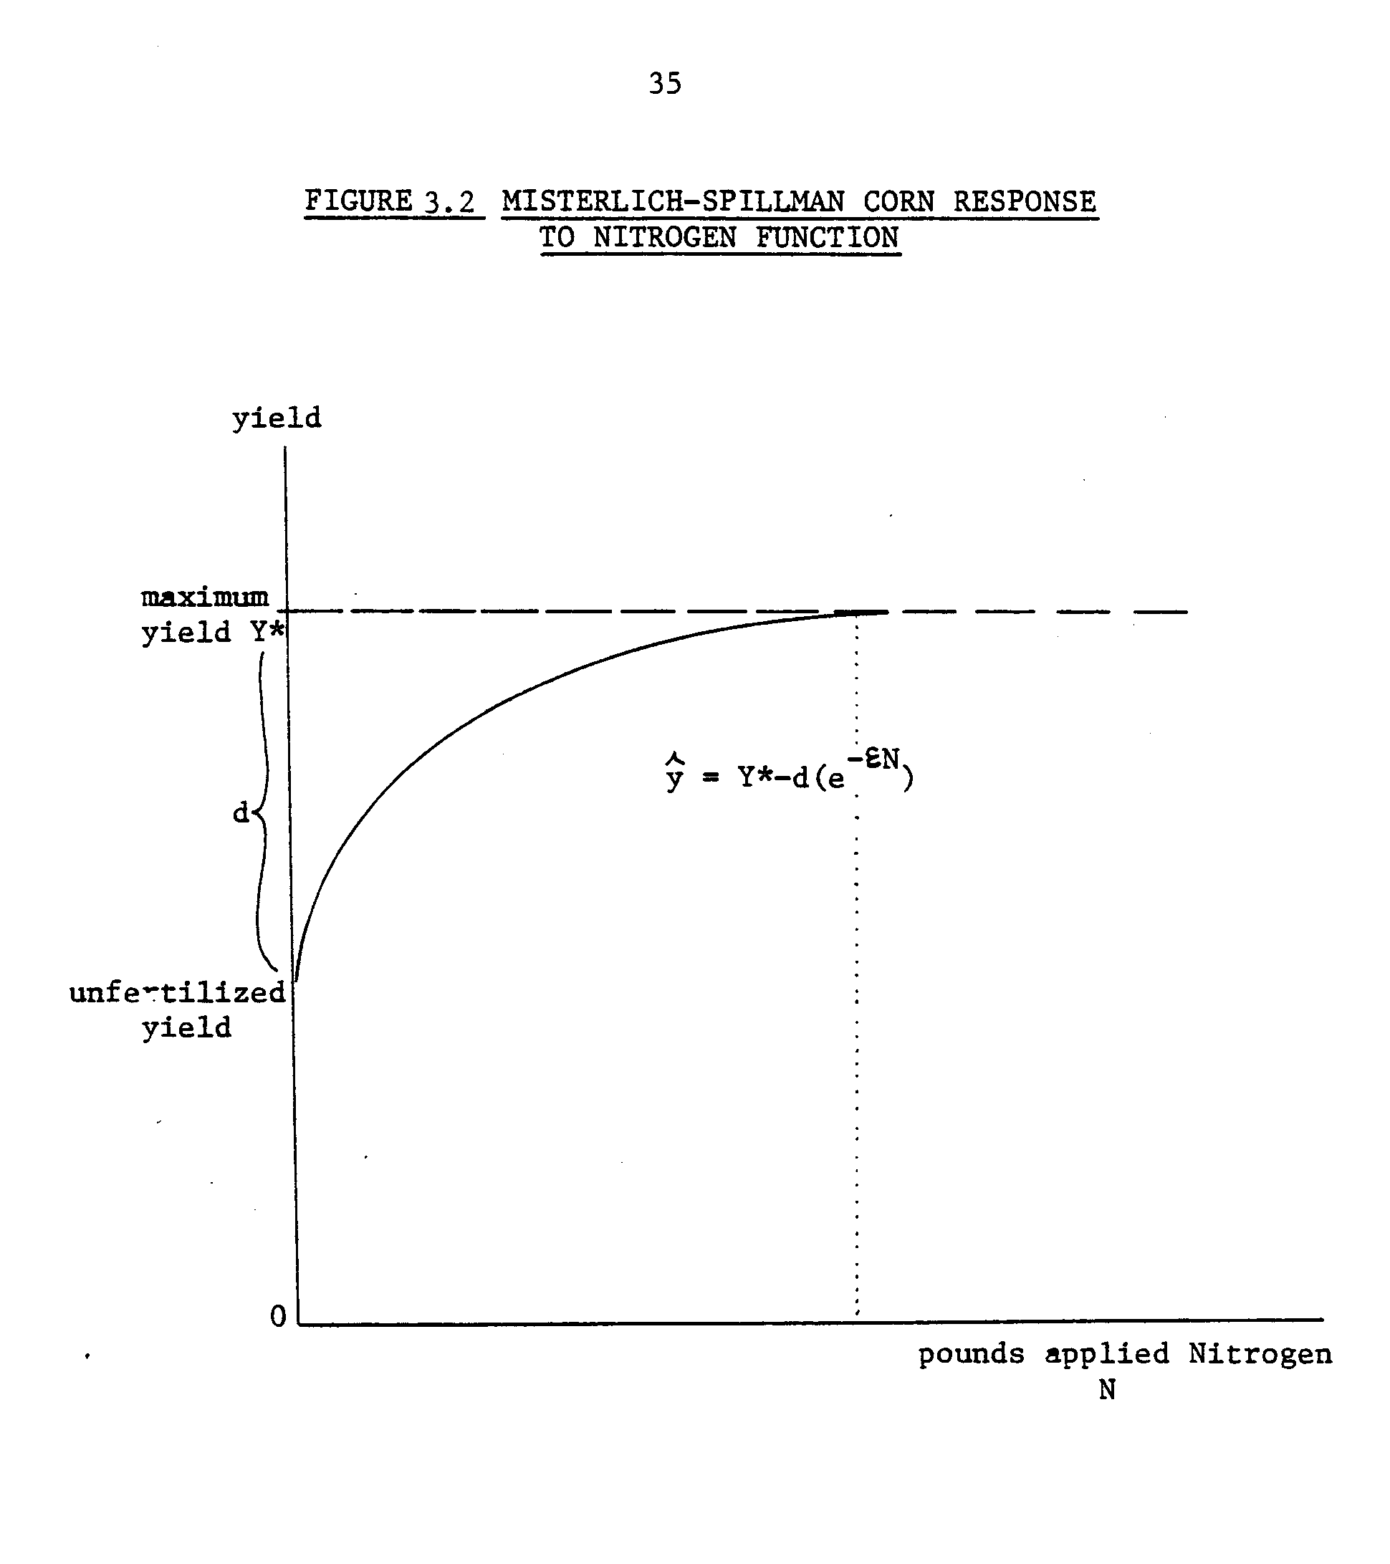
37
rules as to how much nitrogen to apply are based on the response curve (the production function). The recommendations will therefore also vary among locales.
DISCRETE VS. CONTINUOUS INPUTS
Fertilizer nitrogen can be employed in continuously divisible units.. The response in yield of a crop to additional units of fertilizer can be plotted as a continuous curve. This implies a ⁻different type of analysis of response than for the discrete or lumpy input of nitrogen available through crop rotation.
Biologically fixed nitrogen is a lumpy input. It can be recovered in a discrete quantity only if a legume crop was previously cultivated. The lump sum quantity recoverable is a function of the type of legume and management. This nitrogen is fixed in the soil under the legume crop and cannot be varied or moved from site to site.
The appropriate analytical approach to quantify treatment effects of lumpy inputs is functional ANalysis Of VAriance, whereas for the continuous input, OLS regression can be used. Figures 3.4.a and 3.4.b illustrate the two approaches (Dillon, 1966). The former approach does not generate a coefficient for the independent variables that relates the magnitude of the effect on the dependent variable. (Indeed, there is no logic in relating another "unit of crop rotation" per acre to the yield of corn per acre.)
But ANOVA provides evidence if significant differences exist between factors and among levels of factors in an experiment.
The fact that legume nitrogen and fertilizer nitrogen effects can be measured on the common N response curve (Ch. 2) only meets part of the
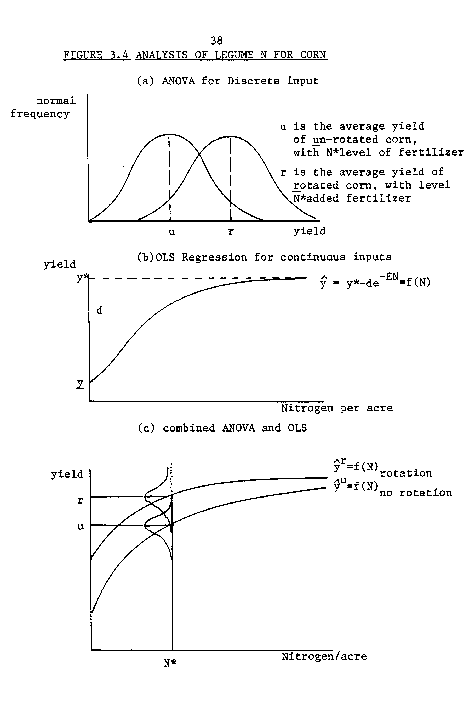
39
challenge in the comparison exercise. The relative productivity of fertilizer and legume-derived nitrogen with rotation effects must still be determined from mixed data. Figure 3.4.c illustrates how both OLS and ANOVA analytical techniques can be used. Analysis of variance is employed on a data set to determine if a statistically significant difference exists between rotations. If it does, OLS regression can be used on the separate rotation data sets to generate distinct response curves. When plotted in the same units, the nitrogen effect and the rotation effects can be measured as the horizontal and vertical differences between the response curves.
CORN RESPONSE TO NITROGEN IN SOUTHEAST MINNESOTA
The following presentation summarizes the estimation of two corn response to nitrogen functions from experiment station data (Appendix VI). Six years, 1975 to 1980 inclusive, of rotation experiments were conducted in Waseca county, which is within the Southeast Minnesota Farm Management Association area. In the experiment, corn was cultivated with six levels of added nitrogen (1) continuously, (2) after a year of soybeans, (3) after wheat, and (4) after alfalfa established with wheat.
The two-step analytical approach introduced above was employed. First, a 3 x 6 x 6 factorial design model was analyzed with a multi-analysis of variance software package “IVAN”. The factors were considered as R_{i}, N_{j}, and W_{k} as follows:
R_{i} for rotations, i - 1, 2, 3. (The wheat-corn rotation was not of interest.)
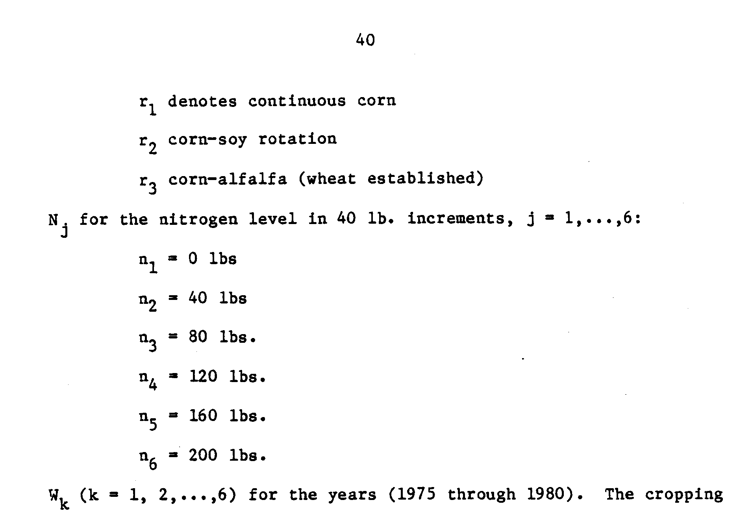

season's weather is the factor that influences yields. This was modeled in proxy by the year.
The model analyzed was:
Y(IJK) - R(I) + N(J) + W(K) + RN(IJ) + RW(IK) + NW(JK) + RNW(IJK). This model implies that a corn yield observation is due to three main factors: the type of rotation, the level of added nitrogen, and the weather that year. In addition to the main effects, synergistic effects among those factors influence yield.
The analysis highlighted (1) statistically significant differences (probability less than .001) between continuous corn and rotation corn (2) strong interactions between weather (years) and rotations, (p < .05) and significant differences among years (p < .001). In fact, weather in 1975 and 1976 was adverse for corn. There was a drought one summer and early rains that delayed planting in both years. Figure 3.5 illustrates the continuous corn yield data as a function of nitrogen for each year. The
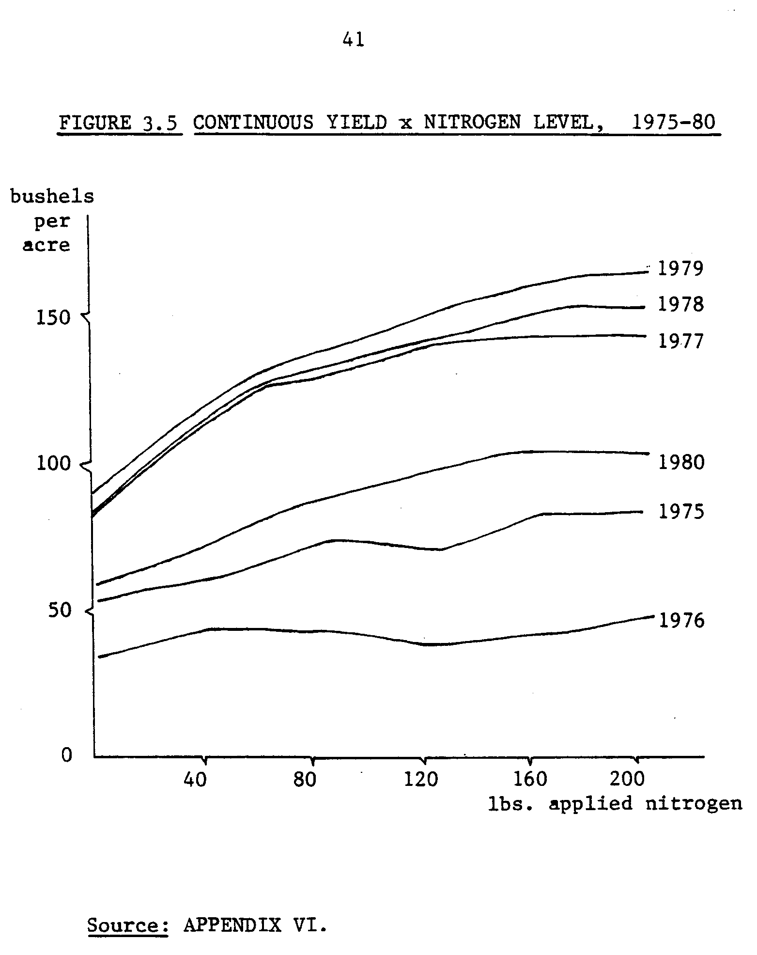
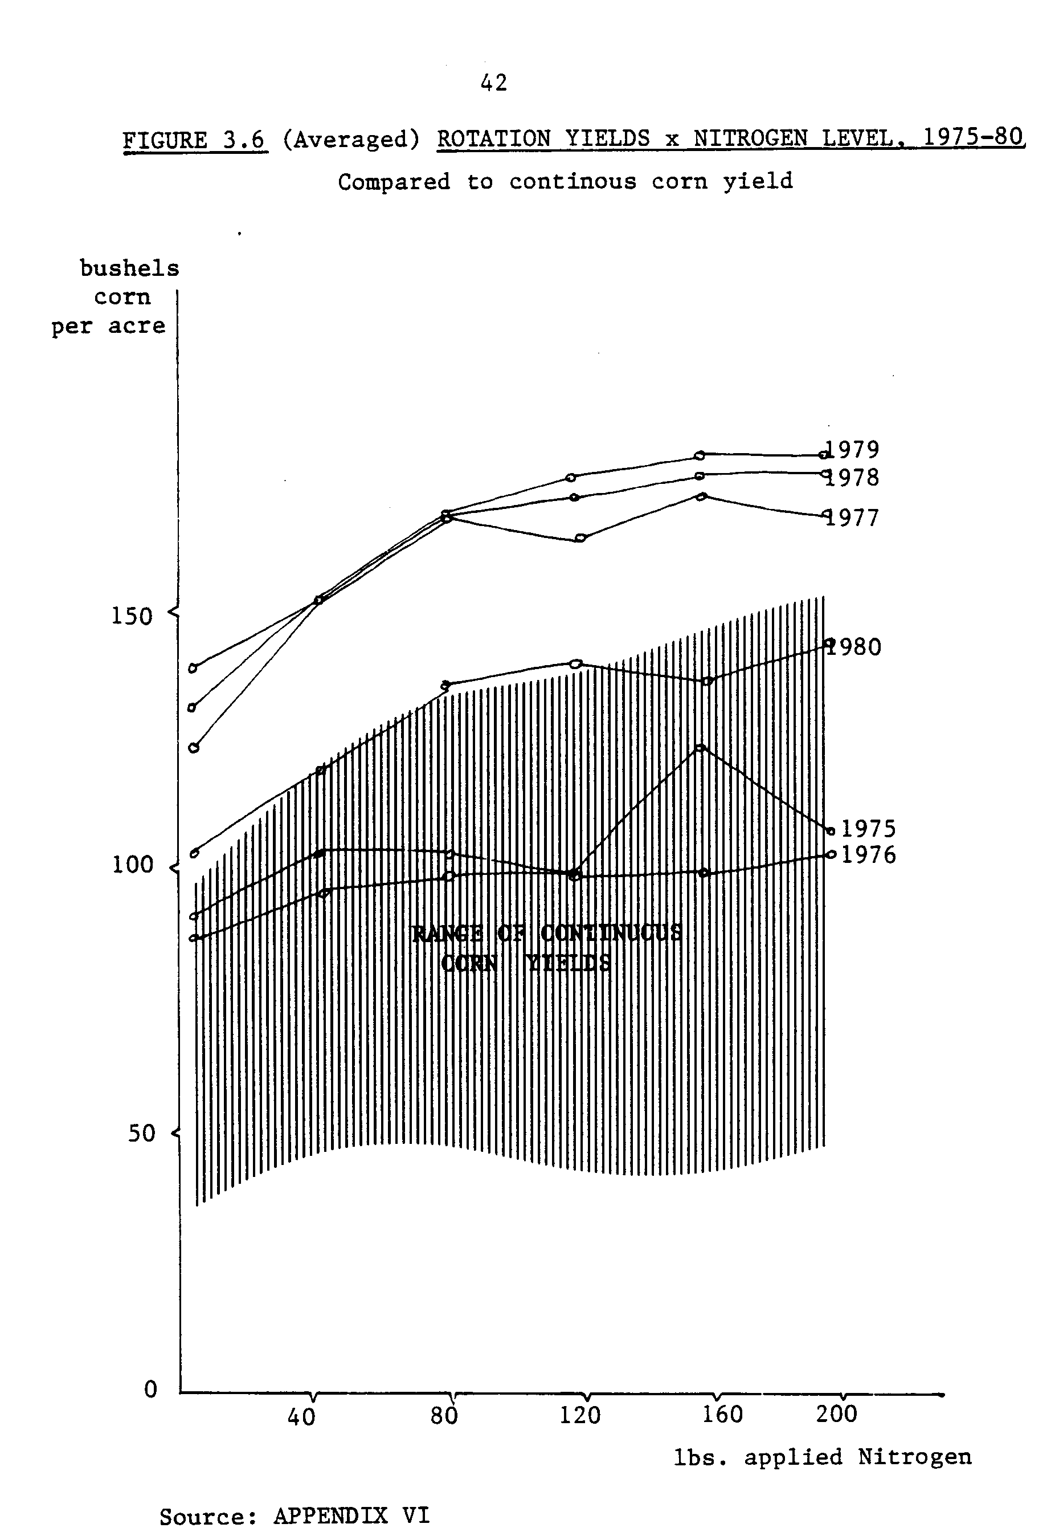
43
legume rotations mitigated the depressing effect on yields of the weather, the spread was much less prominent among years for the soy-corn and alfalfa/wheat-corn rotations. The graphs of corn yields over nitrogen levels by years among rotations illustrate this (Figure 3.6).
After testing various functional forms according to the goodness-of- fit criterion of lowest standard error for interpolation, the MisterlichSpillman functional form was identified as the best model. Two functions were estimated from half of the complete data set. These are the continuous corn and corn after soybean response functions for "good weather years". The alfalfa (wheat established)-corn response curve was close to indistinguishable from the soy-corn response curve. This is presumed to be due to the wheat crop's concurrently high nitrogen sink. The bad weather years of 1975, 76, and 1980 were dropped from the data set to reduce the variation due to weather in order to focus on the nitrogen response. It is assumed that farmers expect normal weather conditions and fertilize at the rate which will generate a good yield.
The generalized Misterlich-Spillman form is, as above,
y*_{i} = y_{i} - d_{i}(e ^{-E}i^{N}ij)
where: y_{i} denotes predicted yield of corn in the ith rotation.
yi is the maximum yield observation from the data for the ith rotation
d_{i} is the difference between the observed minimum and maximum yields data for the ith rotation
e denotes the natural log
Ei is the efficiency parameter for nitrogen in the i^{th} rotation
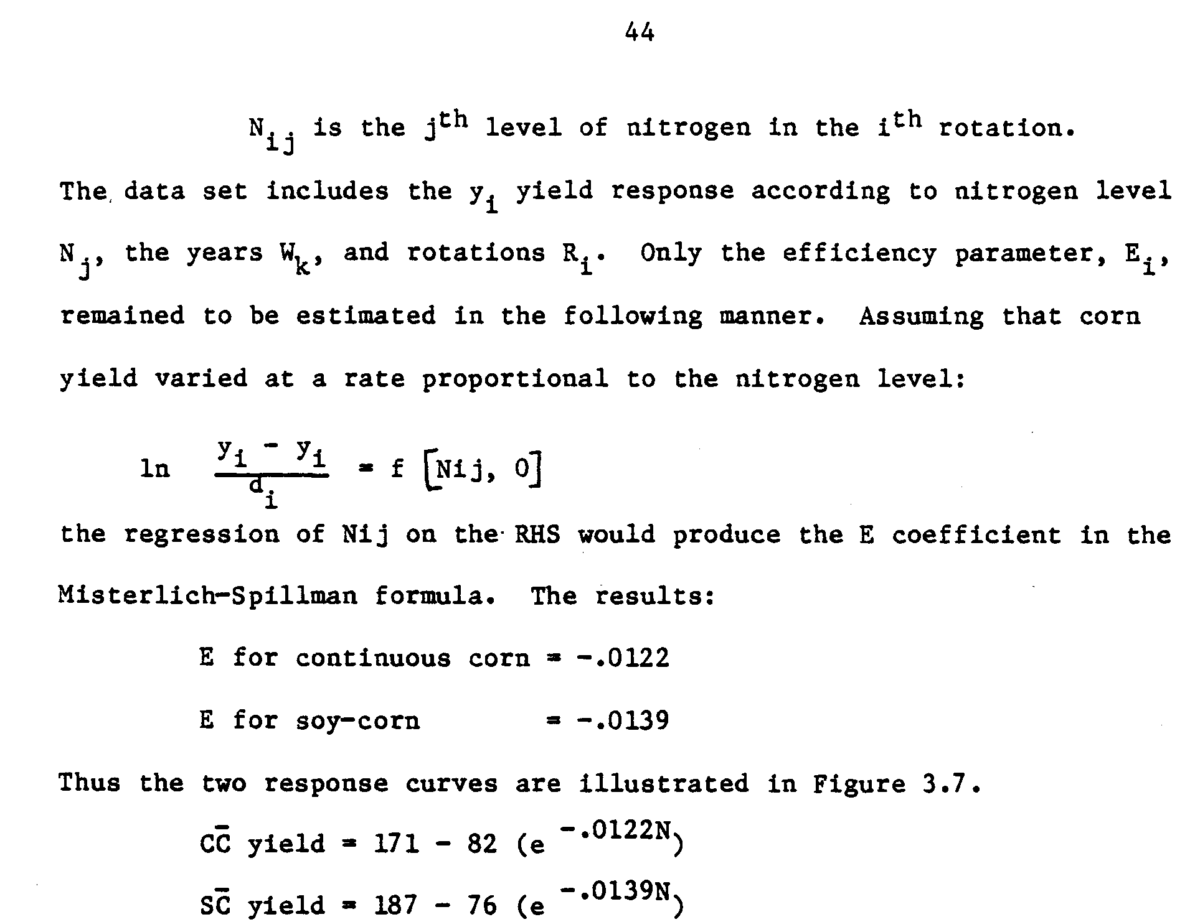

A response curve for corn following alfalfa that was cultivated at least for two years (a "full stand" or "full crop") is needed for the analytical activity in this thesis. From other sources, notably the 1981 Soil Test Guide for Minnesota (Jokela, et al) and from recent search by Heichel, Barnes and Vance (1981), an estimate of the nitrogen effect on corn after a full stand of alfalfa was derived. This estimate is based on evidence that a full crop of alfalfa contributes about 90 lbs. of nitrogen to the following corn crop, i.e., that the same average yield can be harvested from rotation corn as from continuous high fertility corn using 90 lbs. less fertilizer per acre. To the second year of corn, about 45 lbs and for a third year, only 15 lbs. can be credited as a nitrogen effect, and the fertilizer applied reduced accordingly.
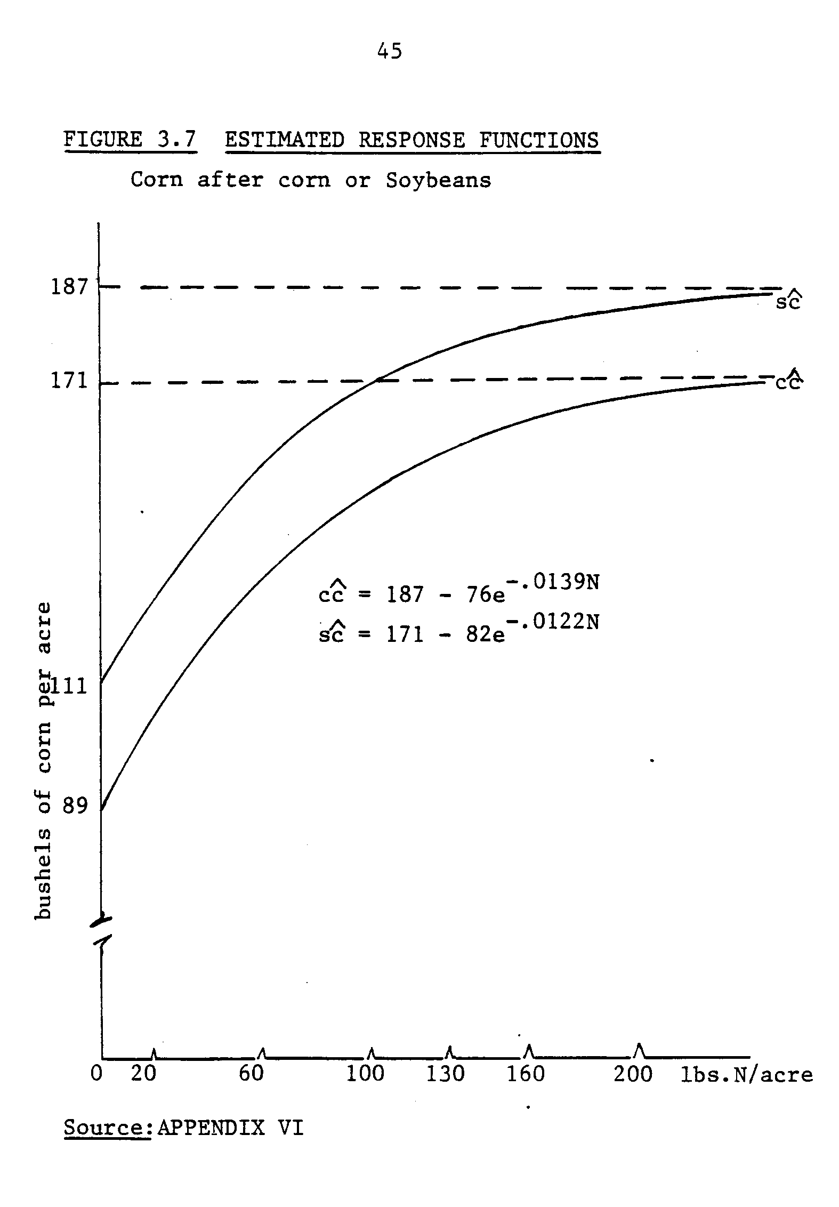
46
Organic nitrogen contained in the roots and crowns of alfalfa is available over time at a rate illustrated in Figure 3.8; Heichel, personal communication (1982). 60% of the total organic nitrogen is available the following year, 30% more after two years, and the remainder available in the third year. This means that if 90 lbs. is 60% of the total quantity of legume nitrogen that could eventually be recovered by the corn grown in successive years, then the total quantity is 150 lbs. The estimates of 45 and 15 lbs. in the subsequent years reflect 30% and 10% of 150 lbs. N_{L}, respectively. These nitrogen effect parameters imply leftward shifts of the continuous corn response curve.
But there is also the rotation effect. Again, the Waseca data was consulted. The maximum yield observations for the alfalfa/wheat-corn rotation was found to be 190 bu./acre. By incorporating this information and the yield x N pair to correspond with a 90 lbs. nitrogen effect which gives the same yield (154 bushels/acre) as corn at 130 lbs. N, an interpolated response curve could-be estimated. The resulting equation is:
AC yield = y = 190 - 65 (e ^{-.0148N})
This equation implies a 19 bushel rotation effect. The magnitudes of the nitrogen and rotation effects thus estimated are well within the range of estimates for rotation corn in Southeast Minnesota.
It is assumed that none of the rotation effect persists for the benefit of second year corn, so that the estimated response curve is based on a 45 lb. nitrogen effect alone. Also, no rotation effect is assumed for third year corn. Figure 3.9 presents the estimated and extrapolated response curves for those five different courses of corn in Southeast Minnesota.
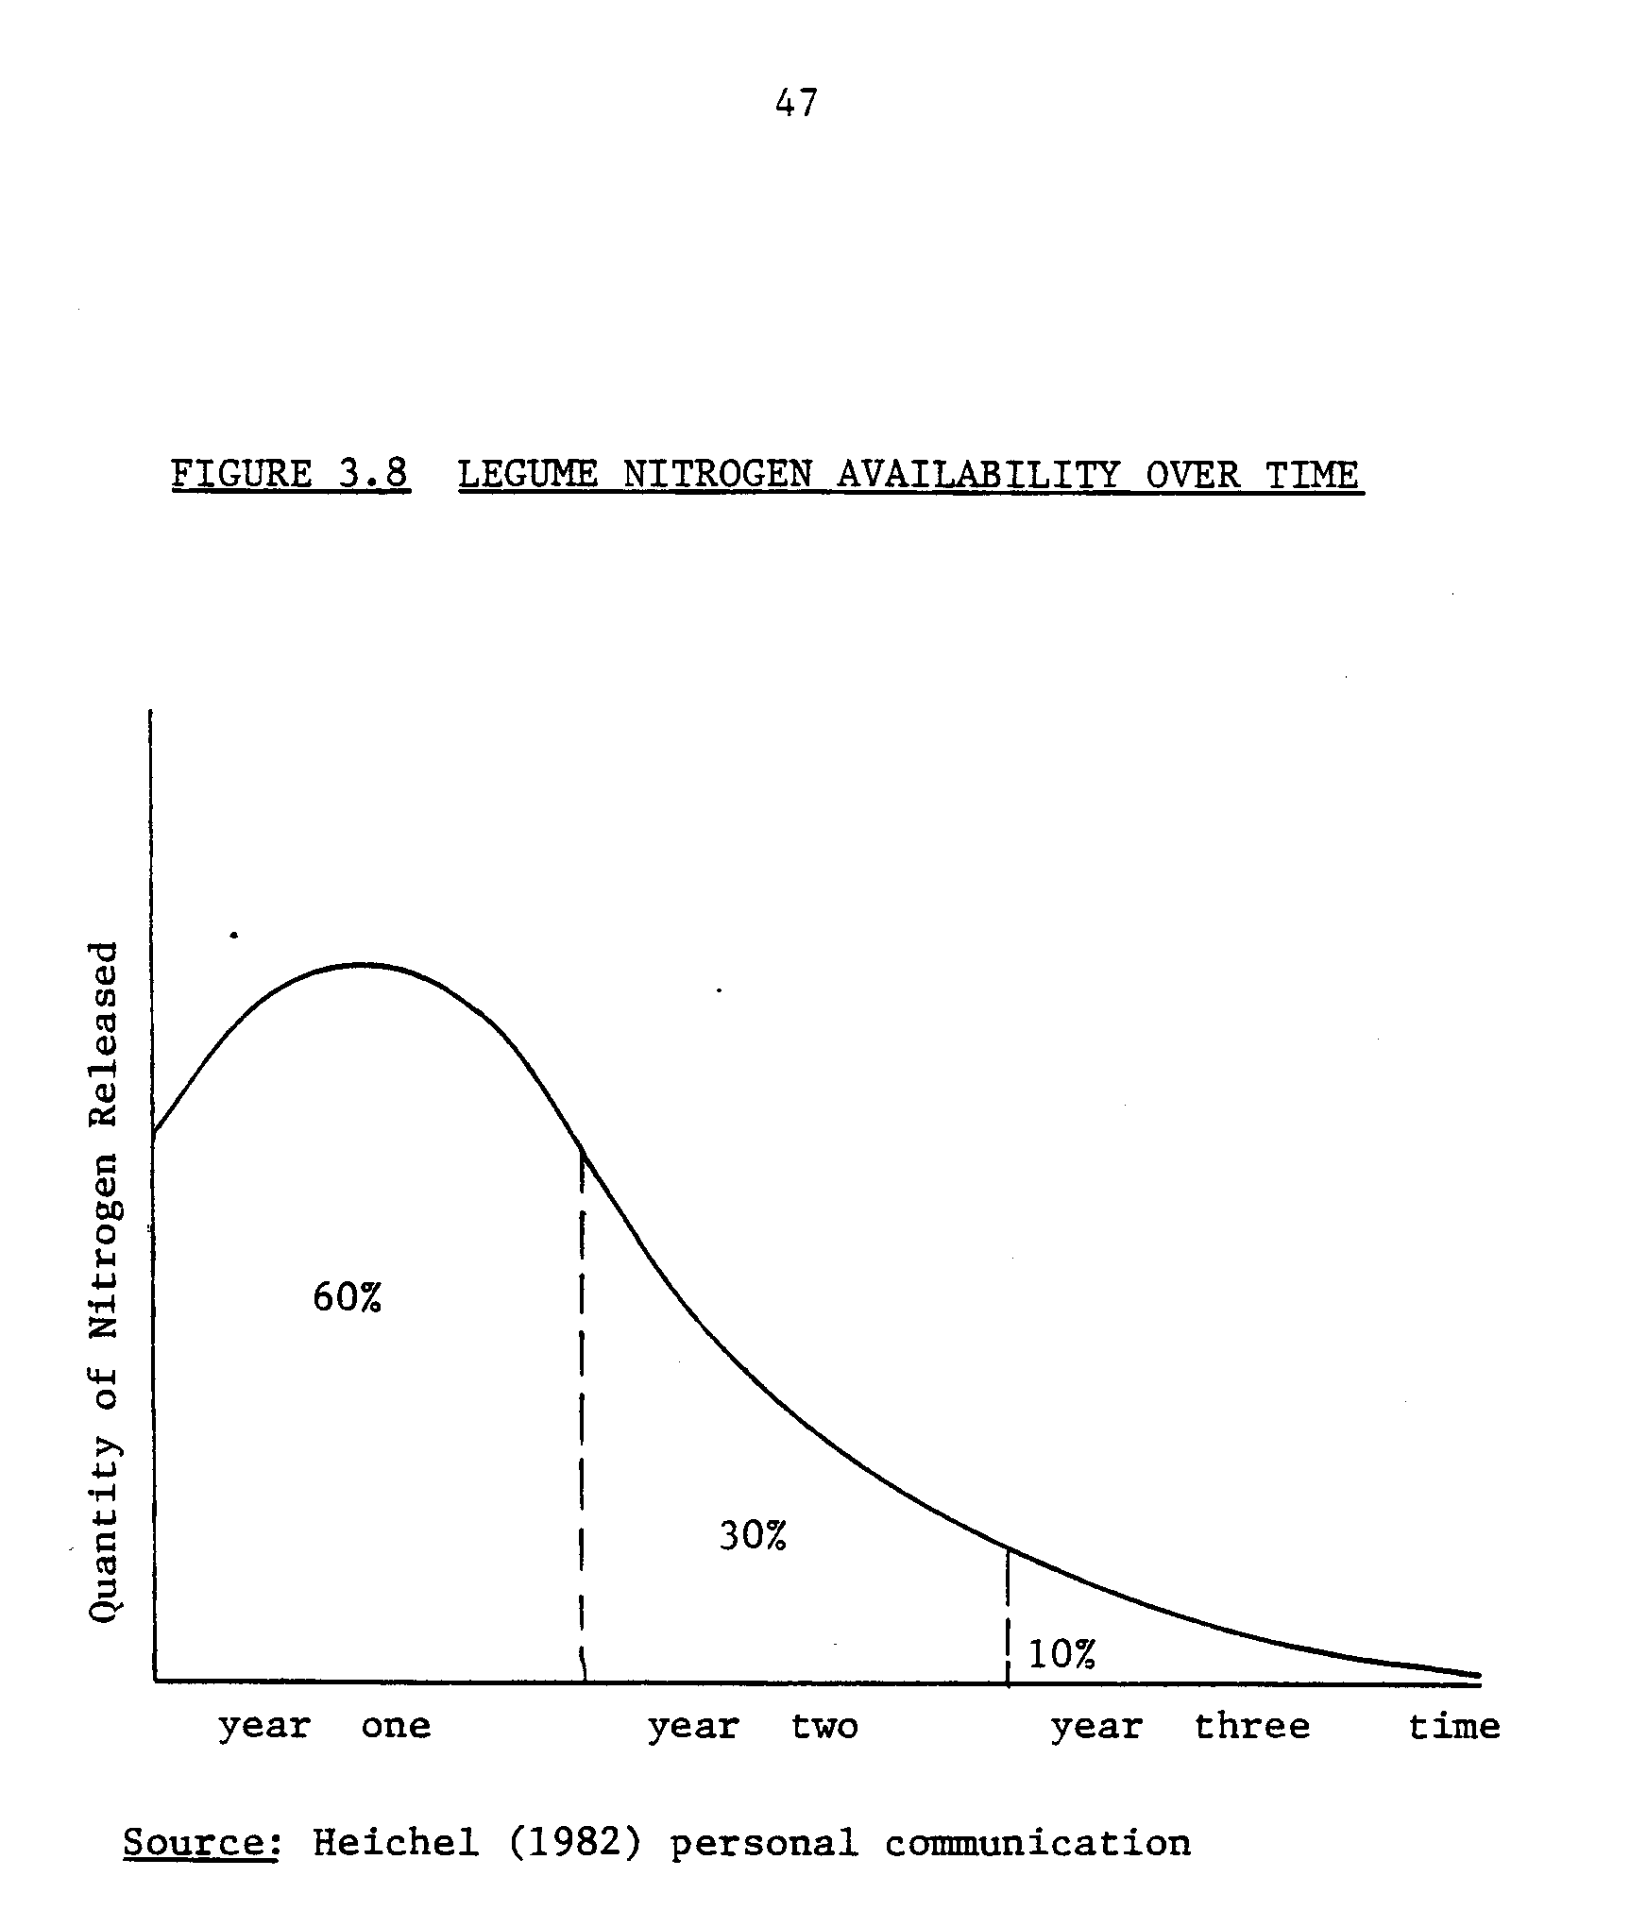
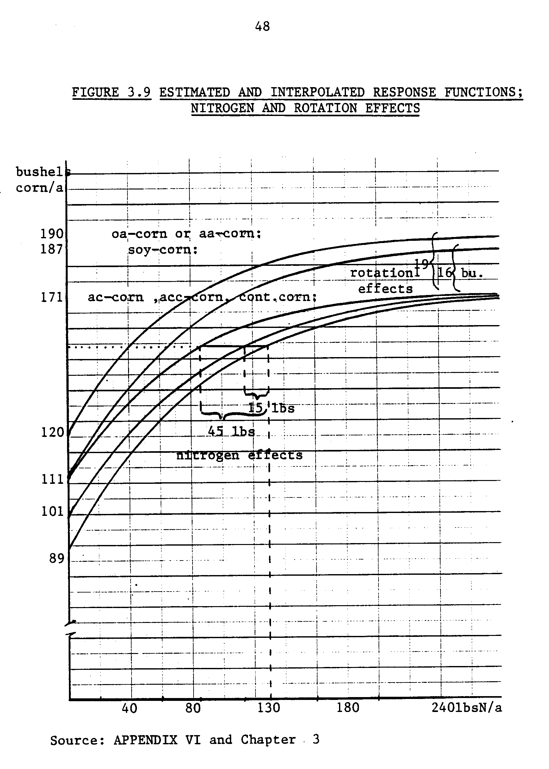
49
ECONOMIC DECISION RULES FOR NITROGEN APPLICATION
The neoclassic theoretical economic model for determining the quantity of an input (such as nitrogen fertilizer per acre) in production expresses the optimal level of input use as a function of the output price, the marginal productivity of the input in the production function, and the input cost.
Profit maximization implies that the marginal value product is not exceeded by the marginal cost of an input. In the vernacular, the last dollar spent on fertilizer returns a dollar's worth of product. This relationship is derived as follows.
Define profits as revenue minus costs due to production. Let p denote an output sale price vector, f(x) denote the production function using the x vector of n inputs, and w denote the input (factor) cost vector:
(1) π = pf(x) - wx
The optimization problem is to choose the level x_{i} for each ith input in the process f(x) such that profits are largest possible. The limits of profitability are due to the production function--the physical output possibilities from given inputs.
Assuming that the profit function is strictly concave, the maximum profit is determined analytically where the first derivative of the profit function with respect to the choice variable x is zero:
(2) pf’(x) - w = 0
This is the first-order condition for profit maximization, and it is equivalently stated and interpreted as follows:
(2.1) pf'(x) = w
50
The Marginal Value Product (MVP) equals Marginal Factor Cost (MFC). This relationship will obtain for every input:
(2.2) P ∂ f(x)/∂x_{i} = W_{i} for all i.
Figure 3.10 illustrates the application of the first order conditions for profit maximization to the corn/nitrogen problem using the response function estimated earlier. From this data, the economically optional rate of nitrogen to apply per acre is found to be 195 lbs. nitrogen, which is 237 lbs. of anhydrous ammonia.
This "economically optimal rate" was not the rate actually applied by the Southeast Minnesota farmers. Figure 3.11 contrasts the trend in actual fertilizer application rates per acre with the "economically optimal rates" from 1970 to 1982. The economic optima are calculated according to the prices prevailing each year, assuming the stated production function. Thus, the evidence that the economic model does not provide a valid simulation model of farmer practice is quite strong.
The modeling effort for this thesis will require a fertilizer rate decision rule that will mimic the response of Southeast Minnesota farmers to changes in fertilizer prices. In order to develop such a decision rule, an explanation for the apparent deviation of farmers behavior from what is expected according to the assumption of profit maximization was sought. The relevant research is discussed below. Then a model of typical farmer behavior is expressed in terms of a consistent deviation from the standard first order conditions, at all prices.
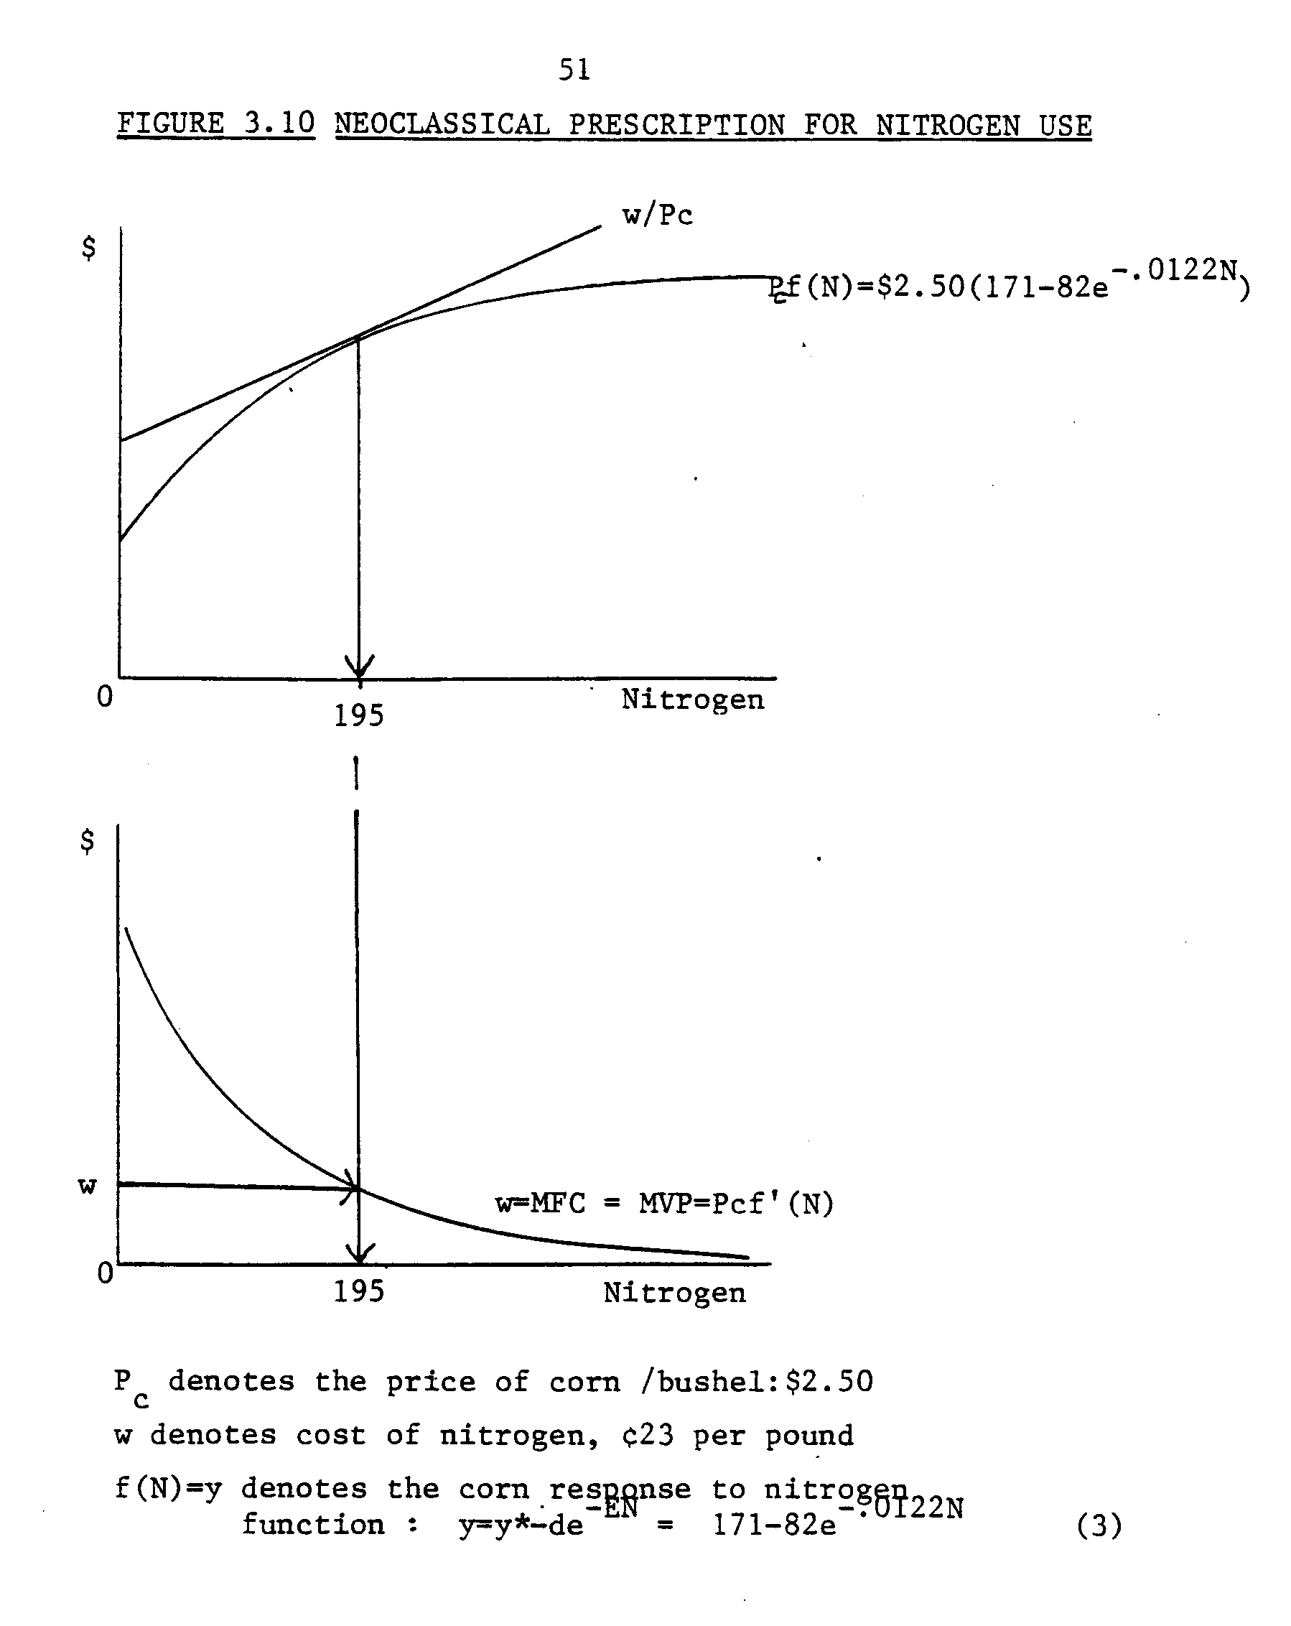
52
Studies that attempt to explain the apparent lower-than-optimal nitrogen application rates for corn comprise five general topics. These are (1) the notion that fertilizer use technology has not yet been fully adopted by farmers, (2) that the inherent riskiness of yield depressing over-fertilization, or loss of the investment due to unpredicted adverse weather, encourages farmers to use nitrogen conservatively; (3) the initial level of soil fertility alters the value of the marginal product of nitrogen and interferes with the farmer's subjective decisions about rates; (4) that a high price elasticity of demand implies that some type of optimal rate is being applied; and (5) that "capital-rationing" is employed--i.e., a minimum rate of return per dollar expenditure is subjectively established by the farmer, and the expenditure on fertilizer is bounded by it, regardless of the low price of fertilizer relative to its marginal value.
Empirical evidence suggests that farmers are now fully aware of the "optimal" fertilization strategies. Therefore, it is not out of ignorance that the techniques are not fully adopted, and technical progress lag theories do not sufficiently explain the current underutilization.
Three studies on the question of a conservative response by farmers .to subjective ideas about weather-related risk were reviewed. Dry weather could disadvantage lush fertilized corn to the point that cobs don't mature; and wet spring weather could render all the applied fertilizer useless since rain leaches the nitrates down and way from the corn roots where it was needed. Experiments conducted over a seven-year period designed to estimate the magnitude of year-to-year variations in economically optimal estimates for fertilizer nitrogen rates concluded
54
high initial levels of soil fertility, resulting from improved grain-legume rotation management.
The study by Swanson, Taylor and Welch (1973) introduced the theory that fertilizer demand is relatively price-insensitive because fertilizer is employed at levels where the revenue exceeds the cost. They propose that this differential is a cushion between the cost and the return to nitrogen fertilizer, so that farmers are not compelled to reduce fertilizer application rates even through the price increases relative to corn prices. Theory suggests that at optimal factor employment levels, a change in the factor price would result in a larger change in factor employment than would result if factor employment was sub-optimal initially. Therefore, the low price elasticity would imply that the neoclassically optimal level of fertilizer is indeed' being applied. A high price elasticity would imply that it's not. But this does not explain why the strategy is chosen.
AN ALGORITHM FOR FERTILIZER RATE
The most plausible explanation for the deviation between neoclassically-prescribed economically optimal fertilizer application rates and actual farmer practice in Southeast Minnesota is that farmers are rationing scarce cash. The farmer wishes to equalize the marginal value of the cash allocated among the inputs purchased. He would be maximizing profits, given his cash constraint, when each purchased input employed returns the same quantity of product, on the margin. This is the concept of equi-marginal returns.
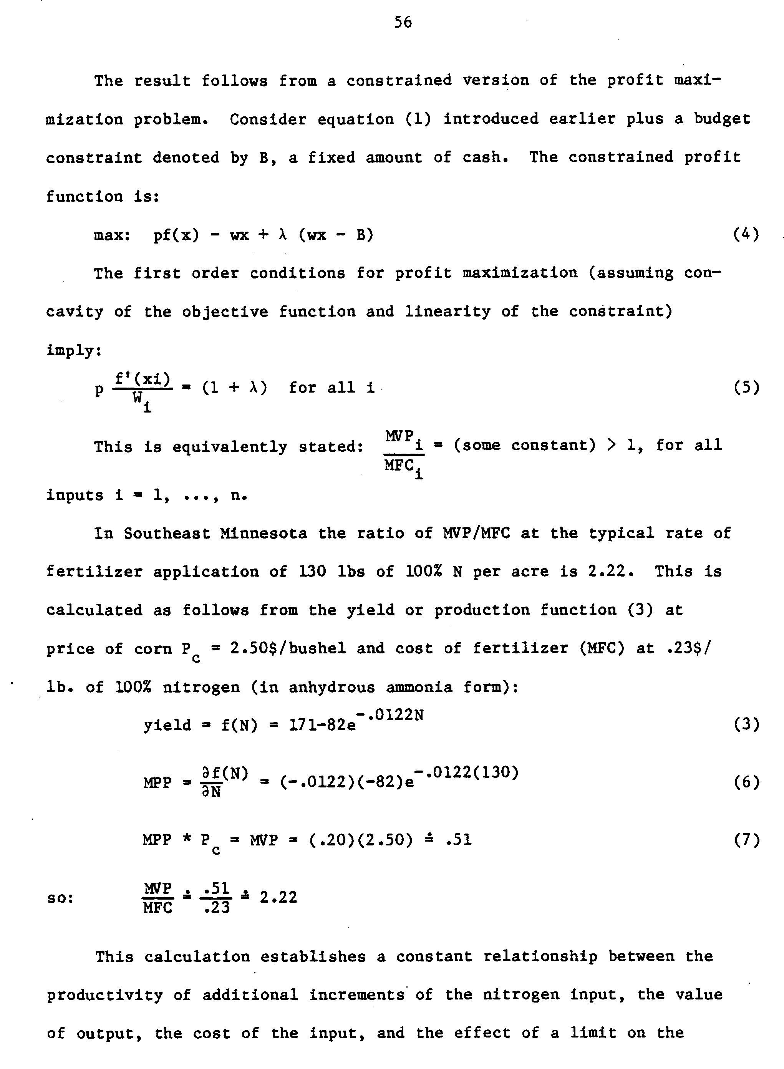
57
available cash. If the price of corn is net-out as a scale factor, this relationship can be expressed as a constant function of the nitrogen input price:
∂f(N) = .20 =.87 (8) ∂N .23

This relationship results from the behavior of a farmer who expects a return of over 2.2 dollars per each dollar allocated to purchase each input, assuming the price of output doesn't change.
A critical assumption is required in order to employ this fixed .877 MPP/MFC ratio condition as an algorithm for fertilizer application rate. This rationing formula must be assumed to hold at all prices of nitrogen fertilizer, all other things constant. Then the formula is employed simply by interpreting the level of nitrogen use implied to equate
∂F( N* ) = (price of nitrogen)(.877).
∂N

An example of how the nitrogen fertilizer rate is obtained from the production function, cost and price information, and the assumption of cash-rationing is shown in Figure 3.12. Consider a nitrogen price of .23$/lb. 100% N. The level of nitrogen required to obtain F'(N) = (.23)(.877) is 130/lbs. for corn grown continuously. This is read from the graph through the MPP functions for the continuous corn rotation to obtain the indicated levels of fertilizer application that maintains the relationship. For corn after soybeans, that level is 116 lbs. For corn in an alfalfa rotation it is 104 lbs. of 100% N.
In order to employ this algorithm the following generalized formulas were used in addition to (3) the production function and (6) the marginal
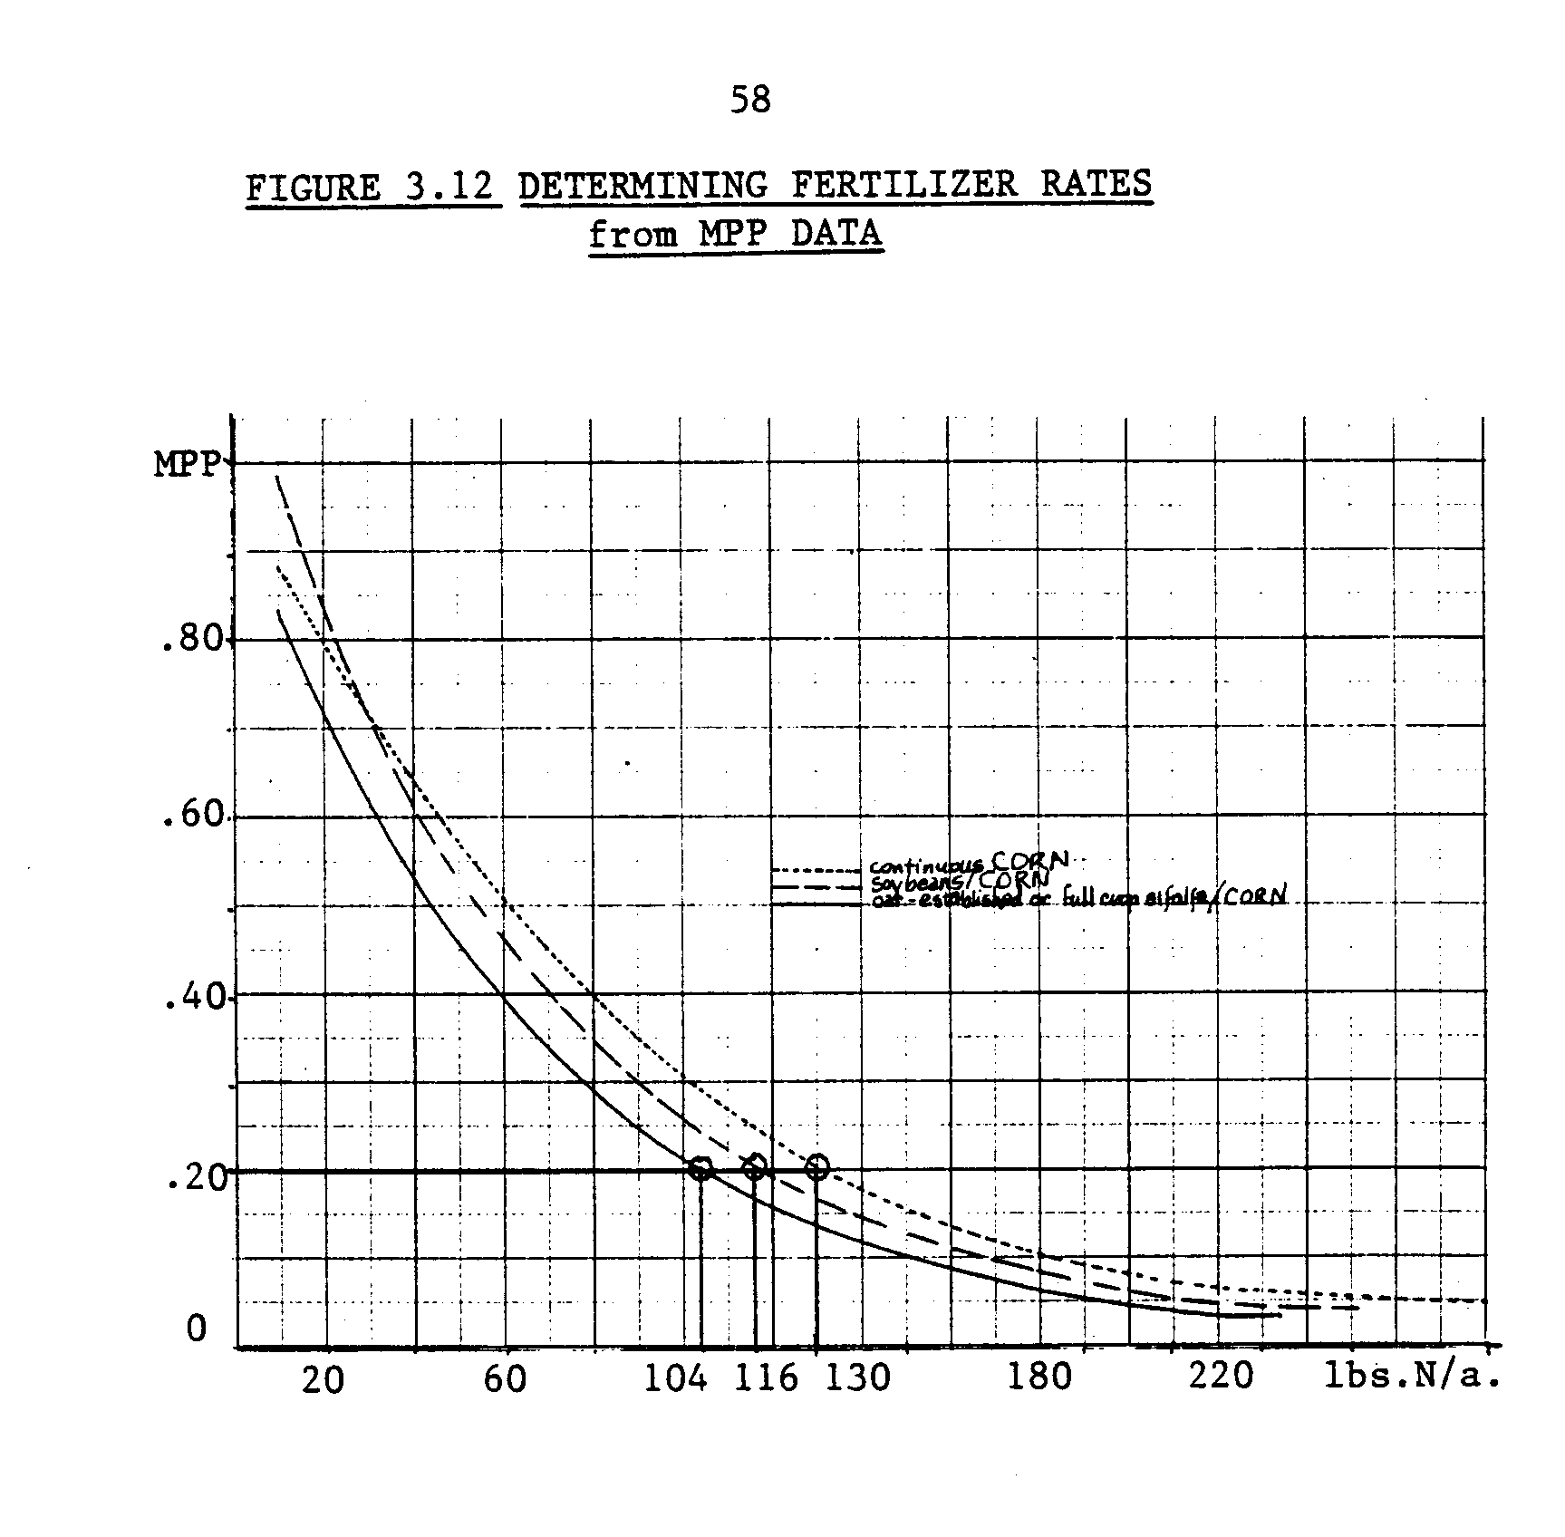
59
productivity formula, to find MPP* and N* , the optimal marginal productivity and level of application of 100% nitrogen according to the fixed returns/cost ratio of 2.22:
MPP* = [(2.22)(PN)] (1/P _{c}) (9)
N* = [ln(MPP*/(E*d)] (1/E) (10) where Pc, PN are the current nominal prices of corn per bushel
and per lb. of 100% nitrogen.
E, d are the curvature and difference parameters for each rotation corn response to nitrogen function.
The algorithm compares favorably with historical data on nitrogen fertilizer use. Assume that farmers base their decision on fertilizer rate given only previous years' corn prices plus past and current nitrogen fertilizer prices. Assume also that farmers' expectation of corn prices 7 to 12 months later is a simple average of previous and expected higher future prices. Over the thirteen years 1970 through 1982, taking the average price P received for corn as an expected price, the formulas (9) and (10) provide prescriptions for the rate of 100% N application as a function of the revenue/cost ratio, the nitrogen price, and the response parameters. These are the estimates illustrated in Figure 3.11; page 55. The dashed line in Fig. 3.11 indicates the suggested trend for the years 1974 through 1982. Prior to 1974, both nitrogen and corn prices were significantly different from post-1974 prices. Thus the prescribed rate is a poor mimic of actual practice for those unusual years. The prescription for the nine years after 1974 is quite similar in both level and direction of response to P_{N} changes to the actual data. In contrast
68
the neoclassically prescribed rate peaks and toughs in an inverse relationship to the actual data.
The fertilizer rate decision algorithm will be used to model the demand response to fertilizer price fluctuations. The algorithm incorporates the notions of cash-rationing, the constraints due to the agronomic possibilities for corn production in the specific area, and the current parametric input prices. In the context of the farming system model to be discussed in the next chapter, it will provide a straightforward formula to construct the appropriate corn production functions at different nitrogen prices, given a ceteris paribus output price environment.
Chapter Four
MODELING
There are four parts to this chapter on modeling. The first part applies the rudiments of the system-analytical approach to describe the Southeastern Minnesota crop-dairy farming system. The second provides a critical review of four previous studies in which BNF was included. The third presents₋₋the theoretical basis for the math programming model and a discussion of the special features of goal-oriented linear programming relevant to the problem. The fourth consists of the specification of the programming model. There is a brief but inclusive description of the resources/constraint and activities sets. The model is verified according to the data on the existing farming systems in Southeast Minnesota.
THE SYSTEMS APPROACH
The procedure followed in the construction of the model is illustrated in Diagram 4.1. Defining, analyzing, constructing and validating the model requires more than simply carrying out a sequential set of steps. At each phase there is continual rechecking, feedback and reformulation. For example, this research started with the question, "What is BNF worth in Minnesota?" The process of defining the various modes of biological nitrogen fixation led to the identification of crop rotation as an alternative to continuous cropping of grain, requiring use of nitrogen fertilizers. The question was therefore reformulated into, "How does nitrogen from legumes, when recovered by grain or used directly, compare to nitrogen purchased from commercial sources?" Answering this question is the objective of the simulation effort.
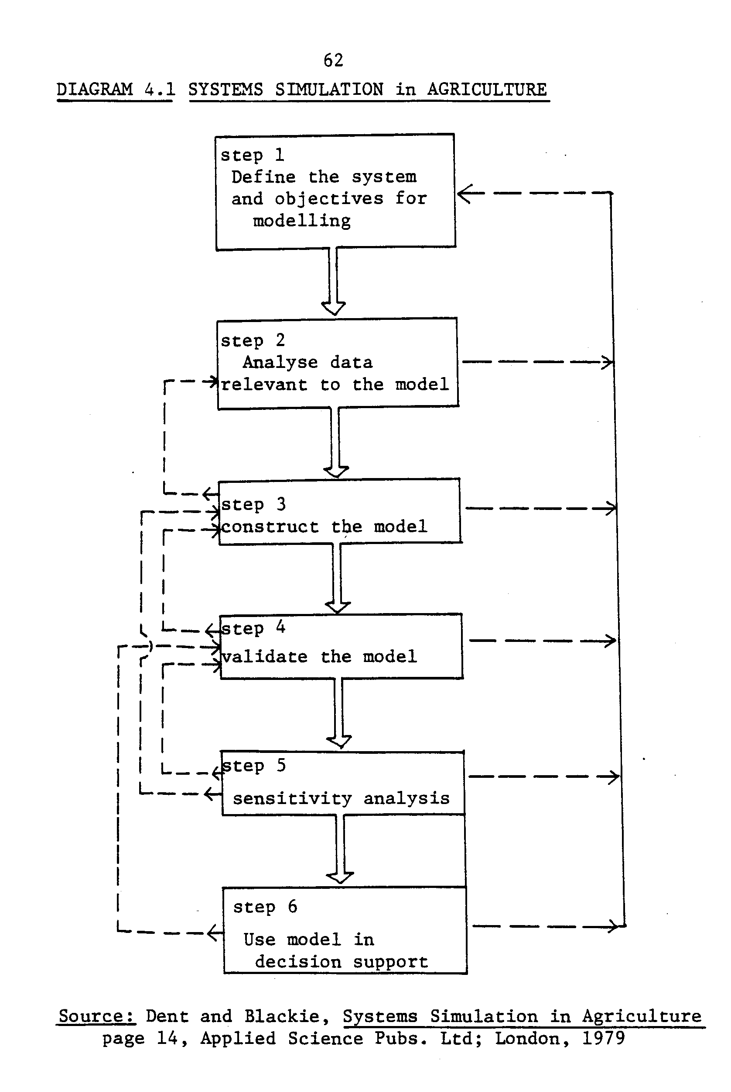
63
This more narrow specification of the research question does not imply a less wholistic analytical approach than the broader question would have. BNF is a factor in three subsets of a Southeast Minnesota farming system: the cropping system inputs set, the cropping system outputs set, and the livestock system inputs set: These subsets are fully integrated and no analysis is valid to the whole if any facet of the interrelations is excluded. According to Teng (1981), the appropriate systems research procedure consists of two phases: analysis and synthesis. The system components must be defined and their interrelations specified through static analysis. Then a model is constructed (.synthesized) to quantitatively describe the complete system by means of mathematical equations in a dynamic, interrelated framework.
Boundaries
An essential concept in systems analysis is that of the boundary, which delimits the system being analyzed. Systems are hierarchical (each system is a subsystem of a larger system). The analyst limits the analysis to a manageable study by stipulating the boundary.
Within the boundary, values of variables are determined endogeneously. Outside of the boundary they are parametric. The upper boundary for this study includes the farm and excludes the market, such that the quantity of farm output sold has no effect on market prices, but market prices determine farm output. The lower bound is set at the crop-soil interface. Therefore, fertilizer demand and crop yields are a function of soil and other environmental parameters, but soil microbial activity is determined exogenously.
64
These concepts are illustrated in Figure 4.2. The hatched area encloses the crop, livestock, and internally produced input transfer subsystems which are directly relevant to the model. The system environment contains the driving variables, such as prices. Driving variables can be defined in this example as those parameters faced by the farmer that influence his decision-making but are not affected by the outcome of those decisions.
Other aspects of the system environment as defined for this problem include the fixed equipment and capital of the farm, the land and it's soil characteristics, weather, and the genetic load of the relevant cultivars.
The entire crop subsystem is constrained by a fixed quantity of farmland, and a specified machinery complement. A relatively short-run period of time is assumed wherein no land or capital equipment purchases are allowed to occur. The number and types of tractors, plows, etc.; and the capacity of the shelter and milking equipment is set at the average level documented in the Southeast Minnesota Farm Record accounts, 1981-82. Maintaining a ceteris paribus fixed factor complement should help avoid misinterpretation of confounding adjustments. If the model were to be designed to compare an investment in BNF and crop rotation to, for example, corn drying technology or on-farm gasohol production as farm adjustments to energy constraints, then setting the boundary to include equipment or other capital structures would be required. Since the model is not postulated to identify optimal farm adjustments to parametric shocks, avoiding such provisions is acceptable.
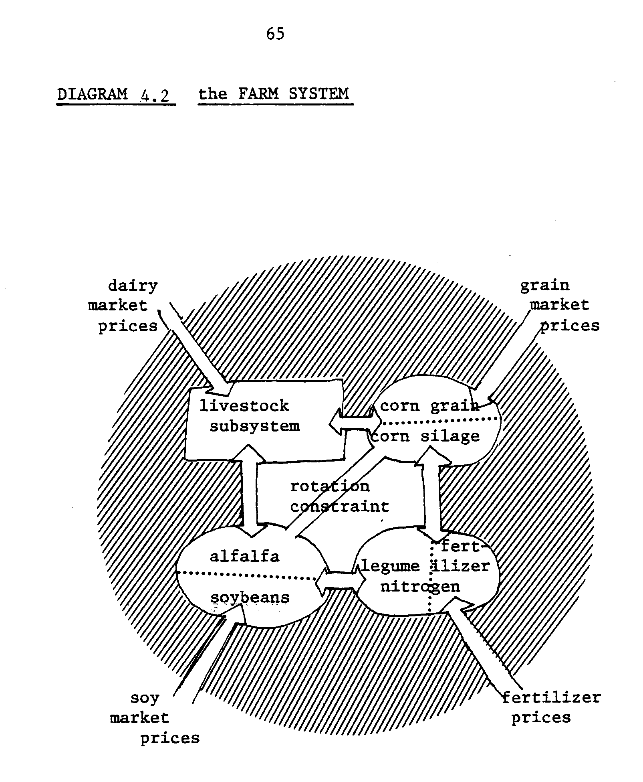
66
The soil must be defined in terms of initial fertility, organic matter, tilth, and type (clay or silt, etc.) because these factors define further fertility requirements and management considerations such as how soon after rains can the soil be worked, and how far and how rapidly nitrates leach out of the profile. These characteristics were researched from a soil test guide for Minnesota by Jokela, et. al. (1981). From this information and the corn response to nitrogen function estimated for the site, (Ch. 3) the optional management techniques are also determined.
The nitrogen-fixing capacity of the alfalfa (or soybean) rhizobia subsystem is one subset of the genetic load environment which is defined and fixed exogeneously. Another is the yield response of corn to the management and environmental variables facing the farm.
Interactions and Driving Forces
Designating the associated management responses to these fixed characteristics in the system environment as invariant features simplifies the model of the farming system. If an activity neither affects nor is affected by the level of exploitation of BNF, then it can be parameterized without restricting the validity of the modeling implications.
Also, the interdependencies among activities must be characterized.
The first step in this modeling process is to identify the driving variables and the interdependencies between activities on the farm which directly affect a farmer's decision to exploit BNF from rotations and/or use nitrogen fertilizer. At the heart of the modeling problem lies the relationship between biologically-fixed nitrogen and commercially applied nitrogen. The driving variables which determine the level of activity of
67
this subsector are (1) the relative price of commercial nitrogen and the derived-demand for nitrogen as an input to the corn production activity, and (2) the supply of legume nitrogen as a joint product of soybean or alfalfa production.
Production of legume nitrogen as a joint product of alfalfa production is driven mainly by the derived demand from the livestock sector for alfalfa as feed. The livestock system is in turn driven by the revenue from milk. Feed can be either produced on farm or purchased, so the market price of feed is also related to the derived-demand for alfalfa. The types and quantities of feed must be endogeneous to the model to mimic the flexibility of the decision-maker, given his farm resources to produce feed and the market alternatives.
The supply of legume nitrogen as a joint product of soybean production is driven by the relative price of soybeans to corn which are the two marketable crops. The farmer maximizes his profits by allocating acreage to the more profitable crop, given his equipment and time constraints.
The various crops substitute for each other on the market and in - the feed ration, so all of the crop and feed prices, and all of the costs associated with each alternative will affect the decision-maker's choices. How much fertilizer to purchase depends on which crop rotation is followed, and on the acres devoted to corn in the rotation. For these reasons, all of those subsystems are inside the system boundary and are interconnected as illustrated in Figure 4.2.
68
LINEAR PROGRAMMING
Of the available simulation modeling techniques, linear programming is best suited to this problem for at least four reasons. First, the L.P. format allows a large number of variables to be considered simultaneously. This permits analysis of the interrelationships among technical alternatives in a whole-farm context. Second, the method relies on response analysis and direct-cost functions, insuring that both the agronomic and economic functions relevant to the question are incorporated. Third, the price environment is modeled parametrically. Fourth, by using a dynamic LP formula it is possible to approximate the timeliness of crop production activities and the time-related value of flow resources such as labor. The next section contains a discussion of several previous applications of mathematical programming to problems involving a tradeoff comparison between legume-derived nitrogen and nitrogen fertilizers.
REVIEW OF RESEARCH
All four of the studies reviewed here included the question of the substitutability of BNF for commercial fertilizer as only one of a set of questions on farm adjustments to energy price increases and/or to controls on nitrate pollution. Unfortunately very little information was provided in the published papers which documented the models about how the substitutability was quantified. The following reiterates each specification of the relationship between N_{f} and N_{L} and a discussion of the results and shortcomings.
69
Farm Level Models
Miranowski (1979) developed a farm-level model to evaluate energy use reducing alternatives for typical grain/livestock farms in the Corn Belt. Three energy substitution alternatives are modeled: (1) methane-generated electricity; (2)-crop residue and/or livestock excreta as livestock feed; and (3) manure and/or legume N as fertilizer N substitutes. Conservation tillage and field-drying of corn are not included as options.
Substitutes for commercial fertilizers are legume-N and manure. Legume-N is supplied by alfalfa and by soybeans (levels unspecified) in rotation with corn. Two levels of fertility are modeled, reflecting two levels of corn yields. This implies that a very narrow range of adjustment of fertility/yield is possible in response to a fertilizer price parameter increase.
In the base scenario, the model farmer grows corn continuously on more than three quarters of the cropland and a CCOM rotation on the rest. This base plan differs drastically from perceived practice in the corn belt as. documented in Sundquist, Neumeyer and Menz (1982) pages VII-7, who report that only nine percent of corn belt corn acreage is actually in corn grown continuously, while 48 percent is typically in a corn-soybean rotation.. Although this varies among regions of the corn belt, nowhere do farmers on the average cultivate more than 50 percent of their acreage in corn in any sequence. Miranowski's base plan does not change even at a doubling of energy (and therefore fertilizer) prices.
Miranowski concludes that such results,
"indicate insensitivity to moderate increases in energy prices ... because direct energy costs account for less than 8% of total agricultural production costs."
70
An alternative explanation of such results is that the model as constructed without a range of fertility/yield alternative and without appropriate disaggregation of time is both a poor simulation model and insensitive to input price parameters. Without an appropriate disaggregation of the time periods, the crop mix chosen may inaccurately reflect the existing time and weather related constraints on flow resources, and thus specialization towards continuous corn production appeared optimal (Baker and McCarl, 1982). Only at a five-fold increase in energy and fertilizer price levels did the crop pattern alter towards CCS and COMM rotations.
This thesis avoids two major weaknesses of the Miranowski study. First, this analysis will provide a description of a variety of corn-nitrogen fertility levels. This means that more than two fertility levels will be used for the nitrogen-fertilizer price-ranging analysis. Second, the model developed for this thesis will be time-disaggregated to a higher degree, to the extent that a reference or base farm plan reflects actual crop diversification of the target area of Southeast Minnesota.
The second farm-level model was developed by Walker and Swanson (1974) to assess the impact on dollar returns less direct costs to the farm, and the adjustments of crop activity on a cash grain farm, of (1) a fertilizer quota, and (2) restrictions on the nitrate pollution potential. The model is structured to generate an on-farm nitrogen balance account. In this way the numerous sources and sinks of nitrogen for farm use are modeled. This is represented in Figure 4.3 which is a reproduction from their paper.
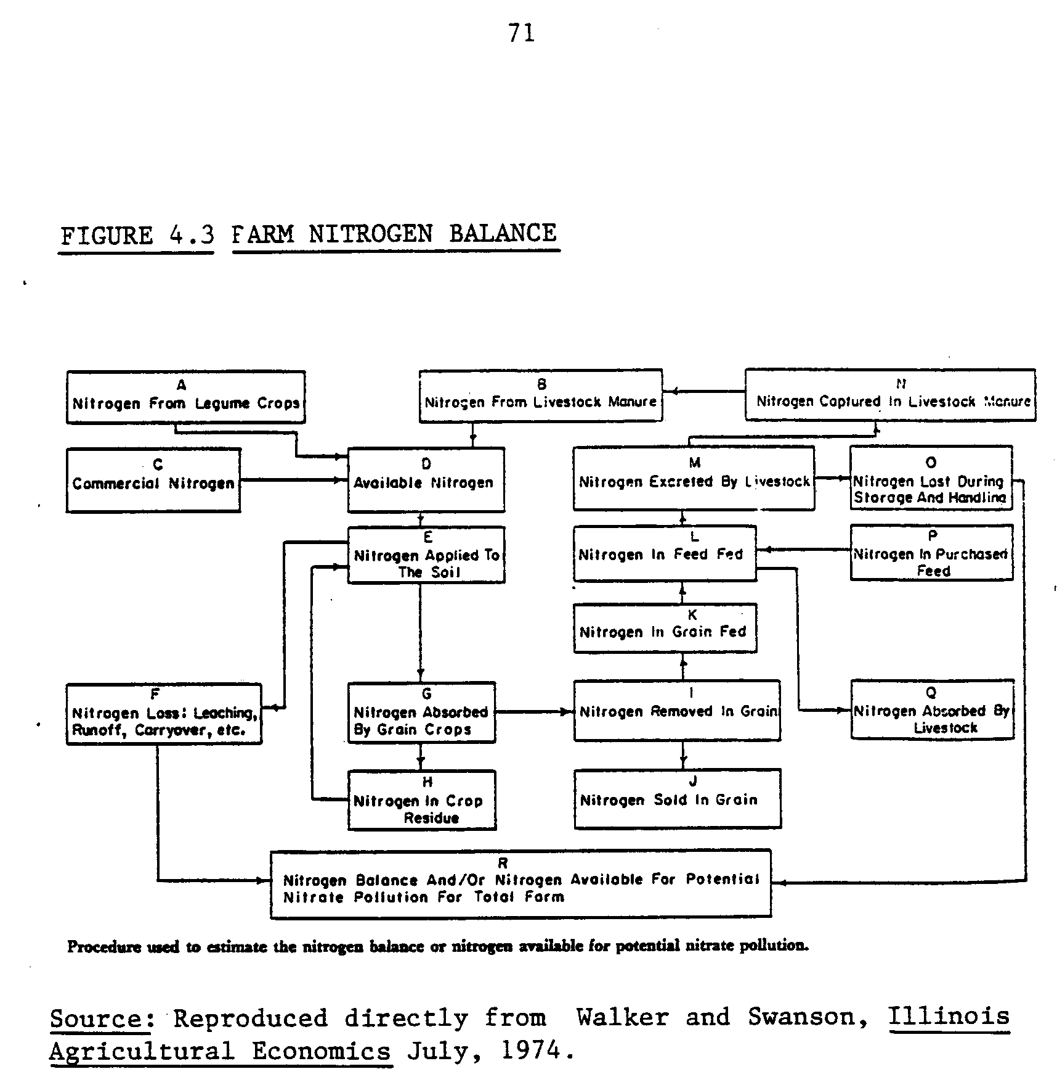
72
Although the model's nitrogen balance is calculated exclusive of a livestock sector, the authors suggested that an analysis which includes livestock is a relevant extension of the work. In contrast, this thesis is based on the premise that the substitutability of legume-derived nitrogen for commercial fertilizer alone is insufficiently profitable to be adopted. Direct use of the legume is a necessary feature for crop rotation to be efficient under relevant circumstances.
In Walker and Swanson's model, five points on the production function for corn (0, 50, 100, 150, 200 pounds of nitrogen per acre) are included. Also, corn can be grown in "a sizeable number of alternative ways... following selected legume crops." Corn yields on land planted to legume crops in the previous year are estimated by inserting the amount of nitrogen produced by the legume crop in question into the production function. How this fits with the five points modeled (above) is not explained. Nitrogen from all sources is assumed to be homogeneous in the sense of having an identical influence on-corn yield a la Shrader, Fuller and Cady (1966).
When restrictions on runoff of fertilizer and/or restrictions on the quantity of commercial fertilizer use are imposed, a rapid drop in farm profits is observed as acreage is shifted toward corn rotations with an alfalfa crop for which there is no other use than as green manure.
As with Miranowski's model, the base plan is continuous corn, and this plan is quite stable. Out of the possible 50 constrained scenarios of fertilizer quota cum nitrate balance, half of the farm plans are continuous corn; 6 are corn-soybean rotations, and the remainder are mainly
73
soybeans. There is no mention of time-disaggregation. Thus, the criticism of the specialization tendency of time undisaggregated models is certainly germane in this case as well.
The shortcomings of the Walker and Swanson approach fall mainly into two categories. One, the model may be improved by disaggregation of the time-related constraints such that the base plan appears more typical. This would surely have consequences under all scenarios implying different results. Two, the production function for corn and the substitutability of organic and commercial nitrogen needs clarification and possible reformulation. Both of these issues are dealt with in this thesis.
A general shortcoming of farm-level models is the assumption of parametric prices vis-a-vis aggregation. If the farm level model results are being used to assess aggregate farm responses to changing conditions and to formulate policy, the fact that crop prices have not been modeled endogeneously allows an upward bias on prices, for example, favoring soybean production. In actuality, if all farms responded similarly and flooded the market with soybeans, the soybean price would fall too low to justify the level of production indicated.
General Equilibrium Econometric Simulation
Olson, Heady, Chen and Meister (1977) produced a national model, using quadratic programming, that incorporated the market supply price response. Prices as well as quantites of agricultural outputs and inputs are determined endogeneously. They proposed to assess the optimal
74
response to constraints on nitrogen fertilizer. But they did not formulate any substitution alternatives for commercial nitrogen fertilizer. That report epitomizes the approach many analyses take which ignore the potential of legume-grain rotations. It also suggests the seriousness of endogenized crop prices when assessing a farm choice of alternatives when one input price fluctuates. The implication for this thesis is that if large crop output fluctuations results from the analysis, then quadratic programming should be employed to reflect market feedback.
National Farm Sector Model
The final model considered is by Nicol and Heady (1976), a national farm sector model with endogenized market prices. It has been elaborated upon and employed to analyze many various farm sector problems. The problems concerning fertilizer use include a specification of substitutability between legume nitrogen and commercial fertilizer nitrogen. Unfortunately, the documentation of this substitution relationship contains contradictory explanations. There are two formulations: (1) the contribution of legume N increases the yield of grain above the trend level fertilization rate yield. (page 106 of Nicol and Heady). This means that for example, under normal circumstances farmers would not be able to benefit from rotations because they would be applying excessive fertilizer and getting only a rotation-effect additional yield increment. The second formulation is presented three pages later. (2) Legume nitrogen substitutes directly for commercial fertilizer, reducing the quantity of applied fertilizer required to obtain the reference yield.
75
This approach seems to capture the economic potential of rotations, but this formulation of substitutability has some flaws; to be explained as follows.
The supply of legume nitrogen carried-over is assumed to be a function of the legume crop yield, with respect to time. Nicol and Heady developed the following equations in consultation with W. Shrader to express carried-over nitrogen as a function of yield:
N1=50.0 *Y-5.0Y²+ .2 Y³
N2 = 8.5 * Y - (81.5) .8Y
where N1 and N2 denote legume nitrogen available in the first and second years after a legume crop and Y denotes the legume harvested in units of tons of dry matter.
As an illustration, applying these algorithms to yield data of a good stand of alfalfa at 85 percent D.M. gives an N1 estimate of 137 lbs./acre and an estimate of N2 at about 50 lbs./acre. This implies a total net contribution of 190 lbs. N/acre from alfalfa, which is entirely within the previously estimated ranges discussed earlier in this thesis. It is not, however, clear how these algorithms can be applied to soybeans. It seems that the nitrogen contribution of soybeans will be overstated.
Apart from the lack of clarity concerning which method is actually employed and how the nitrogen contribution from soybeans is calculated, there is another, more fundamental question. This question is whether or not it is correct to express the available legume nitrogen as a function of yield when the legume is not harvested or removed from the field. Results of agronomic experiments by Professors Heichel and Vance (19781981) suggest that this is not the case. For example, the no-harvest,
76
green manuring zero "yield" approach to an alfalfa rotation provides a similar nitrogen benefit as that of a normal harvest and an early fall plowdown approach.

Implications
These four papers represent the existing analyses wherein BNF is assessed as farm input. None of the attempts have clearly explained how the substitution relationship is modeled, and each of the models have additional shortcomings such as lack of time disaggregation, unvalidated base plans or lack of general equilibrium (market price) effects also leading to overspecialization.
Each paper that incorporates the BNF benefit to the farming system does so by tying the nitrogen remaining in the soil after a legume to a crop rotation sequence in order for that nitrogen to have economic value. If the legume nitrogen was not recovered by another fertilizable crop then it would not have a value since the nitrogen credit would be redundant. The model developed for this thesis will also tie the recovery of legume nitrogen to a crop rotation sequence.
The other problem with the farm level models is that only a few discrete corn fertility alternatives are available. To assess the nature of the substitutability between fertilizer nitrogen and legume nitrogen it is possible to range the fertilizer price and observe the adjustments in quantities of each input demanded. But without a more complete specification of the production function (corn response to nitrogen) the models above remained insensitive to gradual price changes.
77
THEORETICAL FRAMEWORK
In this section the theoretical underpinnings of the analytical approach to linearly programming the BNF/fertilizer nitrogen substitutability problem are presented. First, the concepts of profit maximization for math programming, substitution between inputs and substitution between production techniques are explained. Then, a list of the economic, agronomic and technical criteria relevant to the problem is compiled. The section also includes discussions of the limitations of the L.P. technique and the steps taken for this thesis to overcome them.

Profit Maximization for Math Programming
It has been demonstrated by numerous studies that American farmers generally behave as profit-maximizing economic agents. Cases in which they do not are usually explained by the effects of imperfect knowledge, uncertainty, asset fixity, and the length of biologically based production processes.
As entrepreneurs, farmers must make the usual short run managerial decisions of how much to produce, and to a certain extent, what to produce, although because of the biological nature of agricultural production, what to produce usually is an intermediate or long run decision.
For this study the corn-response to nitrogen function developed for Chapter 3 will serve as a single variable input production function as illustrated in Figure 3.9. In the short run the profit-maximizing farmer chooses the production process defined by the combinations and levels of inputs, the sum of which can be illustrated by the corn production function. He surveys his fixed equipment and considers the costs of variable
78
inputs needed to produce crops on his endowment of land. Then he chooses inputs not simply to maximize output, as described below.
The usual decision rule is to maximize returns above variable costs. Because farmers typically do not think about paying themselves or family workers for their labor, management, and equity capital, the concept of "gross marginal" is both useful and logical term to use to describe how farmers interpret profit maximization. The gross margin is defined as the gross revenue minus variable cost. It is the dollar return over costs resulting from the sales of production due to short-run decisions. This includes both profits and a return to fixed resources, and will be the measure to be maximized as a proxy for profit in this analysis.
The unconstrained neoclassical determination of the level of input use which maximizes profit is not suitable for the problem in which resource constraints exist. The constrained optimization algorithm of linear programming is well-suited to this type of problem. The algorithm applied to a linear programming problem consists of simultaneous comparison of a fixed number of production functions subject to the resource constraints. The analytical question of "how much" is necessarily reformulated into, "What use, if any, is to be made of a resource given the choice of production processes and the input supply constraints?

Derived Demand for Inputs
The level of use of or the demand for a factor of production is "derived" from the demand for the final product. Derived demand for a factor can be easily quantified if all other factors used by the firm are
79
held fixed. In perfectly competitive markets and assuming no operational constraints, the factor should be employed where VMP = MC. The derived demand curve for factor N would simply be the marginal physical productivity curve converted into monetary units by multiplication with the (corn) product price, i.e., the VMP curve of Figure 4.4.
A reduction in the cost of an input would allow an increase in the quantity demanded, which would in turn increase the productivity of all other factors. For example, increased application of fertilizer results in a higher yield of corn, implying a greater return per labor hour at harvest time. Since the employment of these other inputs can be profitably increased as a result, the productivity of the orginal input again increases, i.e., the MP curve shifts right.
Due to these associated shifts in average and marginal productivity at different levels of employment of a factor, the actual derived-demand curve for that factor consists of points from different MP curves. At different prices for the input, the quantity demanded of other inputs will be different. This derived demand curve will also be more elastic than the VMP-based derived-demand curve because of the increased demand for complementary factors at low prices of the input.
In the linear programming formulation of this problem in which a derived-demand curve for legume nitrogen is sought, these theoretical results are approached in a somewhat different manner. To discuss this it is necessary to digress for an explanation of how production activities are mathematically expressed for linear programs. A corn production activity will be posited as an example.
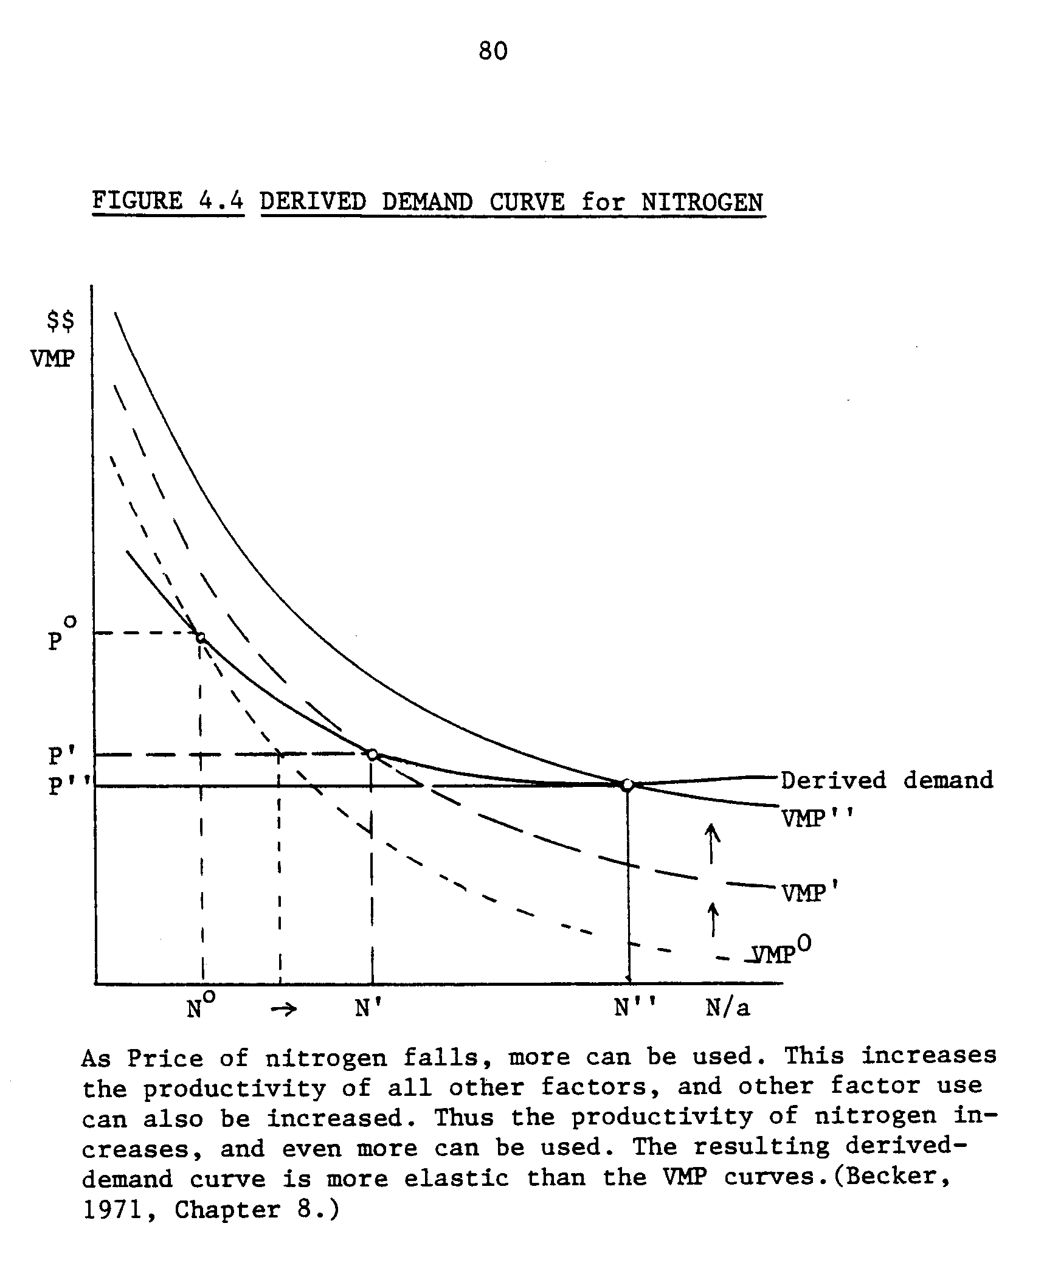
81
Linearity and Additivity
The linear programming model rests on the assumption that the relationships between variables can be expressed linearly, i.e., as a fixed proportions production function. A change in the level of use of an input results in a proportional change in output. This implies constant returns to scale. The Misterlich form of the corn-response-to-nitrogen function is non-linear. Output increases at a decreasing-rate when increments of nitrogen are added (decreasing marginal productivity). But it can be modeled linearly in the following way.
For farm problems the widespread approach to modeling crop production is to express the relationship between inputs required to produce a stipulated yield per acre. Therefore, one point of the Misterlich function, i.e., one pair of (yield, N level) variables, is chosen as the distinguishing feature of the corn production activity, and the other variable input requirements are expressed per acre. All of the inputs are therefore required in constant proportions to each other in order to produce a specific yield per acre. This formulation is known as a Leontief or fixed-coefficient production function. Implied by this is a zero elasticity of substitution between inputs. For example, having imposed the condition that a certain level of nitrogen will result in a specific corn yield, there is no possibility in the fixed-coefficient production function for a substitution of more labor time for less fertilizer while the same yield is obtained.
Obviously, one point from the Misterlich equation does not describe the full relationship of corn to nitrogen. But it could be approximated by the formulation of, for example, three corn production activities as
82
suggested in Heady and Chandler, (1958). one activity would stipulate a low level of fertility and the accompanying low corn yield per acre. Another might be a medium level and the last might be a maximal fertilizer rate. These production functions would be almost identical in terms of the coefficient on land preparation activities, seeding rates, cultivator requirements and harvester use, etc. A solution consisting of half of the acres in a mid-fertility corn activity and the rest in high fertility can be interpreted as all of the farm under corn at a level of fertility that is the convex combination of the two, Figure 4.5.

Substitution
A very important implication of this fixed coefficient formulation for the BNF problem is that inputs are strongly complementary. Instead of increasing the level of employment of a single input as its price is decreased, the entire activity in which the input accounts for a larger proportion of the marginal cost should be increased. This contrasts with the traditional analytical results in the following way. Neoclassical analysis provides a quantitative estimate for the substitution between inputs in a production activity. In linear programming it is activities which are substituted. A comparison is illustrated in Figure 4.6. If the costs of production for an activity are reduced because of an input price decrease, then the cost-minimizing choice of activities is reflected as an increase in the level of the less costly activity, and a decreased level of the relatively more costly activity.
Although the two approaches fundamentally obtain the same analytical results of a shift among total employment of inputs as relative costs
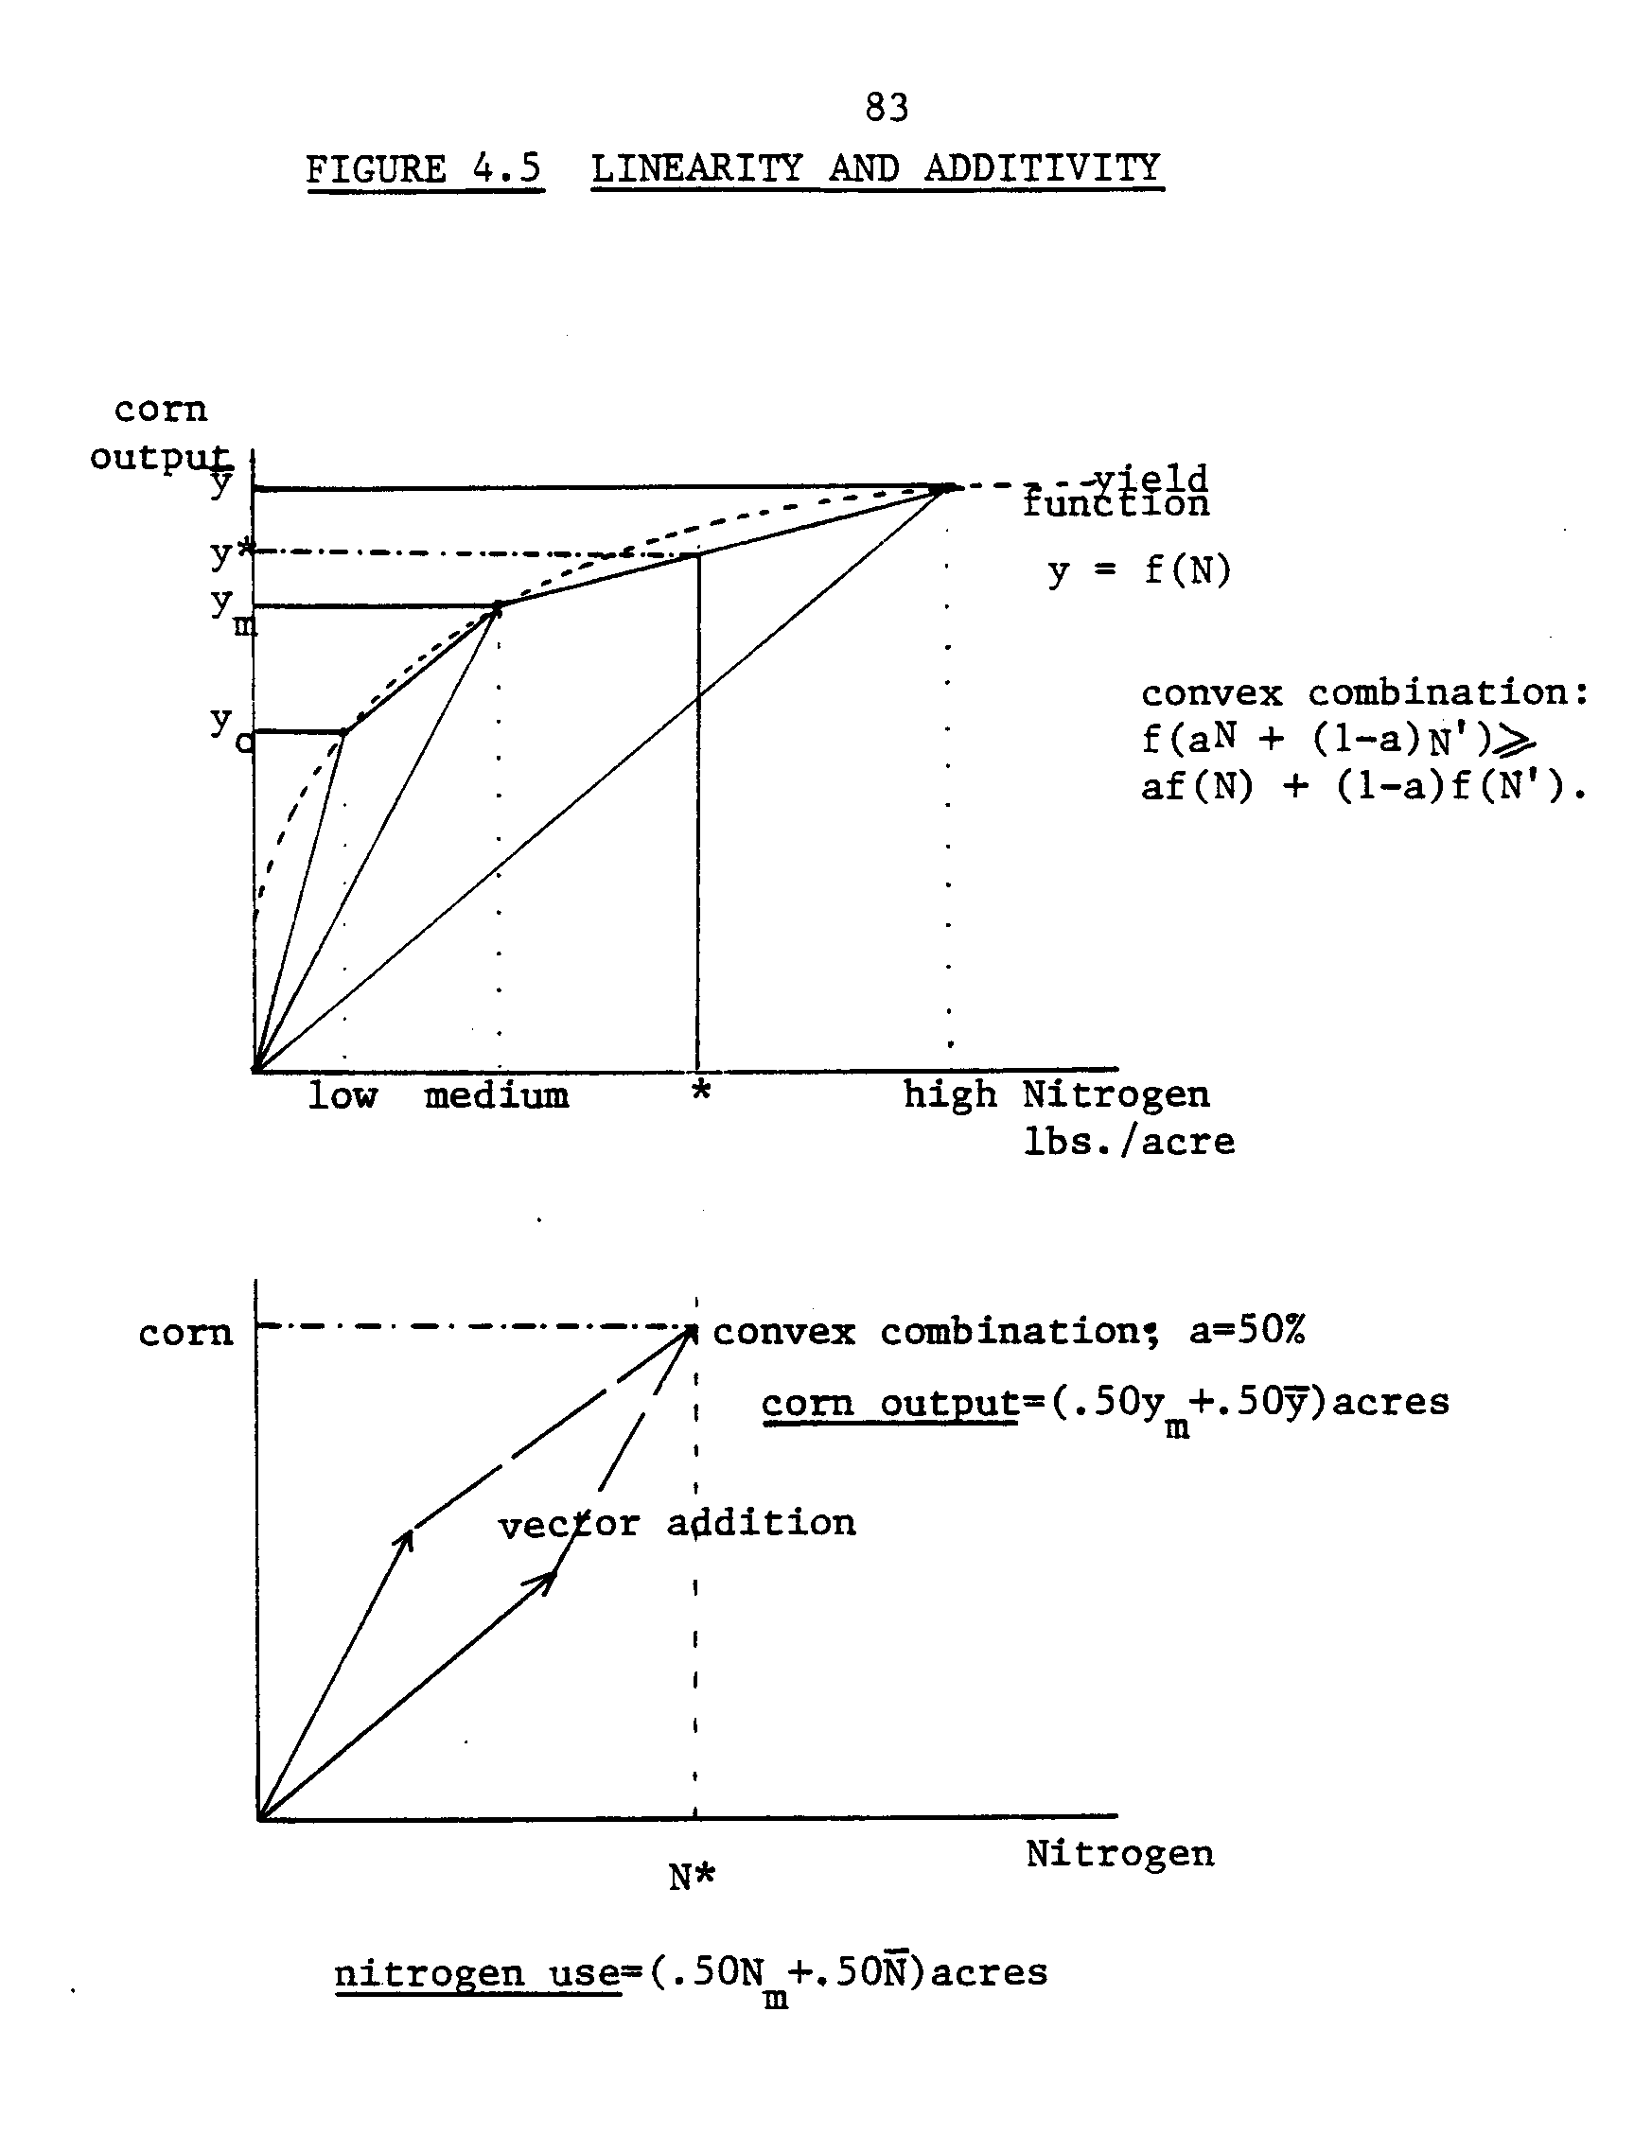
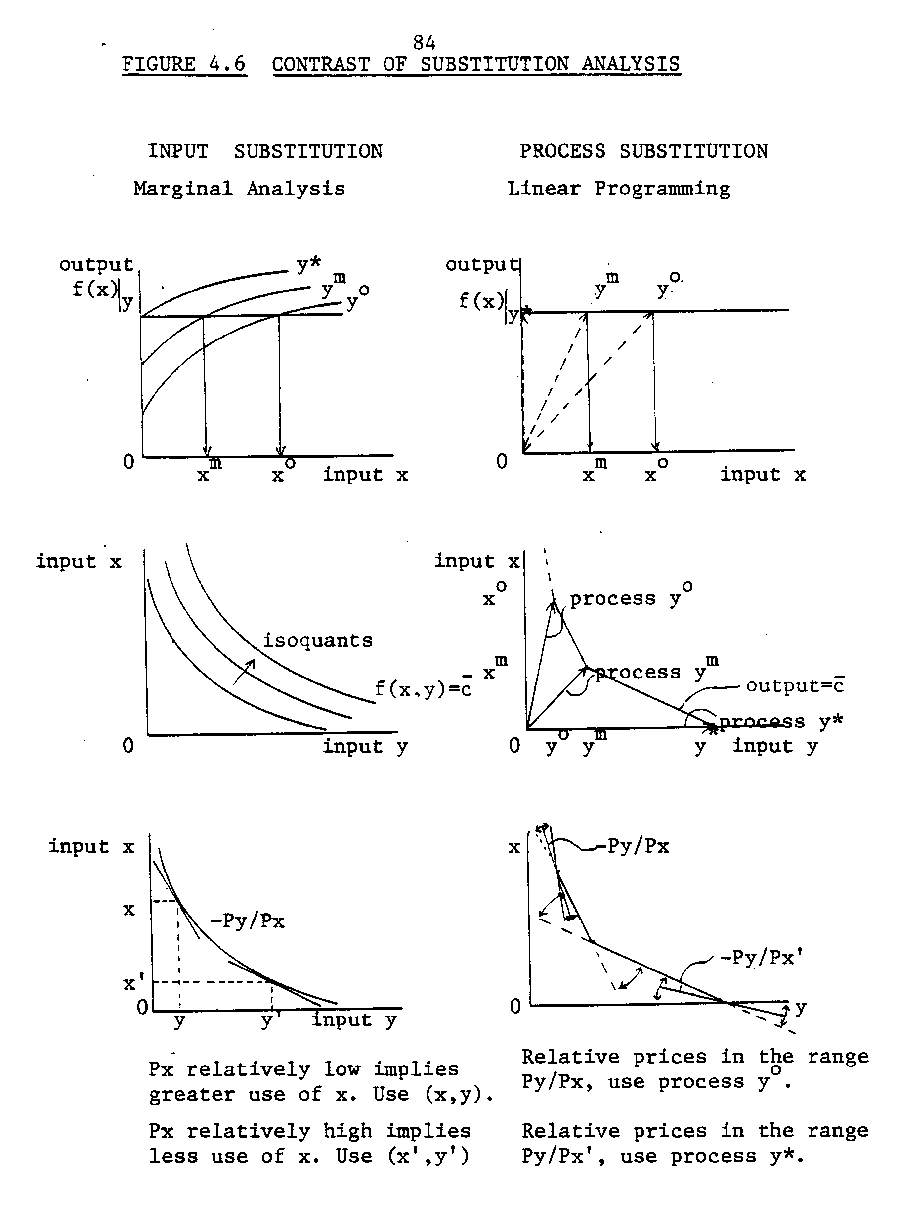
85
change, the linear programming formulation is only an approximation of continuous production function analysis. For these reasons the term "derived-demand function" will not be applied to the results the price ranging analysis for this thesis in order to avoid confusion due to misuse of terminology specific to only one of the two distinct analytical techniques.
The input-cost induced shifts among production activities are the consequences of composite expansion and substitution effects. The decrease in marginal cost associated with one activity results in an expansion in the use of all inputs required for that activity. Meanwhile, resources are transferred from the more costly activities to the less costly activity when the activities are substituted for each other. Therefore, the relationship between the cost of an input and the level of employment of the input analyzed with linear programming should be negative regardless of which effect is more powerful.
The relationship between inputs that perform similar roles in the production process as the price of one changes is more difficult to stipulate a priori. Fertilizer nitrogen and nitrogen carried-over from a legume crop both provide the same input into corn production. First of all, if the corn production activity is differentiated among types of rotations, and corn in a legume rotation receives no added N, then as fertilizer becomes more costly, a transition to rotations would be observed. As long as it would be profitable to engage in any corn production, the two techniques would substitute for 'each other. More legume nitrogen would be employed. On the other hand, if the corn activities are distinguished by rotations and the level of added nitrogen, then
86
both rotation-derived nitrogen and the fertilizer nitrogen would be required as complementary inputs in fixed proportions. Therefore, as the cost of fertilizer increased and the total farm employment of it decreased due to a concommittant decrease in the level of those corn production activities, less legume nitrogen would be exploited as well.
Thus, whether or not legume N-based technologies appear to substitute or complement the use of nitrogen fertilizer depends on (1) the formulation of the model alternatives and (2) the relative weight of the expansion and substitution effects. Due to the strict complementary relationship among inputs implied by fixed coefficient linear production functions, the bias against the expansion effect is stronger if potential substitutability among production activities that do not require any nitrogen are well specified.
Synopsis
At this point it may be helpful to recap this chapter by compiling the list of economic, agronomic and technical criteria important for the model. While describing the farm system seven points were raised.
(1) The question about the economic value of biological nitrogen fixation is best stated as a question concerning the substitutability between the two inputs of commercial or legume-derived nitrogen. Therefore, the model must focus on the activities that require or drive the demand for either input.
(2) The model must be formulated appropriately flexible in terms of commercial nitrogen purchase activities and legume nitrogen substitution
87
such that simulation of farm response to commercial nitrogen price increase has validity.
(3) The problem requires a system approach due to the interdependencies among farm activities involving either type of nitrogen. Foremost of these system interdependencies is the one between the crop and livestock sectors.
(4) Due to the demand for legumes as protein-rich feed, and in order to reflect in the feed ration the adjustments in crop acreage, this fourth criterion of a flexible least-cost feed ration must be met. This is directly related to the next criteria:
(5) The supply of legume nitrogen is driven by the derived demand for alfalfa as feed for livestock, or for soybeans. Therefore, given the far level assumption:
(6) Prices for inputs and produce should be parametric.
(7) The farm problem should be formulated with time disaggregated so that it adequately reflects the timeliness of crop production activity and how this affects the demand for flow resources.
From the discussion of the theoretical basis for the formulation of the LP model an additional three points were added.
(8) Profit maximization, in the form of maximizing gross margins is an appropriate objective function for the Southeast Minnesota farm model. Nevertheless:
(9) The simple profit maximizing rule-of-thumb for input employment, i.e., where VMPi = MCi should not be assumed for this problem where the existence of constraints on the availability of farm resources exist. For example, there are limits on the quantity of land, number of machines,
88
facilities and laborers, and cash. Most of these constraints are easily modeled using the L.P. format where the rows of the matrix sum the input requirements across the activity columns and charge the total against the stipulated available quantity. Expenditures on purchased inputs that are not restricted in supply are assumed to be controlled according to a cash-rationing principle. Specifically for this model an algorithm is developed in Chapter 3 that stipulates the rate of N fertilizer applied as a function of nitrogen fertilizer price, given a benchmark expense/return ratio. This algorithm must be incorporated in the model for the N price analytical phase.
(10) The tenth challenge is to specify the corn production activities and crop alternatives with an appropriate range of technical alternatives such that the substitution effects and the complementary expansion effects can be observed. The "appropriate range" must reflect the range of practices observed in Southeast Minnesota. This implies that, within the relevant range of nitrogen prices rotation corn is also fertilized with added nitrogen. But at free and prohibitively expensive prices of nitrogen, corn can be profitably grown entirely with commercial and entirely with legume nitrogen, respectively. Also, at all prices of nitrogen the option to grow corn continuously and rely entirely on commercial fertilizer nitrogen must exist, as well as options to rotate corn at different levels of fertility.

THE MODEL
The following pages describe the model in it's final form. Five subtopics are presented. First, the main distinguishing features of
89
the model are discussed. Those features are (1) time disaggregation, (2) crop rotation constraints, (3) variable input specifications, and (4) the least cost-minimum nutrient feed ration specifications. This subtopic is accompanied by a schematic tableau illustrating the full model. Second, the method of accounting for the costs of revenues is discussed.
The third and largest subtopic contains the details of the constraint and special restrictions set. Frequent reference is made to tables in the appendix containing actual model data.
Fourth, details of the activities set are provided and illustrated by exemplary schematic crop activity tableaus.
The fifth and final subtopic presents the actual benchmark model. This comprises the verification step. The model's base plan is compared to farm record data averages.

The Data Base and Software
The linear programming model is constructed from production data collected from three main sources. The main data source is the Southeastern Minnesota Farm Management Association Annual Reports (1980-81). The annual reports contain data on the farm resource base and levels of activities typical for the region. The farmer (with vacation time help from a son, or equivalent) manages a 60-cow dairy herd (140 head in total, including replacements) and cultivates 400 acres of well drained silt-loam cropland. Facing the current (1980-82) market prices for corn, soybeans, oats and alfalfa hay, the acreage can be devoted to any combination of these crops in rotations or in continuous cropping.
90
The alfalfa hay and corn silage markets are severely limited to reflect actual conditions in Southeastern Minnesota. The farm produce market activities do include sale of 15,000 lbs. milk per producing cow, sales of corn and soybeans, purchases of feed supplements and crop inputs.
The records data does not disaggregate fertilizer use so that a typical practice must be extrapolated from complementary sources. The next most useful sources of data were the machinery and crop budgets prepared in the Department of Agricultural and Applied Economics by Professor Fred Benson and staff. These budgets are drawn up by region and incorporate perceived practice of farmers, agricultural engineering standards, and other information.
The records data reports that successful farm managers are harvesting an average 140 bu/acre of corn. This information is reiterated in the crop budgets where a nitrogen application of 130 pounds of 100% N is recommended. Given the corn response to nitrogen function estimated in Chapter 3 which is based on good weather years (excluding 1980 and 1981), the three sources are considered to be reasonably concurrent regarding the nitrogen-corn relationship.
Additional information concerning timing of cropping activities and special management techniques to capitalize on rotation benefits were gathered from a wide variety of agronomy publications. All of the data are presented in crop budgets, appendices VII.1 through VII.6.
The data were formatted to correspond with a matrix generator to employ the generalized computer model ROMP-FS1 (Apland 1983). The L.P. data are transmitted to an APEX-1 (Control Data Corporation) linear programming solver, from which a Fortran-readable solution file is
91
created. Apland also prepared a report writer which organizes row and column solution values into an easily readable report on the crop, livestock, labor and variable input activities in the final bases.
The matrix generator and report writer programs were edited for use in this thesis to accommodate the dimensions and the crop rotation restrictions encountered. These programs were named BNFMG and BNFRW, respectively. But these programs are otherwise identical⁻to those available for ROMP-FS1.

The Main Features
One distinguishing feature of the model is that it is formulated with discrete production time periods within an annual production cycle. All production activities are generated with tillage, planting, cultivating, harvest or other operations occurring in 21 specified periods. By disaggregating time, two conceptual problems are solved. One, this captures the timeliness of crop production activities. Two is that flow variables such as labor and machinery time are disaggregated into units available each period.
Crop production activity is regulated by time-related factors such as weather. Weather influences production in two ways. First, the spring rainfall determines the number of days available for field work. Land prep machinery cannot work in too wet soil. Thus, particularly in spring, the model's specification of available field days in each period, Appendices VIII.1, 2, and 3; reflect the weather trends. These estimates were-interpolated from two main sources: Boisvert and Jensen
92
(1973) and dissertation research (unpublished) of Judy Ohannesian, Department of Agricultural and Applied Economics, University of Minnesota.
The second weather-related influence on the crop activities is the set of maturation and crop drying time factors. Each crop can be planted and harvested in several production periods. The typical corn variety in Southeast Minnesota matures in three months. The longer it is left in the field, the lower the moisture content, but also, a yield reduction incurs. Yield and moisture coefficient data for corn and soybeans according to planting/harvest dates are presented in Appendices VIII.4 and .5. If the harvested crop moisture is above the storage or sale level of 15 percent, a crop drying activity is generated.
The second major feature of this model is the way crop rotations are imposed. At this point it is most helpful to observe the schematic tableau, Figure 4.7.
There are several equations which stipulate that a rotation crop cannot be grown in excess of the acreage of the crop it follows. For example, the corn rotation with alfalfa credits corn with a nitrogen benefit and a reduction in pesticide expenses. The rotation is actually a three year rotation which involves at least two rotation constraints. First there is an alfalfa establishment constraint. Alfalfa can be established by seeding it under an oat cover-crop. In this case, two constraints are imposed which maintain equal acreage in oats and established alfalfa, since they are two distinct outputs. The other method of establishing alfalfa is by herbicide clearing and direct-seeding the alfalfa. In either case, the next year of alfalfa must be
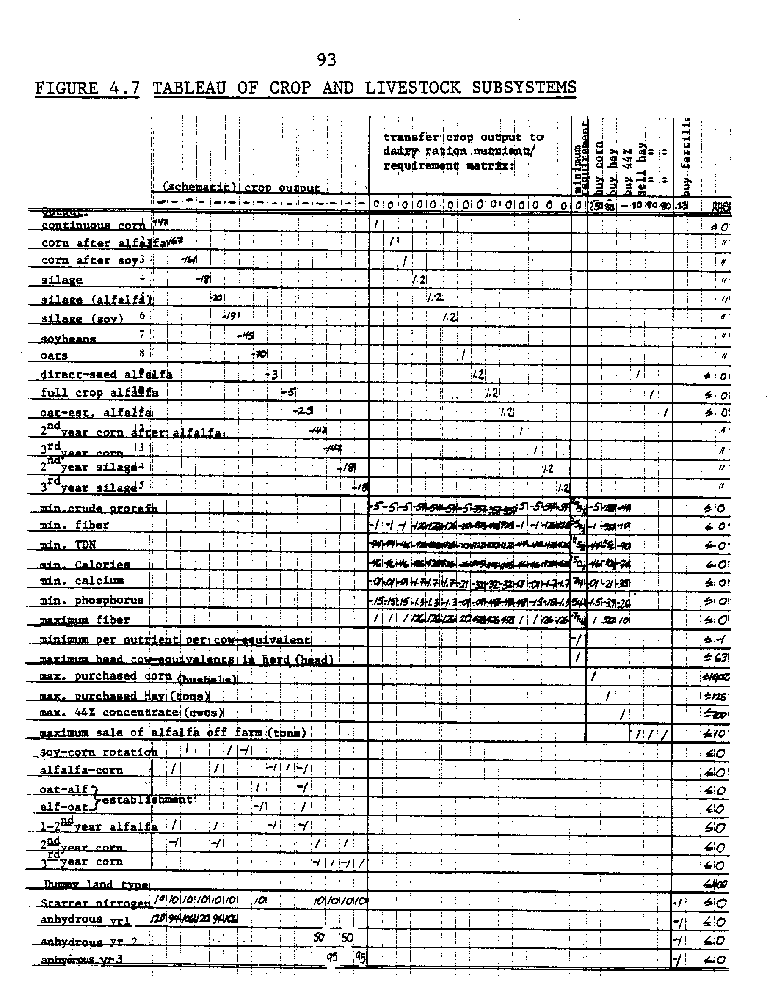
94
constrained at a level less than or equal to the total established acreage. Subsequently, the sum of corn crops following alfalfa--either first year corn for grain as for silage, cannot exceed the available full crop alfalfa acreage. These constraints are specified completely in Appendix IX.
The rotation constraints guarantee that the benefits credited to crops following legumes are always accompanied by the requirement that a previous investment has been made by cultivating that legume. In this way the nitrogen available for a subsequent crop after alfalfa or soybeans is effectively tied to the soil. Meanwhile, the options to grow corn continuously and to grow alfalfa without rotating are still available.
Other formulations for the recovery of legume nitrogen were considered, such as employing transfer rows into which both commercial fertilizer nitrogen and legume nitrogen would be pooled. This approach was rejected because (1) it does not effectively tie the legume nitrogen to the soil, and (2) another benefit from rotation--the yield increment simply due to the change in crop (explained in Chapter 2)--is-also left unaccounted for. Under the current approach, rotation corn is credited with a yield increase and a cost decrease relative to non-rotated corn. This difference could not be captured if transfer rows for nitrogen were employed, even if rotation constraints were included and corn crops were distinguishable. Transfer rows might also result in legume nitrogen being credited to continuous corn while no rotation corn is being cultivated under that specification.
95
This discussion has introduced the topic of the third distinguishing feature of the model, the specification of variable inputs. Inputs whose use incurs costs that change with changes in activity level are considered variable inputs.
For farm problems labor, machinery hours, seed, fertilizers, pesticides, full, etc.; are variable inputs. The labor and equipment inputs are modeled in terms of hours of availability which reflect day length, season, and weather. The seed, pesticide and fuel type inputs are stipulated at recommended and/or typical practice levels of use in each fixed coefficient crop production function. The costs are summed and entered in two categories: (1) variable costs for the entire land preparation sequence of tillage operations; and (2) variable costs for all of the plant/post-planting operations. There is also a variable cost charge if crop drying must be undertaken. These costs are summed across final basis activities at their respective levels and charged against the objective function.
Notably, the nitrogen fertilizer variable input has been isolated and modeled as a distinct variable input with its own variable cost transfer to the objective function. As discussed in the system modeling section of this chapter, other factors could be set at specified levels to maintain the simplicity and directness of the model if their level of use was not linked with the choice of nitrogen source.
To facilitate accounting, a nitrogen input has been distinguished into four categories. "Starter Nitrogen" refers to the solid nitrogen applied during the last land prep operations. Since in ROMP-FS1 (BNFMG) variable inputs are associated with land prep systems, crops, and special
96
activities, this 10 pounds of starter nitrogen is applied to all corn crops employing the same land prep system, including the rotation corn. Then anhydrous ammonia, expressed in pounds of 100 percent nitrogen, is associated with each crop that is fertilized, at levels appropriate for each rotation. The third category is the anyhdrous required for corn crops in the second corn year of a legume rotation. Likewise, the last category is anhydrous required for the third corn year in an alfalfa-corn rotation.
All of the added nitrogen levels are determined according to the response analysis Figure 4.8. The second and third year corn activities N level are an extrapolation based on hypothetical estimates of legume nitrogen availability over time. It is assumed that 60 percent of the total nitrogen locked in legume residue is-available in the following year. Note that along the horizontal yield level of 154 bushels, the "nitrogen effect" can be seen at 90 lbs. N between corn rotated with alfalfa and continuous corn. If 90 lbs. N is 60 percent of the total N, then the total residual N is 150 lbs., of which 30 percent is available the second year (45 lbs.) and the remaining 10 percent in the third year (15 lbs.).
In addition to the nitrogen effect, the rotation effect is seen as the vertical yield difference between the response curves after the maximum yield plateau has been achieved with maximum N fertilization. This yield difference is 19 bushels between alfalfa rotated with corn and continuous corn. The assumption is that this effect is non-existent for second year and third year corn. Otherwise, the second and third years of rotation corn require the same variable inputs as continuous corn, specifically, pesticide inputs; and the yields are targeted as the same as continuous corn.
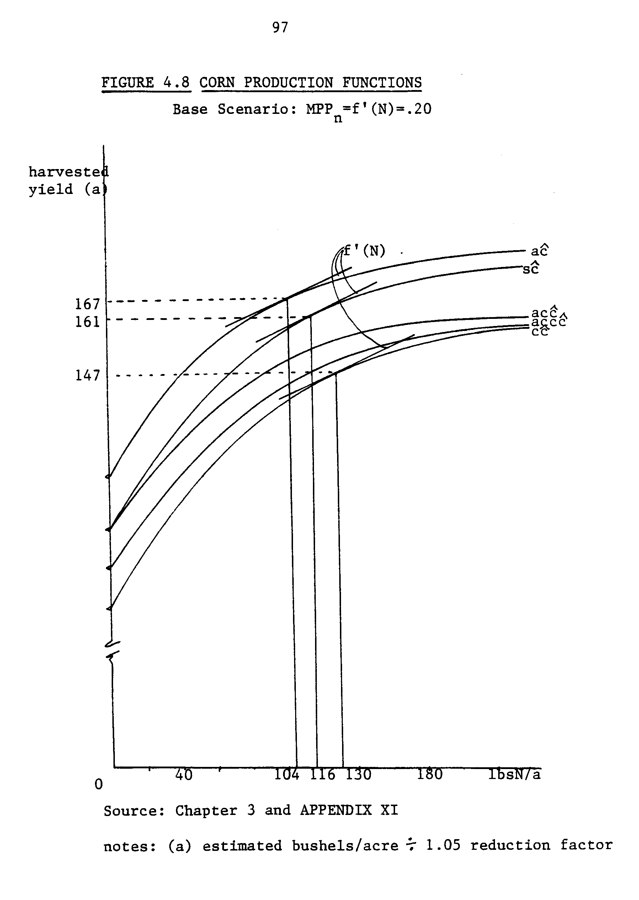
98
The main reason that the nitrogen input is disaggregated separately from the other variable crop inputs; in addition to its role in differentiating among rotation crops, is to facilitate the nitrogen price ranging analysis. With this separate accounting row, only the unit charge against the objective function (the price parameter) must be adjusted by hand, instead of recalculating the per crop variable costs each time. Therefore, to calculate nitrogen use as a function of price it was sufficient to employ the nitrogen rate algorithm based on cash rationing at each price level, and indicate the associated yield from the response function. These data points are listed in a schedule in Appendix XI.
The fourth distinguishing feature of the model is the way in which the livestock feed requirements are modeled. As stated earlier, the dairy activity constitutes a derived demand for both corn and alfalfa hay as feeds. Despite the existence of a variety of milk production functions based on fixed coefficient feed rations, a least-cost type nutrient content matrix is employed instead, described as follows.
Corn, silage, oats and hay harvested from the farm can be transferred to the dairy activities. The dairy activity is modeled in terms of seven nutrient, mineral, vitamin, and fiber constraint rows and a feed activity column for each type of the above four crops. This is illustrated as the central block in the exemplary tableau 4.7 page 93. The coefficients in the matrix represent the units of the nutrient per unit of 100 percent dry matter for each feed. One column activity represents meeting the minimum (or maximum) requirement "per cow equivalent".
99
A cow equivalent is a unit of feed per year to support one milking cow for 316 producing days (15,000 #/year) and 49 maintenance days, plus portions of the rations for replacement in the herd; springers (full ration), yearlings (half-ration) and heifer calves (quarter ration). Earlier it was explained that the herd size is bounded from above by the capacity of the milking facility. The facility is assumed to have a capacity to handle 60 head. A typical herd consists of 60 cow-equivalents or less. That is, 60 producing cows, plus 20 springers, 30 yearlings and 30 heifer calves. This calculated to approximately 105 yearly complete rations which is normalized to a per producing cow equivalent ration by division by 60. Therefore, the solution herd can be from 1 to 60 cow-equivalents in size, and a proportional replacement herd ration will also be accounted for along with the producing cow ration.
The feed ration is modeled in this way to be completely flexible in terms of size of herd and composition of the ration within the constraints imposed by facility size and nutritional necessity. Most importantly, the ration can reflect the variations in acreage between corn for grain or silage, oats, and hay by adjusting the corn/hay mix in the ration within the nutritional and fiber limits. Corn, hay, and 44 percent protein concentrate can also be purchased in limited amounts to reflect maximum feed market activity documented in the farm record data books. All of the model data for the livestock sector is presented in Appendices X.1, 2, and 3.
100
The Constraints and Special Restrictions
In the following section the constraint and special restrictions set will be fully described. The constraint set defines the productive potential of the farm. The previous discussions of time disaggregation, crop rotation constraints, and the dairy ration requirements covered the most influential aspects of the constraint set. Additional constraints include the quantity of tillable acres, the quantity of workers available, the sequencing of operations within activities, and the market sale and purchase activities.
The most important accounting rows in the L.P. matrix are the charges to the objective function (maximization of the gross margin). The coefficients are the crop prices, the fertilizer price, the variable costs of land preparation and crop production activity per acre, the feed costs, and the dairy products gross margin. These items are summed and charged or credited to the total gross margin. This model is not formulated to include many income and expense categories faced by the typical Southeast Minnesota farmer on the basis that only those income and expense items directly related or interlinked with the nitrogen source are relevant to the problem. Therefore, the total gross margin calculation correctly reflects only the subset of cash activities considered. The model is not intended to be used to generate farm plans and gross margins which can be assessed on a cardinal basis.
The land constraint expresses two things. The quantity of tillable acres totals 400. These acres are considered homogeneous with respect to crop except in one case. In order to harvest both the oat cover crop and the establishment year alfalfa crop, a provision of 400 acres of a
101
second type of land was made. The two crops are grown in equal proportions as constrained in the rotation constraint matrix. The same land appears to be counted twice but it is really only used to produce two distinct crops. The double-counting has been avoided by providing the "ghost" land type.
The labor, tractor-time, land preparation, machinery time, planter time, and harvester time constraints are modeled similarly. Appendix entry VIII.1 lists production periods within which the number of good field days are distributed; Appendix VIII.2 the hours per day by period; and by type are listed in Appendix VIII.3. The available labor time appears in the Right Hand Side, and the coefficients are the hours per acre. The exemplary crop tableau Figure 4.9 highlights the labor flow resource allocation scheme. Machinery data is handled in an analogous manner.
The sequencing constraints are an integral part of the modeling of the flow resources. In the tableau these appear as rows of 1's and (-1)'s in triangular fields. A (-1) appears in a time period column if the operation is performed. This will be multiplied by the level of that activity in that period. The following operation can then be performed up to that level in the time period column indicated by a (+1) coefficient. These must sum to 0 as required in the RHS. Some operations can overlap in time, such as the harvest and fall land prep operations. But the operations, once completed in one time period do not have to be redone in the next to maintain the required equality. These constraints maintain the sequencing of each crop-related operation. There is no charge to the objective function.
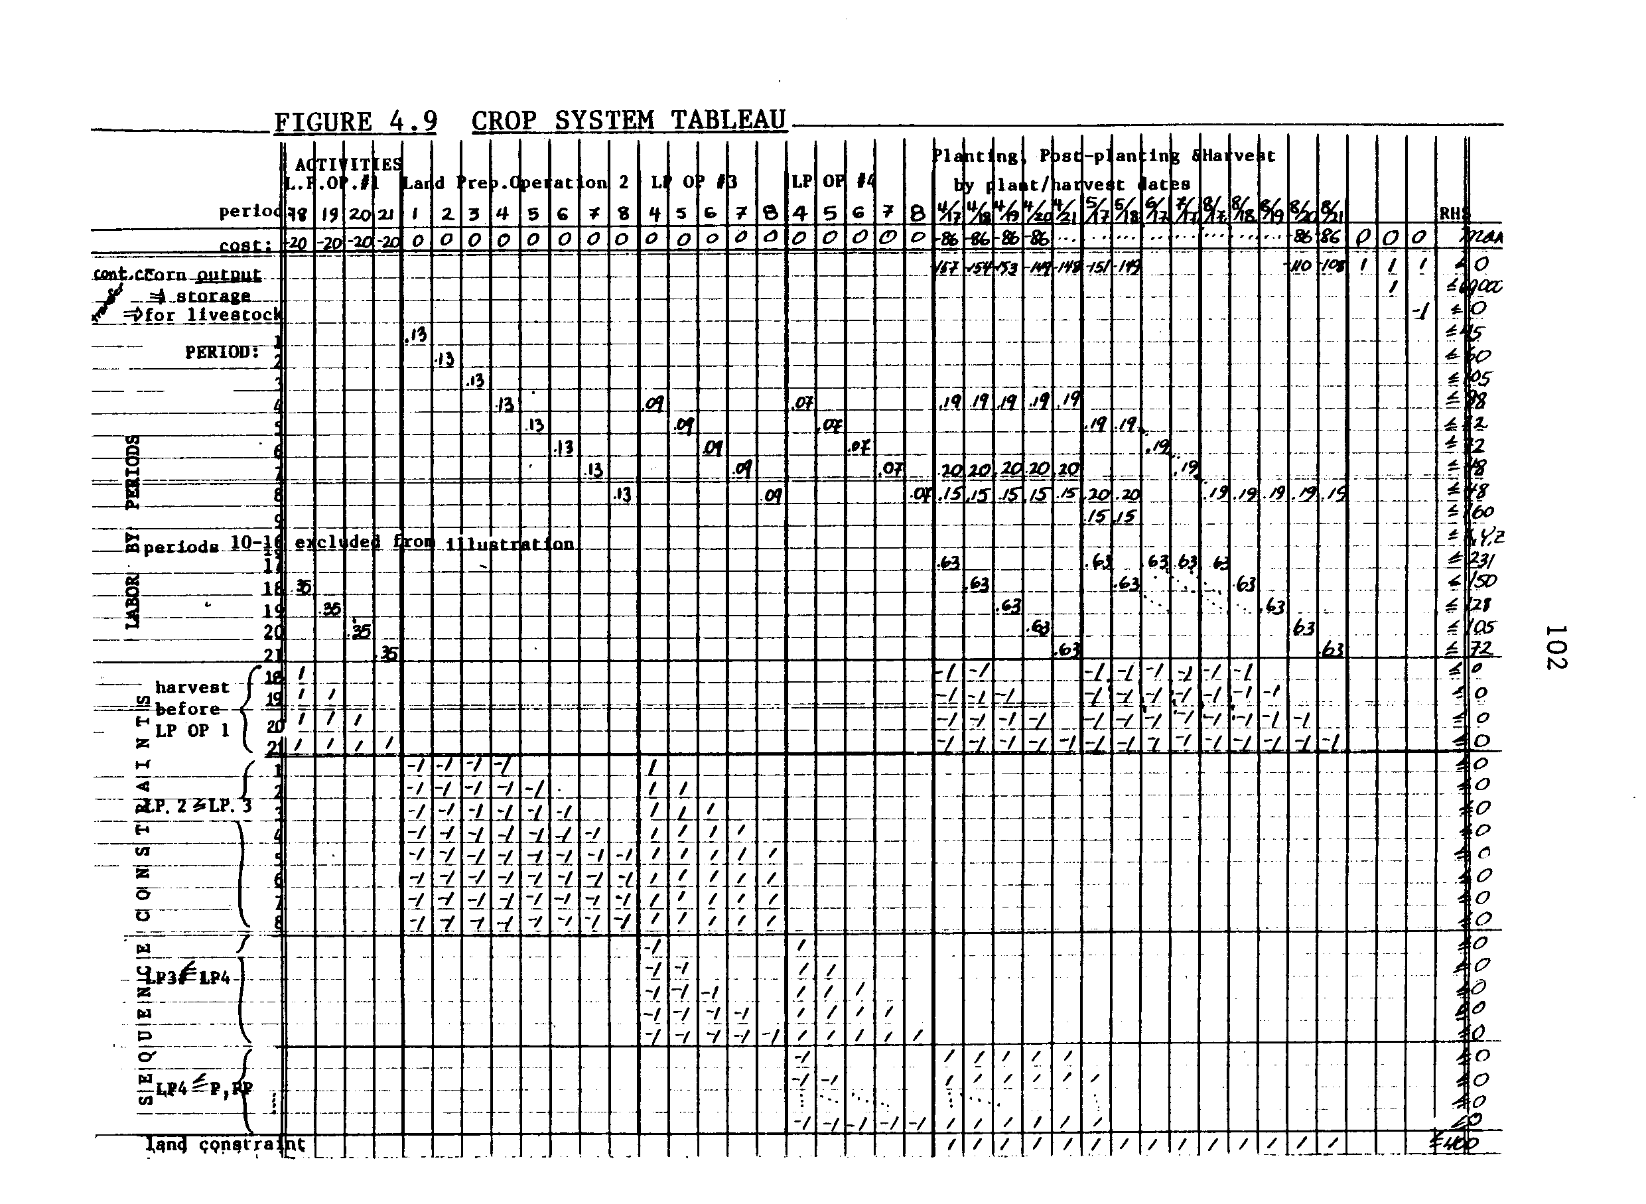
103
There is also a section of crop drying time, use, and cost constraints. The use of the crop dryer is constrained to equal the level of drying activity, which cannot exceed available dryer time. The variable cost for drying is summed over harvested crop drying activity and cannot exceed the cost transferred to the objective function. There are two drying alternatives: one farm (in the field) or on farm using a dryer. The crops can also be sold directly or stored, given the maximum storage capacity; or they can be transferred for use in the dairy system. These alternatives are accompanied by a number of constraints that act as control rows among the storage, use, or sale activities.
There is a volume restriction on the alfalfa hay sale activity to model the imperfect alfalfa market faced by farmers in Southeast Minnesota. Alfalfa is not traded in much volume there. The record data estimates a high of ten tons trading by the average association member. The restriction is illustrated in the schematic tableau 4.7 on page 93. Otherwise, sales of crops are constrained simply by the level of production, less on farm use; and silage is not sold at all.

The Activity Set
The ROMP-FS1 farming system model employs a more sophisticated specification of activities than was explained in the previous "theoretical underpinnings" section. At that time, farm activities were described in gross terms such as corn production and milk production, etc. To model these activities in a linear program, fixed coefficient, production functions are used. These equations become columns in a matrix where the rows are the designations for the resources used or
104
transferred. The coefficients in these columns represent the rate at which the resource must be employed to generate the stipulated output, given the rate at which all other inputs are employed.
For the ROMP model, activities as described above are actually the sums of sequences of time-specific activities (Figure 4.10). And, tableau 4.9, page 102, is one illustration of this. Notice that the columns are specific operations differentiated by the timing option. The sum of all of these options and operations comprise the continuous corn crop production model. The rows in the tableau designate the quantity of labor available per production time period. There are analogous rows for machinery and all other time disaggregated resources, for each crop and special activity.
Five rows at the top of the matrix in 4.9 are also noteworthy. The uppermost is the cost row. The coefficients are the variable costs per land prep, and plant/harvest activities. In another part of the full tableau, this would contain the sale prices of crops, etc. The second row is the land constraint. One acre is debited from the total 400 tillable for each acre of time-specific corn production alternatives. The other three rows transfer corn output to storage or livestock. These are examples of the types of transfer rows accounting for crop use. In the corn output row, the coefficients are the yields achieved for the given management, specifically, the planting-harvest dates.
The activity set for the model therefore consists of land prep, plant/post-plant/harvest, land use, labor use, variable input use, crop drying, storage, sale or on farm use, and "special activities": meeting nutritional requirements for the dairy herd and producing milk.
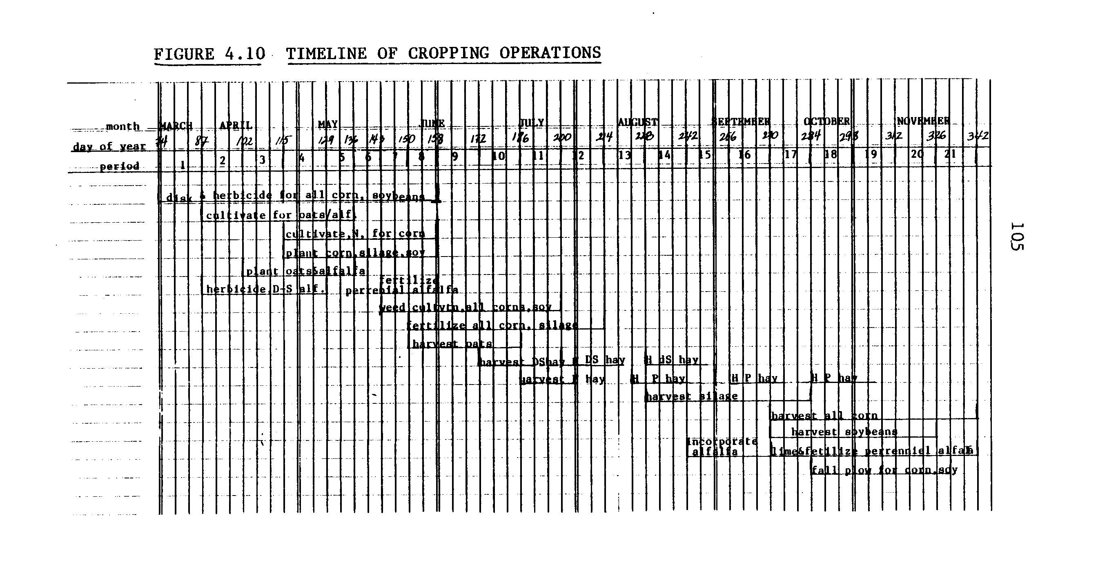
106
In terms of gross crop production activity designation the model posits fifteen cropping activities. These are five corn rotations, five silage rotations, two types of alfalfa establishment, full production alfalfa and soybeans. The oat crop grown to establish alfalfa is distinguished (as discussed earlier) by requiring a dummy land type.
The five corn crops and the analogous silage crops are differentiated on three counts. Major distinctions exist between the levels of added nitrogen and the yields, reflecting the nitrogen and rotation effects of alternating corn with legumes. There is a continuous corn activity which also requires an expenditure and application of pesticides. Corn grown after alfalfa or soybeans does not require that. There are also second and third years of corn grown in corn-alfalfa rotations. The data on added N and yield can be found in Appendix XI. All other data is most easily found in the crop budgets, Appendices VII.1 through VII.6.
For a detailed example of the structure of the time disaggregated, sequenced activities involved in the crop production activities, Table 4.11 is presented. This table contains all of the data on equipment, field rates, and operation timing required to prepare the linear program. Table 4.11 can be used in-.conjunction with the exemplary tableau 4.9.
Sale and use of crop activities are simply modeled by transfer rows from crop production to storage or sale, or transfer to the special activities of feeding to the livestock. The crop use activity coefficients represent the per unit requirement of each crop that is transferred to livestock as feed. Since some spoilage and post-harvest losses are assumed throughout the year, these coefficients are greater
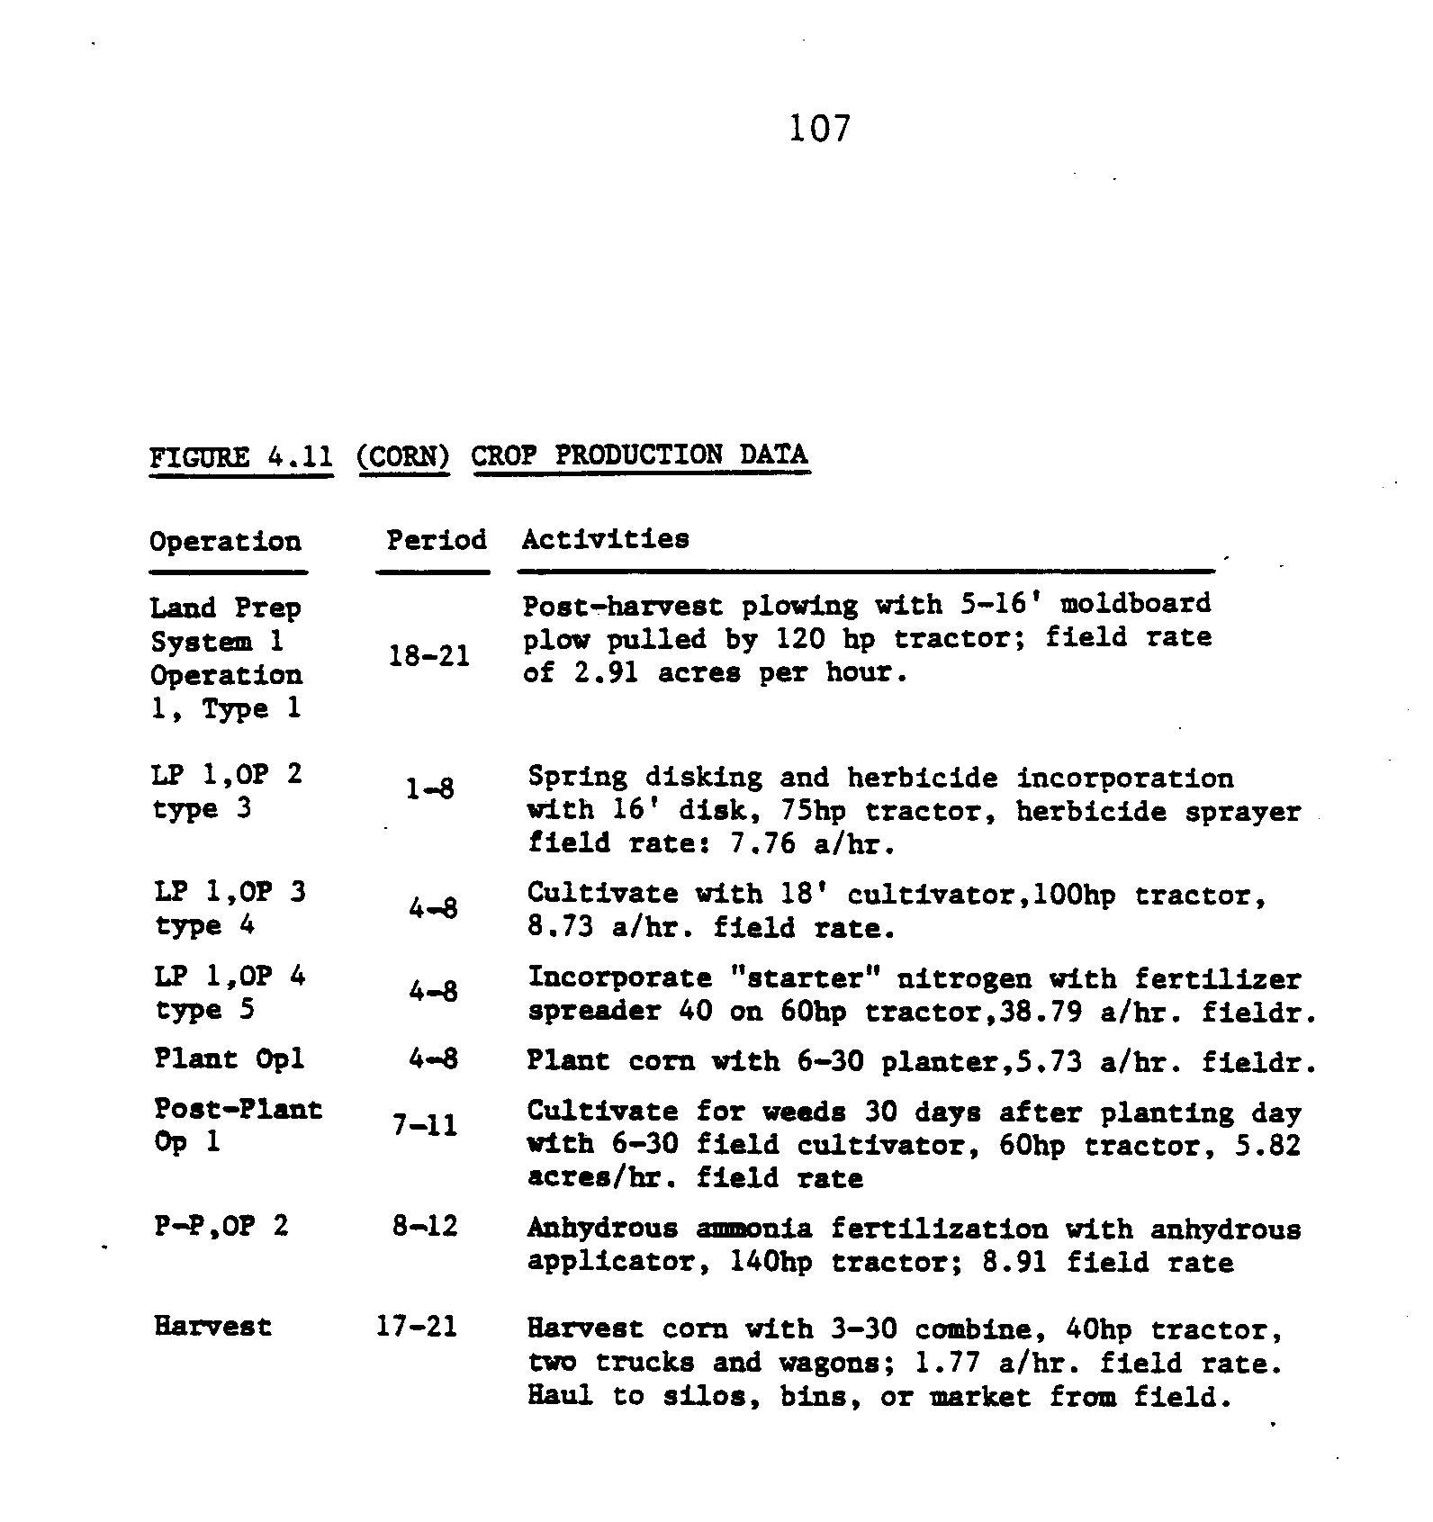
108
than one, implying that more than a unit of feed must be harvested in order that one unit be available as feed. These coefficients are 1.15 for silage and 1.2 for hay.
In summary, the model in its final form has 650 constraint rows and 880 activity columns comprised of over 5,200 coefficients. The matrix density is .875. Solving required under 20 seconds of central processing on a Cyber 730 with an APEX routine.

Degeneracies
The degeneracies in the model resulted from the number of crops with similar operation requirements, the dummy land category for oats, the congruence during certain periods of the available labor, and the overlapping of the oat harvest with post-plant operation on the established alfalfa. The existence of these degeneracies is not considered harmful since they do not affect the sensitivity of the model on the nitrogen choice question.
Verification
To verify that the linear programming farm model could be used to predict and define farm demand for nitrogen and legume nitrogen, the final basis of the model under a current price scenario was compared to common practice in Southeast Minnesota. The Farm Management Association Annual Reports were again consulted. The levels of activity in the final basis were compared with acreage and herd size statistics. Congruence was the verification criterion.
109
The typical record-keeper's farm consists of 160 acres corn (rotation unspecified), 120 acres of soybeans, 80 acres of oats/hay and 40 acres of silage.
The model farm without any acreage constraints on silage consisted of over 150 acres of corn and alfalfa in a three-year rotation, 240 acres in a soybean-corn rotation, and the rest in silage after soybeans. This is acceptably similar to be considered a mimic farm plan. The final basis did not include silage at even an approximate level. The discrepancy in silage acreage can be explained as follows. There are two attractions to harvest corn as silage that are not embodied in our model. One, farmers often harvest enough corn silage to fill the silo as an insurance against the risk of losing other feed crops. Silage is almost fool-proof to harvest and store. Two, the mechanized silage feeding equipment makes it easier to feed the dairy herd silage than hay. If dairy labor is not constrained and if no off farm work opportunities exist, the labor time has no imputed value. This appeared to be the case in almost all periods. Therefore, while profit maximization may dictate more hay and oats than silage, a concern about risk and a preference for leisure may mean more silage. These differences between the model and common practice are not considered serious for the question. The unconstrained plan was accepted.
A close to perfect mimic farm plan could be obtained with a single minimum restriction on silage acreage. Alfalfa as modeled provided the large nitrogen and rotation benefits, so this is seen as the major reason why the freely optimizing model chose more alfalfa over silage. This factor should not be obscured by constraining silage in the model.
Chapter Five
ANALYSIS
The analytical procedure of ranging the nitrogen price and calculating the resulting level of nitrogen demanded from both commercial and organic sources will be the main subject of this chapter. This chapter opens with a restatement of the analytical procedure. This will be followed by an explanation of how nitrogen use accounting was conducted. Then, the results of the price-ranging analysis will be discussed in terms of the questions formulated in the previous chapters. The activity levels and adjustments will be interpreted to provide implications about the substitutability between legume and fertilizer nitrogen.
The analysis consists of two parts. The price-ranging analysis is used to describe the substitutability of the two sources of nitrogen assuming the current capacity for nitrogen fixation and potential for carry-over. The second part of the analysis posits enhanced nitrogen fixation performance by both alfalfa and soybeans, and the demand for direct feed use of alfalfa is deleted. This tests the economic viability of the green-manuring of alfalfa as a very high organic nitrogen supplying technique. This part of the analysis is speculative.

HYPOTHETICAL RESULTS
Figure 5.1 illustrates the hypothetical results of both the price- . ranging and the BNF enhancement analysis. The darkest downward sloping curve labeled Farm Nitrogen Demand represents the sum of all demands for nitrogen in farm production. This includes nitrogen for crop growth and
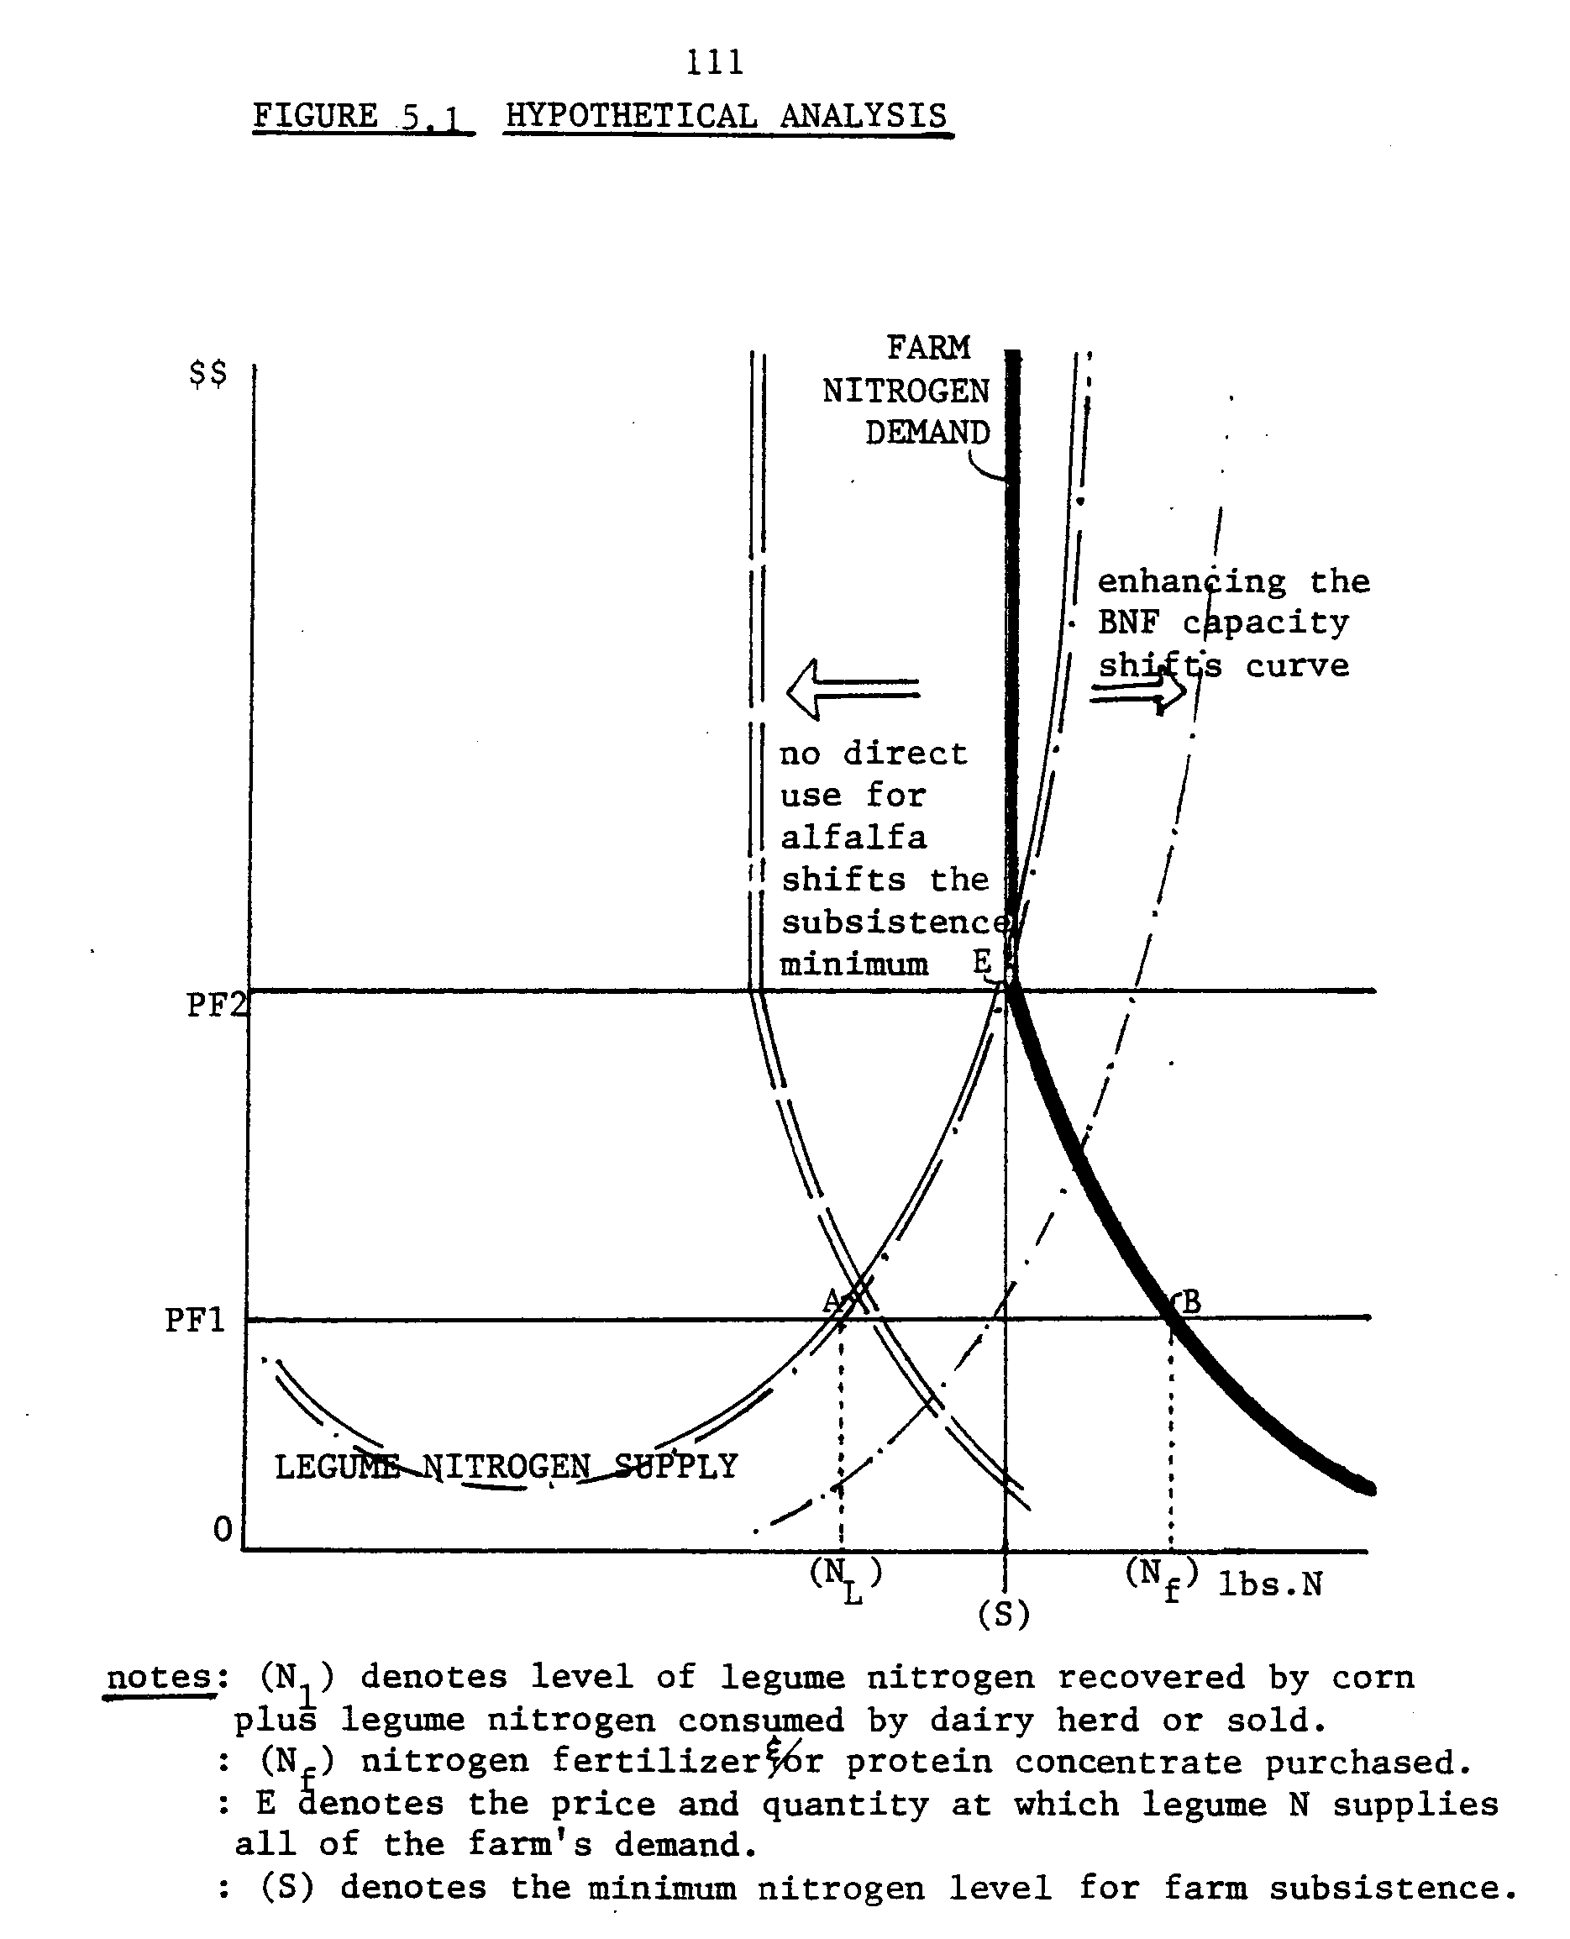
112
nitrogen in the feed proteins necessary to maintain a producing dairy herd. This curve is postulated to have a lower bound beneath which farm activity could not occur at all. This reflects the essential role nitrogen plays. The actual curve must be estimated in the analysis.
The supply of nitrogen is indicated by two different classes of functions. The supply of commercial, industrially produced nitrogen is represented by a horizontal line, the vertical height is set by the market price. The small farm assumption of infinite supply elasticity is crucial at this point. The consequence of infinite elasticity is that individual farm demand for commercial nitrogen (fertilizers and/or protein concentrate or feeds) cannot affect the market price(s). This assumption simplifies the analysis as it is not necessary to estimate supply as a function of price, only the actual demand as a function of price. The calculated demand at each price parameter will provide the coordinates of the normative demand curve for total nitrogen.
The legume nitrogen supply function is represented by the dash-dot curve. This curve is a-shaped because it is hypothesized that generating legume nitrogen is initially subject to economies of scale. Up to a point, the implicit unit costs of legume nitrogen decrease as more acres of alfalfa are cultivated. The economy of scale may also reflect the associated benefits to the farming system of legume cultivation such as the rotation effect on corn yield. This supply locus eventually trends upward because of the further hypothesis that diseconomies of scale are encountered. Legume cultivation at that point implies greater
113
and more costly reallocation of farm resources to the less profitable crop. Finally, a maximum of legume nitrogen supply is hypothesized, the vertical portion of the curve. No matter how intensively legumes are cultivated, there is a physiological limit to the quantity of nitrogen that can be fixed and provided on a given size farm.
This physiological limit is what basic scientists are trying to expand. If legumes could provide more nitrogen at each level of cropping intensity and cost, then the legume nitrogen supply curve would shift rightward. Since the total nitrogen supply will be demanded from the least cost source, this may result in a greater proportion of total farm nitrogen being derived from non-commercial sources without implying a drop in the farm's earnings.
The theoretical solution for the model presented in Figure 5.1 is indicated by the intersections of three curves: the two supply curves for nitrogen (fertilizer N and legume N) and the whole farm nitrogen demand curves. The fertilizer N supply curve, intersects the legume N supply curve PF1 at point A, and the whole farm nitrogen demand curve at point B. The solution is to supply O-N_{L} of legume N, and N_{f}-N_{L} of fertilizer N, with total fertilizer demand equal supply at
ON _{L} + ON_{f}, or O-N_{f}. If the price of fertilizer nitrogen rises to PF2, then whole farm nitrogen demand would be O-S, and met totally from organic sources.
PRICE RANGING ANALYSIS
The first analytical objective is to map the total use of nitrogen as a function of fertilizer price. The nitrogen fertilizer price
114
parameter was ranged from two levels below the current price to five above it. These price intervals are in percentage terms: -100%, -50%, the current price,+ 50%, + 100, 200 and 300%, and above 400%, respectively: free, $.115/lb., $.23/lb., $.345/lb., $.46/lb., $.69/lb., $.92/lb and "prohibitively costly". The cost of 44 percent nitrogen protein concentrate dairy ration supplement was also adjusted for each of the eight runs on the basis of the cost of the nitrogen component in the supplement.
At each nitrogen price, the rate of nitrogen fertilizer was stipulated according to the algorithm for fertilizer use developed in Chapter 3. The level of fertilizer for corn is a function of the nitrogen price and the type of rotation. The data for the model was adjusted accordingly for each price scenario. The appropriate fertilizer rates per acre and the resulting yields (determined according to the response of corn to nitrogen function, also Chapter 3) at each price of N are listed in Appendix XI.
The resulting solutions from running the model were analyzed to determine the degree of complementarity between legume N and fertilizer N. The quantity of legume nitrogen recovered by corn was calculated from the acreage results of each solution. The quantity of legume nitrogen sold (embodied in soybeans or hay) and/or fed was also calculated from the sale and use of crop results of each solution. These recovery, sale, and feed nitrogen totals were summed to obtain an estimate of total nitrogen use at each price of fertilizer N. Table 5.1 is one of the tally sheets illustrating the calculations.
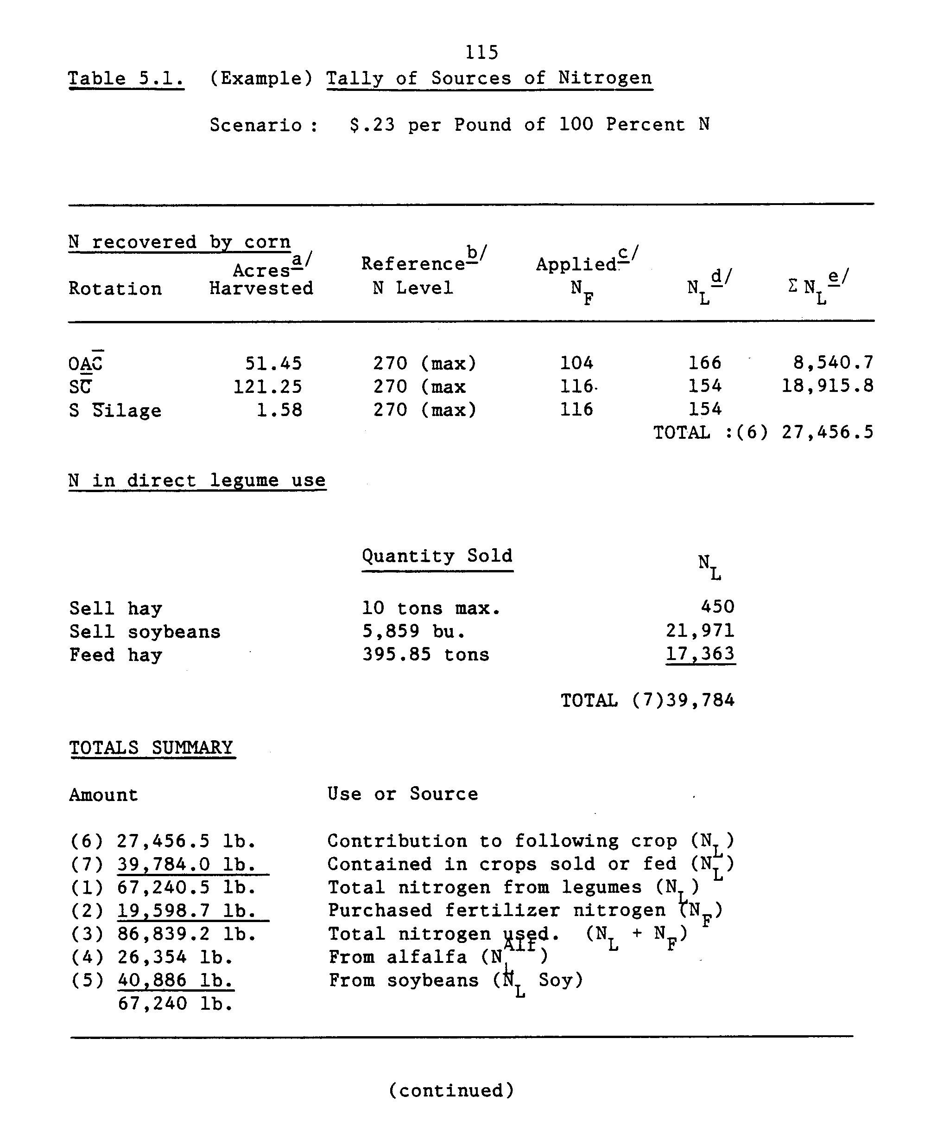
116
Notes to Table 5.1:
_a/ Acres harvested (maximum of 400) on which it was profitable to produce corn in the rotation indicated.
_b/ The "reference-N" level is the quantity of nitrogen which would otherwise be required on continuous corn to achieve the same yield. Since continuous corn never reaches some yield levels attainable in rotation, maximum fertilizer rate is used as a reference. (This caused some difficulty due to a "rotation effect" (Chapter 3) and some perturbation of the N_{L} estimate).
_c/ "Applied" nitrogen is the quantity of fertilizer nitrogen added, determined according to the fertilizer rate algorithm designed in Chapter 3.
_d/ "N " is the difference between the reference or required nitrogen level and the actual applied level. The assumption is that this differential is supplied through the decomposition of the legume residue.
_e/ "E NL" is simply the level of N_{L} per acre multiplied by the number of acres under that particular rotation.
117
The summary of results from each price scenario is presented in Table 5.2, and graphically illustrated in Figure 5.2. The values of interest are indicated by numbers in parentheses. Total nitrogen contributed to the farm by legumes either recovered, sold or fed is item (1). Purchased fertilizer is item (2) and the sum of (1) and (2) is total farm use of nitrogen, item (3). These three values are plotted over nitrogen fertilizer price in Figure 5.2.

RESULTS
There are two major features of the curves in Figure 5.2 which warrant discussion. First, there is a part of the price domain within which the demand for legume nitrogen appears to be a decreasing function of commercial N price. Second, there is an apparent minimum level of nitrogen, net of soil nitrogen, derived entirely via legumes. Commercial nitrogen displays a classic decreasing function of its own price with a regular downward slope.
This discussion will focus on the legume nitrogen locus. The range of prices from 0 to .23 is denoted range A. The range from .23 to is denoted range B. Starting from left to right, as the cost of commercial nitrogen increases, the exploitation of legume nitrogen at first increases from 23,200 to a maximum of 67,240 lbs. on the whole farm, then slowly the level drops to an asymptotic minimum around 63,000 lbs./ farm.
In range A, legume nitrogen is being "substituted" for commercial fertilizer. Even when nitrogen is free, some legume rotations are desirable for two reasons. The first is the non-nitrogen rotation
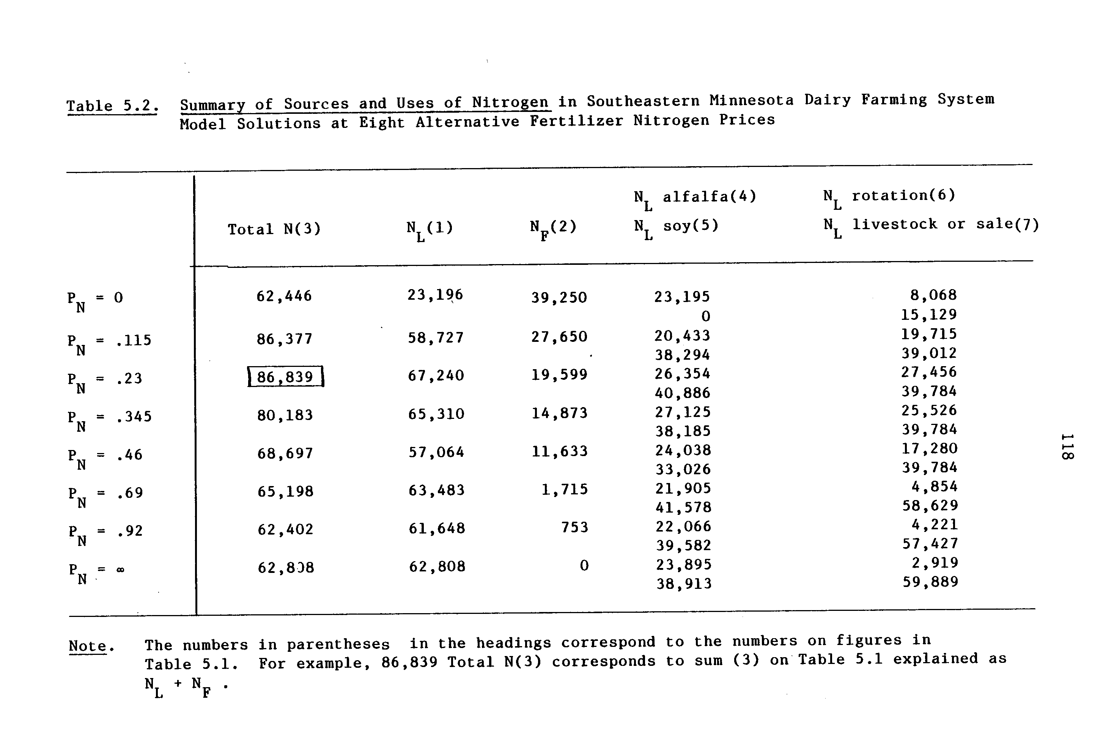
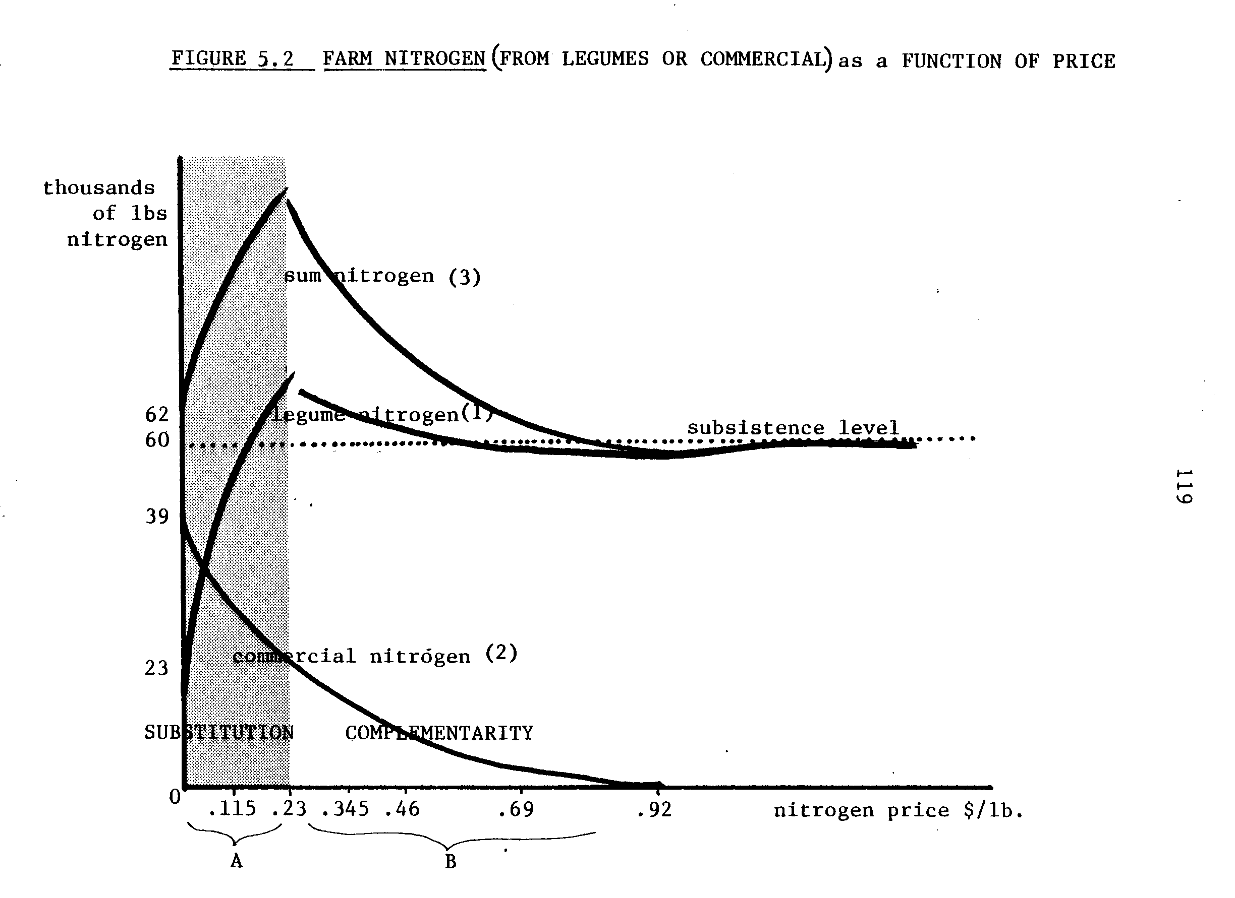
120
effect (Ch. 3). Fertilizer is available "free", so the maximum yield of continuous corn can be obtained with the highest fertilizer rate at no cost. An even greater yield of corn can be obtained from corn grown in a legume rotation. Thus, acreage is devoted to corn in a rotation as well as continuously. Second, alfalfa is demanded for feed. (There is no minimum requirement for alfalfa as feed in the specification of the model.)
These results imply that a significant, non-nitrogen benefit to the farming system arises from legume-based crop rotation. It is characterized as a non-nitrogen benefit because a nitrogen contribution from crop rotation and/or feeding alfalfa to livestock could be met equivalently with free commercial fertilizer and/or free nitrogen protein concentrate feed supplement. Crop rotations and hay/corn rations are a part of the profit-maximizing solutions even when fertilizer and the nitrogen in feed supplements are free.
As the fertilizer price increases from 0 to $.23/lb. more legume nitrogen is demanded. (Figure 5.2) Within range A prices, most of the nitrogen use adjustments occur in the cropping subsystem. Legume nitrogen substitutes for commercial fertilizer. Figure 5.3 shows in more detail how commercial fertilizer reliance declines in favor of increased reliance on recovery of legume N, as fertilizers become more costly.
Through range B prices legume nitrogen and fertilizer nitrogen appear to be complementary inputs. As the price of fertilizer exceeds the current price, use of both decreases. Over the B range there is a 96% reduction in fertilizer use and a correspondingly large reduction
122
in the quantity of legume N being recovered in rotations with corn.
The smooth curve in Figure 5.3 illustrating legume N recovered in rotations obscures the two abrupt changes in the types of rotation. The adjustments in crop acreages on the farm as the price of fertilizer varied are illustrated in Figure 5.4.
Not surprisingly, continuous corn production is favored over rotations when fertilizer nitrogen is free. Soy-corn rotations become cost-effective at the next price interval of .115$/lb.; completely replacing the continuous corn acreage. When the nitrogen price reaches .69$/lb., the acreage in soy-corn rotations declines rapidly to be replaced by continuous soybean cultivation. Up to that point, about one-half of the farm is under a soy-corn rotation and the other half in a three year alfalfa establishment--alfalfa production--corn rotation. Corn rotated with alfalfa requires much less added nitrogen than either soy-rotated corn or continuous corn.
Crops are cultivated at levels where the gross margins are most favorable. When the acreage devoted to the soy-corn rotation drops out in favor of continuous soybean cultivation it is because the returns to fixed factors from rotation corn is less than the return from pure soybeans. The alfalfa-corn rotation acreage is virtually constant over the entire price N range.
When the acreage in the two legume rotations varies, the proportion of legume nitrogen recovered by corn from each source varies. This is illustrated by Figure 5.5. At zero nitrogen prices corn is grown continuously, and in an alfalfa rotation. Thus, 100% of the legume N
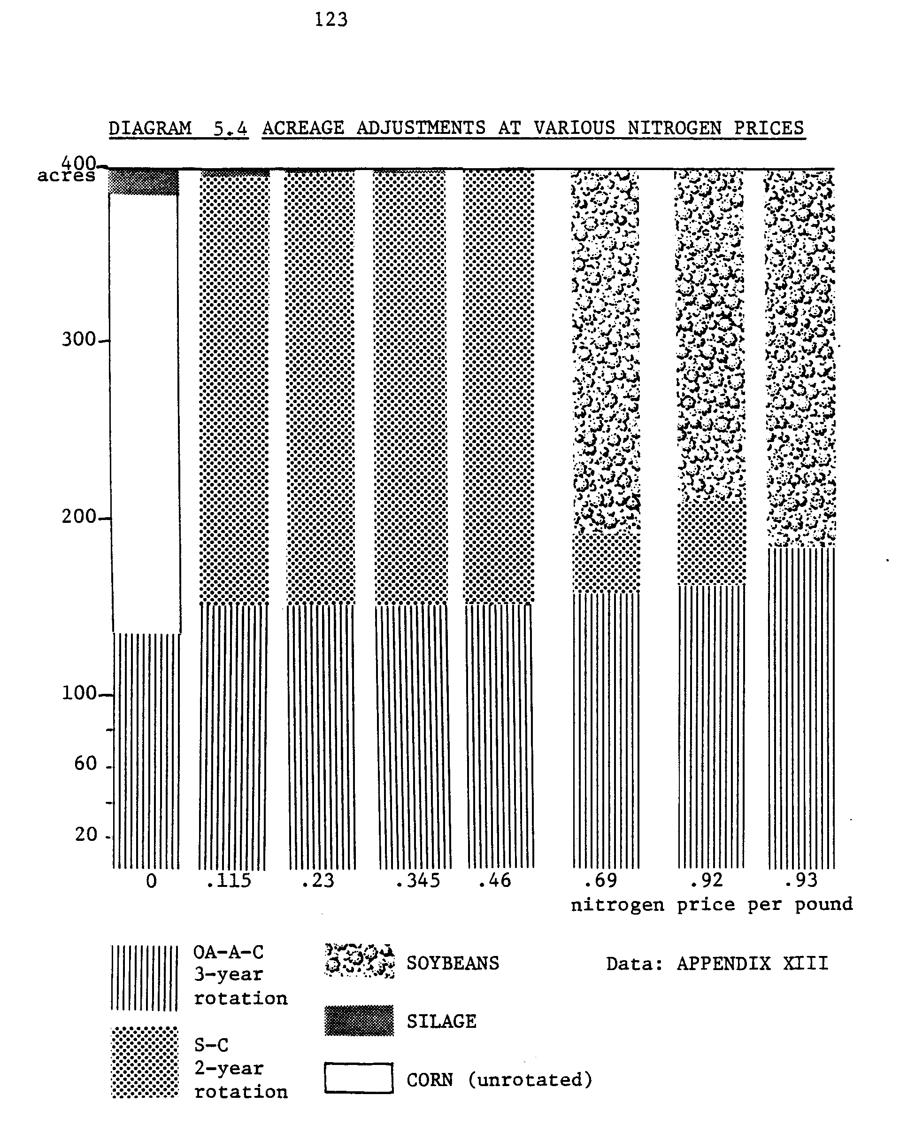
124
125
recovered for corn derives from alfalfa. This level of nitrogen from alfalfa stays fairly constant, while more corn is grown in soybean rotations. Even though the soybean rotation provides lower levels of carried over nitrogen, it is economically quite attractive since the soybeans are also profitable to sell. At the highest fertilizer prices, only the alfalfa rotation corn is economically attractive, and alfalfa again provides 100 percent of the recovered legume nitrogen for corn.
While some inference can be found about the relative gross margins among the three types of rotation corn, other information is needed to complete the picture. The confounding but necessary features of the farming systems model is the integration of the crop and livestock enterprises. Corn as well as alfalfa are fed to the herd. The variations in the composition of the feed ration may reflect the variations in profitability among the types of corn. On the other hand, that may be irrelevant. Unfortunately, the linear programming model does not provide conclusive evidence about relative gross margins through analysis of the feed ration adjustments because of the potential degeneracies among types of feeds as suppliers of the nutrient requirements for the herd.
The adjustments in the feed ration are illustrated in Figure 5.6. This documents how the ration changed to reflect changes in the types of crops while maintaining the prescribed diets for the dairy herd. At all relevant nitrogen price level scenarios, a ration of 50-50 corn and hay is economically and nutritionally superior.
127
ANALYSIS OF EHNANCED BNF
The second analytical objective was to estimate what level of BNF would be necessary so that legume nitrogen is a cost effective supply of nitrogen for a cash crop farm (excluding a market for hay, excluding an on-farm use of hay as feed). In this section the results of the simulation modeling of the role of alfalfa and soybeans with enhanced BNF capacity are presented.
The first step was calculating an enhanced level of nitrogen fixation capacity of both alfalfa and soybeans. This was done in terms of nitrogen carried-over on the basis of the following assumptions. It is proposed that legumes could be developed that support enough nitrogen fixation to (1) supply all of the nitrogen required to obtain the current high perennial and/or annual legume yield, and (2) to supply a net addition of N to the soil equivalent to current levels plus the current nitrogen sink of legumes. The estimates of the nitrogen sink of the legumes soy and alfalfa are derived from the estimated proportion of soil nitrogen in total plant nitrogen. These estimates are 60 percent for soybeans and 40 percent for alfalfa.
The enhanced BNF levels are calculated as follows. For soybeans, the quantity of. nitrogen carried-over in the basic scenario is estimated at 68 lbs/acre. Of that 68 lbs., forty percent (27 lbs.) is assumed to derive from symbiosis. Doubling the symbiotic fixation rate would imply a net nitrogen carry-over of 95 lbs/acre.
The calculations for alfalfa are more complicated because alfalfa's nitrogen credit is recovered over a three year period. The total nitrogen
128
credit is 165 lbs. sixty percent is assumed to be derived from symbiotic fixation (99 lbs.). In order for that total nitrogen carry-over to be met by symbiosis alone, an increase of the capacity of alfalfa to support a level of fixation up to 83 percent of the requirements is necessary. The level of nitrogen carried-over would then be a total of 231 lbs. over 3 years.
The 95 lb. N/acre nitrogen benefit from soybeans and the 139 lbs/ acre (year one), 69 lbs/acre (in year two) and 23 lbs/acre (in year three) benefits for corn in a five year OA-A-C-C-C rotation were entered in the model. Yield of corn and the appropriate fertilizer recommendations were also entered. The dairy enterprise was excluded from the model. Therefore, there was no on-farm demand for any crop, corn or alfalfa hay. Also, the opportunity to sell hay was entirely deleted. If an alfalfa-corn rotation entered the final solution, it would be due entirely to the cost-effectiveness of corn rotations with green manure management of alfalfa.
This did not obtain. In the optimal solution the whole farm was under a two year corn-soybean rotation. Nitrogen from alfalfa (under these circumstances: no direct use or sale) was shown to be too costly, even if the fixation productivity of alfalfa was increased 23 percent.
This analysis is far from complete. Different levels of alfalfa fixation capacity could be postulated. At some point, even green manure alfalfa-corn rotations may become profitable. Also, the level of fixation by soybeans could be varied downward to identify the precise level
129
of fixation at which soy-corn rotations gain a profitability edge over continuous corn. There are many confounding factors in the analysis of that level of fixation by soybeans. The relative sale values of corn and soybeans are enough to alter the profit picture. Such tasks are beyond the scope of this thesis.
This simple investigation did provide some insights. One., even though the additional BNF capacity for soybeans was less (in absolute terms) than one-third the additional capacity of enhanced alfalfa, soybean-corn rotations proved most profitable. Two, the results showed that a two year alfalfa-corn rotation--where the first year of corn recovers 100 percent of the quantity of N that would otherwise have been added as fertilizer from the legume residue--is not an economically competitive rotation when there is no direct use or sale value for the alfalfa.
Chapter Six
SUMMARY AND CONCLUSIONS
The objective of this research was to identify the economic role of BNF in a farming system. The system was chosen from southeast Minnesota where farmers integrate a dairy enterprise with cash crops and alfalfa cultivation. Specific objectives were to measure the extent of technical and economic substitutability between commercial N and legume N. This required simulation. An "upstream" farming systems approach was followed; and a goal-oriented, time-disaggregated, linear, mathematical programming model was constructed. The linear programming format was consistent with the farming systems framework, simultaneously solving numerous interdependent crop and livestock production alternatives. Disaggregation of time permitted realistic modeling of the timeliness of crop production, particularly the days available for field work and the sequence of crop cultivation activities.
Two functions, (1) corn yield response to nitrogen and (2) nitrogen fertilizer use as a function of price; were generalized from agronomic and farm management data of southeast Minnesota. Corn yield is estimated by Misterlich-Spillman response-to-nitrogen functions for five different courses of corn ranging from continuous corn to the third year of corn in an alfalfa-corn rotation. The response of farmers to changes in the price of nitrogen fertilizer is mimicked by an available-cash constrained profit maximization algorithm, inspired by their apparent cash-rationing behavior.
131
In addition to these functions, a least-cost/minimum nutrient requirement feed ration matrix was included in the model. These three features defined the roles of nitrogen in farm production and the economic decision rules concerning the level of use in a flexible way. The relationship between commercial nitrogen and legume nitrogen was explored using the farm model. The prices of nitrogen fertilizer and (nitrogen) protein concentrate feed supplement were ranged from zero (free) to three hundred percent of a current price (1981-82) in seven steps, and then to a prohibitively expensive level. In addition, the levels of nitrogen carried-over from alfalfa and soybeans were doubled in the model, and a solution was obtained at current nitrogen prices.
The results of the analysis can be summarized as follows. Land use shifted from continuous corn to corn-soybean rotation on two-thirds of the crop land, with a fairly constant level of a three year oats-alfalfa corn rotation providing the feed for the dairy herd, over the first seven steps in the price range. At prohibitively expensive nitrogen prices, continuous soybeans displaced the soy-corn rotation, but the OA-A-C remained optimal on one third of the available acreage. The dairy herd was maintained at the upper bound determined by facility size across all nitrogen prices. All feed was produced on the farm, except for the solution under free protein supplement price, wherein a small amount of supplement was used. Otherwise, a 50-50 grade 1 hay-shelled corn ration with oats prevailed.
132
CONCLUSIONS
Fertilizer nitrogen and legume nitrogen are both economic complements and substitutes. From zero to the current price of nitrogen they appear to be substitutes. While fertilizer use declined with increases in its own price, more and more legume nitrogen was recovered by crop rotations. Beyond the current .price, they display complementarity. Fertilizer use continued to decline with a concomitant decline in the level of legume nitrogen recovered in rotations. At the prohibitively expensive nitrogen fertilizer price, the recovery of soybean residual nitrogen also dropped to zero. Nitrogen recovered by corn in the OA-A-C rotation completely substituted for fertilizer; but the nitrogen recovered after soybeans was only enough to complement fertilizer use, and was not optimal at zero or the highest N prices.
When the model was run with the BNF of soybeans and alfalfa enhanced, while excluding both dairy derived-demand and markets for hay, no alfalfa hay was produced at all. Therefore, no legume N was recovered from alfalfa. The farm went entirely to a soy-corn rotation.
There is no a-priori explanation for the economic relationship changing from substitution to complementarity at the current price, other than the following speculations. On one hand, the results may express the true relationship and it is only the length of the price
range intervals that obscure the exact break price, while approximating it near the current price. This can be tested by increasing the number of price intervals. On the other hand, the results may arise from Type Two error: a bias toward base scenario/current price in
133
the model. The possible source of this bias is an unsolved puzzle. A conclusion from the enhancement analysis is that alfalfa-corn rotations where alfalfa is only a green-manure crop are not economically competitive with soy-corn rotations. This holds at current prices of nitrogen even when alfalfa is modeled to provide 100 percent of the corn's nitrogen in the first year of the corn sequence. The residual nitrogen alone is not valuable enough to warrant displacement of cash crops. Specifically, the alfalfa in a rotation must also provide sale or use value.
These results imply that there exist at least four types of economic benefits to a farming system from legume rotation. In order of importance according to the profit maximizing criterion they are (1) legume direct sale value (soybeans), (2) alfalfa hay value as a feed, (3) the nitrogen benefit to rotation corn, and (4) the net revenue increase due to lower costs and higher yields of rotation corn. It is difficult to establish the order between benefits (3) and (4). Both of these last benefits relate to BNF directly. The order between them is less relevant than the conclusion that the BNF benefits in such a farming system are secondary to the direct crop use and sale benefits of legumes. This conclusion echoes the postulates discussed in CAST Special Publication no. 5 (1977).

IMPLICATIONS
This study suggests to BNF researchers that forage yield and use value are essential for the economic performance of a nitrogen-fixing crop also valued as a provider of residual nitrogen in a rotation.
134
Alfalfa as a green manure crop in cash crop grain farming systems probably has important prospects in a world of extremely high nitrogen prices. As its nitrogen contribution is enhanced, convergence between high cost nitrogen and high value legume rotations approaches sooner. This appears to be some years in the future.
With regard to economic research, this study is only an introduction. There are three levels of analysis implied for production problems: farm level, regional level, and national level. This study has demonstrated the appropriateness of goal-oriented linear programming for technical substitution problems. The present model can also be used for more detailed analyses at the farm level, such as testing the price ranging analysis at smaller intervals, or simultaneously enhancing BNF and ranging the nitrogen price to find the point where alfalfa as a green manure nitrogen source for corn is profitable. It could be reformulated for different geographical regions, and the analytical results from other regions could be summarized and generalized for a more complete picture of the nature of the relationship between BNF and fertilizer use. The basic format could also be used in developing countries to model potential cropping pattern changes toward greater exploitation of legumes in traditional agricultural systems where fertilizer is scarce. This effort would require greater levels of interaction between the modeler and the farmers to develop the data base, but the payoff may be very high.
The present model could also be improved by adding some kind of erosion cost function. Continuous row cropping of corn and soybeans
135
have serious soil erosion consequences. Alfalfa cultivation and no-till green manuring techniques are soil-conserving. Results from analysis would probably support land-use policies encouraging integrated livestock and crop production farms based on alfalfa-grain rotations. Unfortunately, a soil-conserving rotation for non-livestock farms is not currently an economic potentiality.
On the regional level, some study has already been done to assess corn belt farming adjustments to energy cost increases. In the final analysis, ignoring the aggregation problem, this study's results corresponded to the results of the other works cited in Chapter Four, by Miranowski (1979) and Walker and Swanson (1974), in terms of adjustments from fertilizer-based continuous corn cropping to soy-corn rotations. In all cases, the increase in fertilizer prices, ceteris paribus, caused decreases in farm incomes. Implications for further research are to assess the general equilibrium impact on farm output mix, prices, farm earnings, and fertilizer demand--with the more detailed and complete formulation of the crop rotation alternatives in this study.
Implications for research policy are based on the notion that cost decreasing innovations which shift a supply curve out or halt an inward shift benefit consumers and at least stabilize producer surplus. This justifies public support for the basic research in BNF, and for forage improvement towards mitigating the upward push on grain prices and downward push on supply in the long run, and the squeeze on farm incomes in the short run.
APPENDIX A
PARTIAL BUDGETS/PARTIAL ANSWERS
Several different attempts to estimate the economic value of BNF by legumes as a substitute for fertilizer have been made. These include (1) the response-function approach using marginal analysis, (2) activity analysis and (3) partial budgeting. To conduct a partial budget analysis, data on expenses and revenues must be gathered. Both of these measures are difficult to quantify. In this section partial budgeting will be considered and critiqued.
Some investigators have employed the "gross benefit," and the "net benefit" calculation approaches to quantify these parameters for BNF. "Gross benefit" is a method of calculating the value of a substitute input, in this case, symbiotic/legume-derived nitrogen, by multiplying
the total quantity of the substitute by the market price of the commercial input. The gross benefit assessment of the value of BNF is often calculated in this manner by scientists in the field, for example, P.J. Dart (1979)(Table A-1).
The implicit assumption basic to this method, that symbiotically fixed nitrogen and fertilizer nitrogen are perfect substitutes, is not sound. Also, an input has no economic value if it is not used, or if its substitute is free. No interpretation of the results of the gross benefit approach avoids these conceptual problems. Symbiotically-derived nitrogen is important for legume production, as the major portion of the total legume-derived organic nitrogen added to the soil, and also as part of the constituents in the protein-rich food
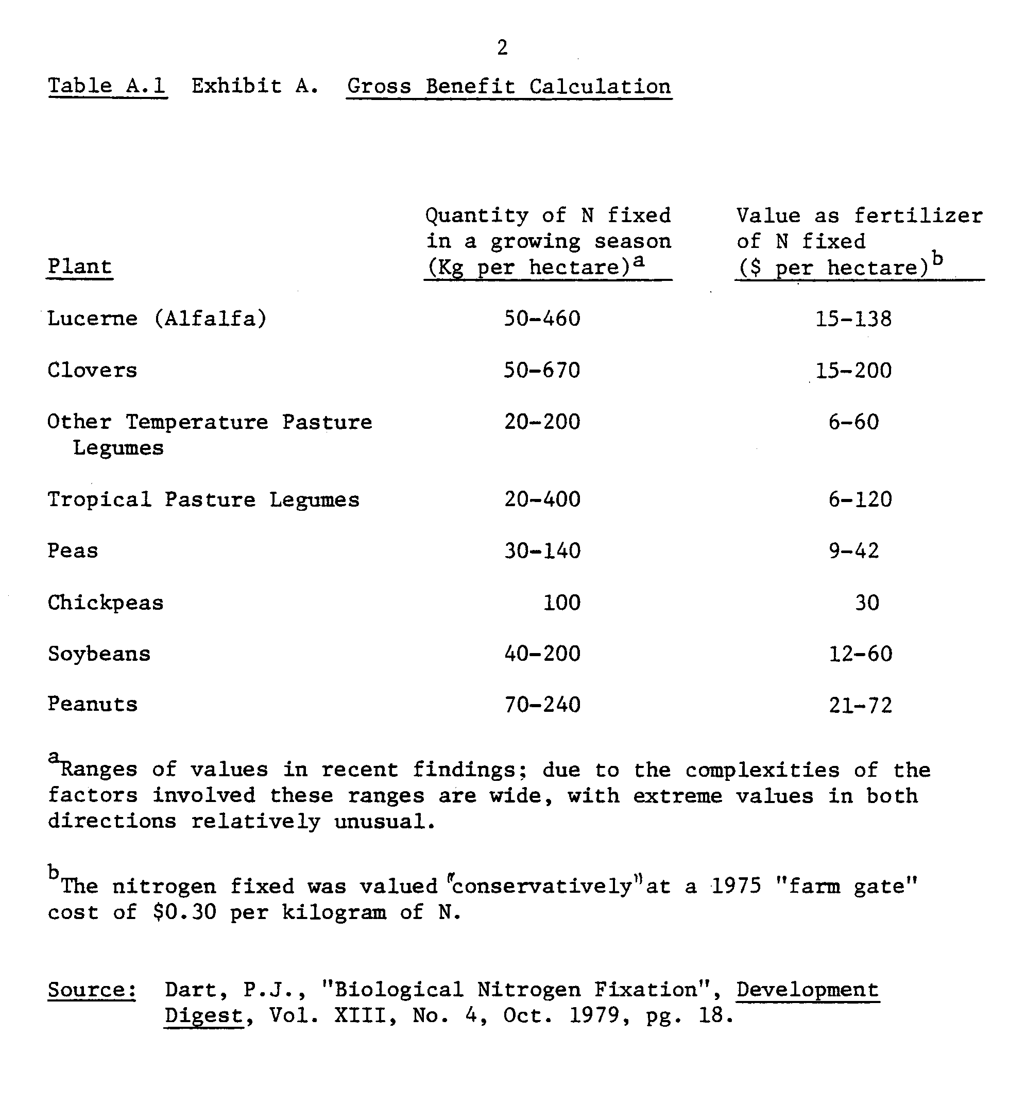
3
or feed harvested from legumes. The value of symbiotically-generated nitrogen derives from the value of the product in which it is embodied. Thus, the value of symbiotic nitrogen in legume production is a function of the value of the legume.
Table A-1 lists quantities of symbiotically fixed nitrogen by various legumes. In order to accept the statement that the maximum quantity of fixed nitrogen by alfalfa (lucerne) is worth 138 dollars per hectare, one must also assume either that $138 per hectare would have been spent on nitrogen fertilizer applied to the alfalfa, or that the alfalfa would be sold at a price reflecting a similar $.30/kg of embodied nitrogen. Alfalfa which is sold for its nitrogen content alone would have to earn $276 above costs per hectare. Since alfalfa fixes about half of its nitrogen, this figure is double the value listed on Table A.1 for the nitrogen. That sums to over $646 dollars gross return per hectare of alfalfa. It is hard to imagine any farmer either applying $138 worth of nitrogen fertilizer to his alfalfa, or being able to earn $646 from each hectare of alfalfa. This is one way that the gross benefit calculation leads one astray.
The second misleading implication from the gross benefit evaluation refers to fixed nitrogen as a fertilizer. Many assumptions underlie that evaluation. First, legume-derived organic nitrogen is assumed equivalent to fertilizer nitrogen pound for pound. This is plausible, as shown by
4
Schrader, Fuller and Cady (1966) who estimated a common nitrogen response function. If no harvest removal of any of the legume occurred, the nitrogen absorbed by the legume from the soil and the nitrogen fixed could be returned to the soil, available for a subsequent crop. This may amount to a net accretion of 460 kg N per hectare as indicated by Dart in Table A.1.
But to capture the value of that nitrogen, a crop which would otherwise be fertilized must be cultivated following the alfalfa. That legume nitrogen is worthless if it simply sits in the soil. Also the fixed nitrogen cannot be extracted, stored, nor transported about to other plots as if it were fertilizer. And again, its value is not $.30/kg. Even assuming the maximum fixation, the costs of cultivating alfalfa ($370/ha) implies a cost of $.80 per kg. N. In other words, the fixed nitrogen actually costs $.50/kg more than commercial nitrogen fertilizer.
Fixed nitrogen is not a "free good". When the costs of cultivating the legume plus the loss of income due to foregone earnings from not cultivating a cash crop are taken into account, it is clear that legume nitrogen is actually more expensive than commercial fertilizer.
This does not imply that legume cultivation is not economically profitable. It must be accurately assessed. The above provides a clear example of the shortcomings of analytical approaches that isolate the fixed-nitrogen aspect of legume cultivation from the integrated role legumes perform in the farming system. Intuitively, fixed nitrogen is an added bonus brought to a farming system by legumes through innoculation. This is true. Legumes are cultivated and harvested for sale or
5
feed, and the residue can be reincorporated into the soil. A grain crop rotated with legumes can earn higher profits since fertilizer costs may be reduced by the quantity of legume-derived nitrogen it recovers. Clearly, the value of nitrogen-fixing legumes must be investigated in this integrated framework. Costs and revenues from all the activities must be summed and compared.
In another form of "gross benefit" calculation by J.⁻Burton (Table A.2) some of the oversights mentioned above are avoided. Burton calculates the costs of the extra labor required and innoculants and subtracts this from the gross "value of the N fixed biologically" to arrive at his returns estimates, i.e., the direct costs of innoculating the legume have been deducted. But the assumptions about perfect substitutability between legume nitrogen and commercial fertilizer nitrogen and the problem of the mode of exploitation of this nitrogen remain.
By assuming that all of the nitrogen fixation is due to inocculation, Burton can compare the relative quantities of legume nitrogen between uninnoculated and innoculated alfalfa and bean crops. This makes it appear that through innoculation, nitrogen can be grown. This can be argued against on two points. First, legumes fix nitrogen to supply the deficit between its needs and what can be taken from the soil. Even when such legumes derive a great portion of their total nitrogen needs from symbiosis, a net drawn-down of soil nitrogen occurs. The nitrogen is recycled into the soil, sold in the crop, or lost. Second, the symbiotic fixation process competes for plant energy with pod-filling and vegetative growth processes. Are the losses of seed production or green matter production
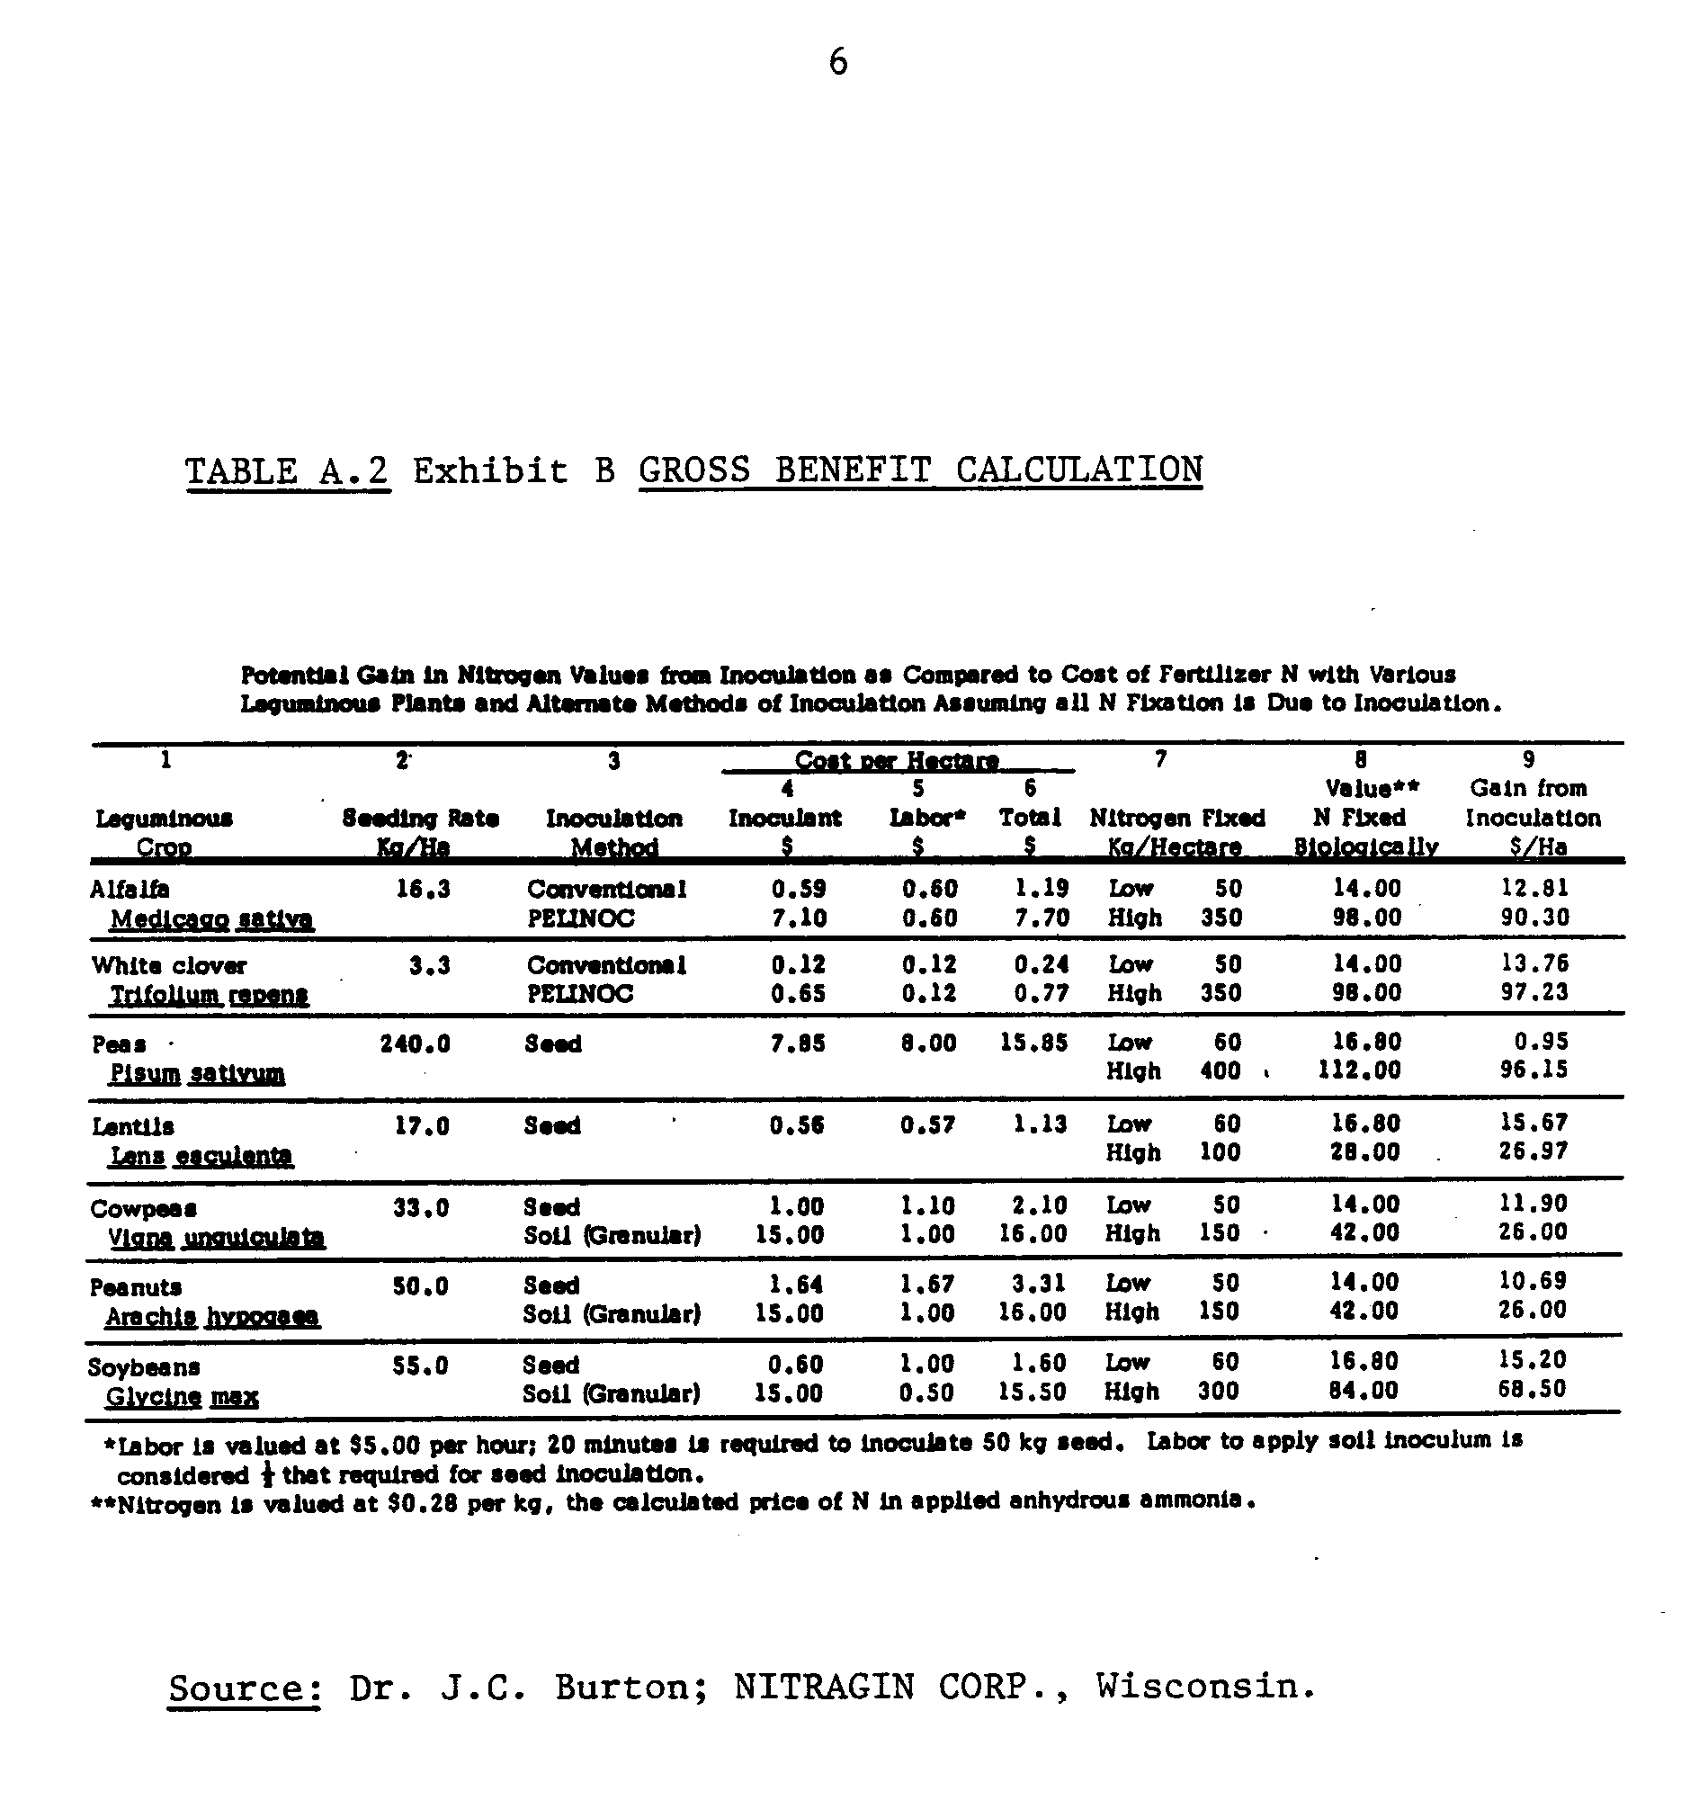
7
significant enough to warrant consideration in the net $/ha "gain" calculation? And, as before, we still don't know what is done with the legume nitrogen. If alfalfa at 45 lbs. N per ton is sold at market prices of $80.00 per ton for the nitrogen alone, its value is $4.22/kg N, fifteen times Burton's estimate.
The general conclusion from this criticism of the "gross benefit" calculation is that the method of exploiting the legume N is as important a clue to its value as is the method of producing it. Cultivating legumes incurs two types of costs, the direct cost of labor and materials and the indirect cost of foregone production of any more profitable crops. Therefore, symbiotically fixed legume N is not a free substitute for commercial nitrogen. The exploitation of the legume crop and the associated fixed nitrogen is accomplished in a number of ways. For each type of legume there are many possibilities. Forage legumes enrich the grass swards upon which livestock graze. The high-protein content of this grazing material due to BNF fattens the livestock faster and saves time and earns money (Jacobs and Stricker, 1976). Bean and pea legumes are harvested and sold for feed or food, and if the residue is plowed under, the remaining legume-nitrogen could be exploited by a subsequent grain crop in a crop rotation program. These are the types of costs and benefits the gross benefit approach overlooks.
Partial budgeting is a method which incorporates these costs and benefits and is commonly practiced by economists in the field for quick assessment of new techniques. An introduction to the partial-budgeting approach, known as "net-benefit" approach by Perrin, et. al. (1976) at
8
CIMMYT, and which is used widely in the international community, is summarized here by way of example. The net benefit approach requires data on all relevant costs of inputs, prices of outputs, yields, labor data, variability factors, grossly defined costs of capital and opportunity costs (foregone earnings for other activities) be acquired. Then the debits and credits are summed and compared among techniques. The technique which shows the largest net benefits is the technique of choice.
The following exercise compares a four-year rotation of alfalfa and corn with conti nuous corn. Prices and costs are assumed constant during the four year period. No means is available of calculating the value of labor among the periods where labor is more scarce than is periods of labor abundance. In both input and output markets, no price/cost adjustments are made for scarcity or abundance. It is also assumed that all the alfalfa can be sold in a convenient market at a constant price.
Variations in yields and market prices are summarized in nine "net benefit scenarios." All combinations of high/average/low prices and high/average/low yields are in the matrix of Table A-3. The necessary data on yields and p ices are listed following the matrix.
The crop budgets in appendix entries VII through VII.6 were developed from Benson's machinery data (1982) and the Southeastern Minnesota
Farm Management Association Annual Reports (1981-82). The cash costs from the relevant budgets are summed to generate the variable cost for each crop rotation. For the CCCC rotation, costs over four years total to $528/acre. For the OA-A-CC rotation, the total cost is 4498/ acre. Corn drying costs are entirely excluded. These costs are
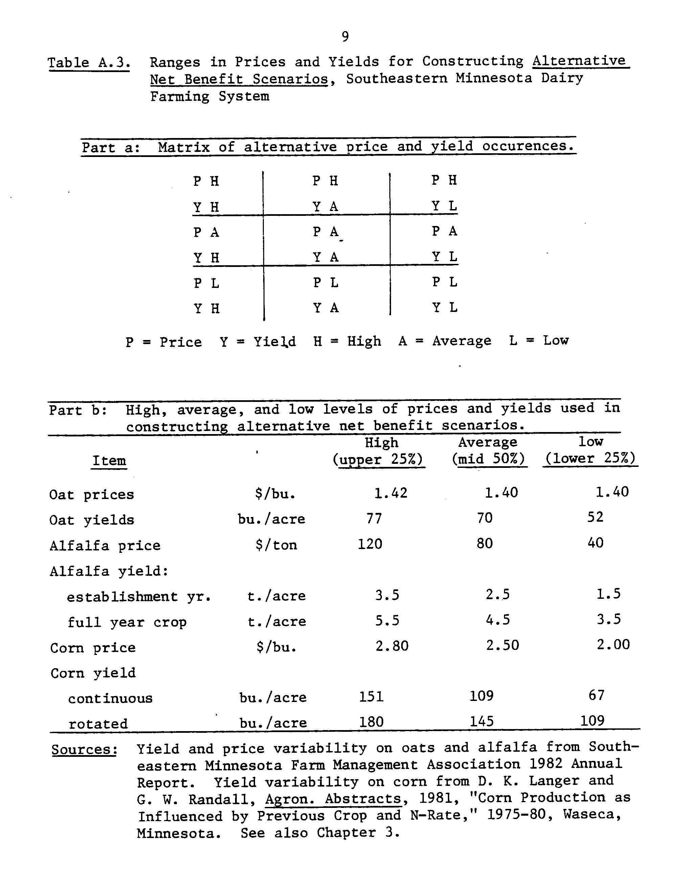
10
exclusively related to timing of planting and harvest, and are another aspect of time-related costs that partial budgeting cannot account for. The results are presented in Table A.4.
In four of the five scenarios, the rotation plan appears clearly more profitable than the continuous cropping. In the high-yields, low prices scenario, the continuous corn technique is slightly more profitable. This is due to the extreme range in the alfalfa prices from high $120/ton to a low of $40/ton. Conversely, the stability of yields in rotation with alfalfa is the main reason for the higher profitability of rotation corn even under the low price, low yield situation.
This exercise could lead on to wonder why, if rotating corn with alfalfa could be so profitable, is it not clearly the technique of choice? The exercise also gives the evidence as to why partial budgeting or "net benefit" approach is not a sufficient technique to assess the value of crop rotation with legumes. The problems of (1) lack of time dynamics, (2) inability to account for variations in costs/prices due to scarcity or abundance, and (3) the constraints on computation complexity (to be discussed) are serious drawbacks.
This partial budgeting approach also assumed a market for alfalfa which does not actually exist. An alternative to an alfalfa market is to integrate the activity of crop production with a livestock operation, (as is common in Southeastern Minnesota). But the complexity of the calculations of the transfer of alfalfa as feed for the livestock operation and the evaluation of the net benefit contribution from the rotation with alfalfa would become untenable in a partial budget.
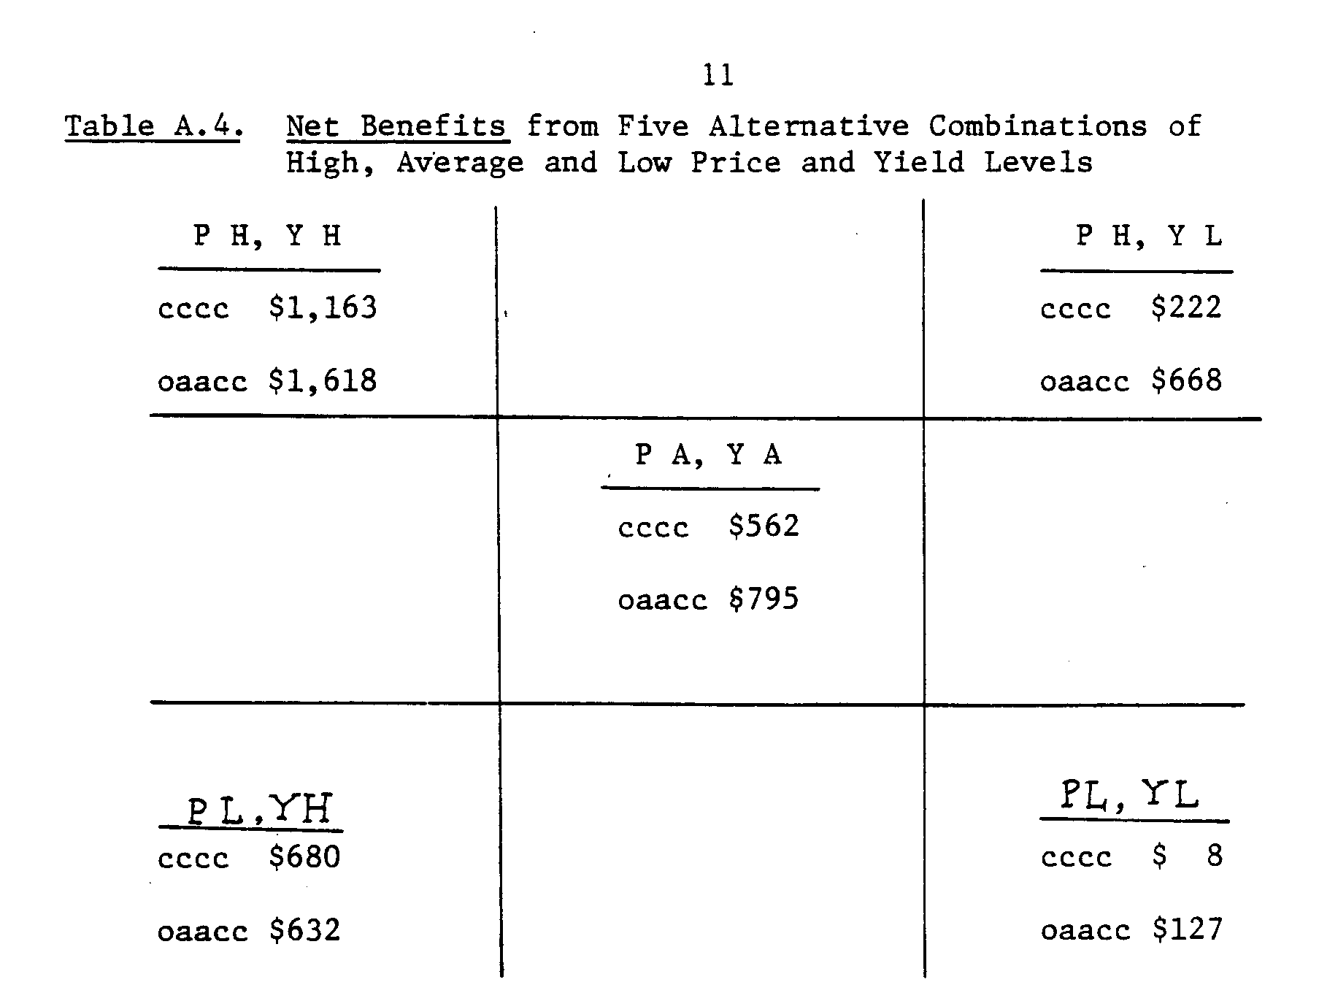
12
Another serious oversight of partial budgeting is that the flow of labor services are considered unbounded. Alfalfa harvest requires labor during the summer when other activities do not require labor. But the planting operations occur during the spring when all cropping activities compete for the available labor. To adequately assess the farm problem, an algorithm is needed that will evaluate labor values among each cropping activity during periods of excess demand and allocate labor where it would be most profitable.

Summary
The gross-benefit approach to evaluating the dollar benefit of biological nitrogen fixation over-simplifies the cost/benefit picture of legume cultivation so much that very relevant factors are obscured and ignored. The partial budgeting "net benefit" technique is based on unrealistic assumptions in the attempt to make the complicated integrated farm system problem setting tractable. Neither approach captures the full range of benefits to a farming system which result from integrating nitrogen-fixing legumes with other crop and livestock activities. Neither approach provides an estimate of the cost of fixed nitrogen.
It is thus demonstrated that a more.sophisticated analytical approach is required to assess the value of BNF for a farmer. This approach must be able to consider many integrated production activities simultaneously. Costs and revenues must be summed for a clear net benefit estimate. The approach must account for use of legumes as a food or feed, and/or accurately reflect market conditions for legumes.
13
The opportunity costs (shadow prices) must also be considered⁻. And in order to evaluate the required flow resources (e.g., labor), some type of time-disaggregated distinctions for each such resource should be incorporated. One such analytical approach is goal-oriented math programming. An example of math programming is presented in this M.S. thesis.
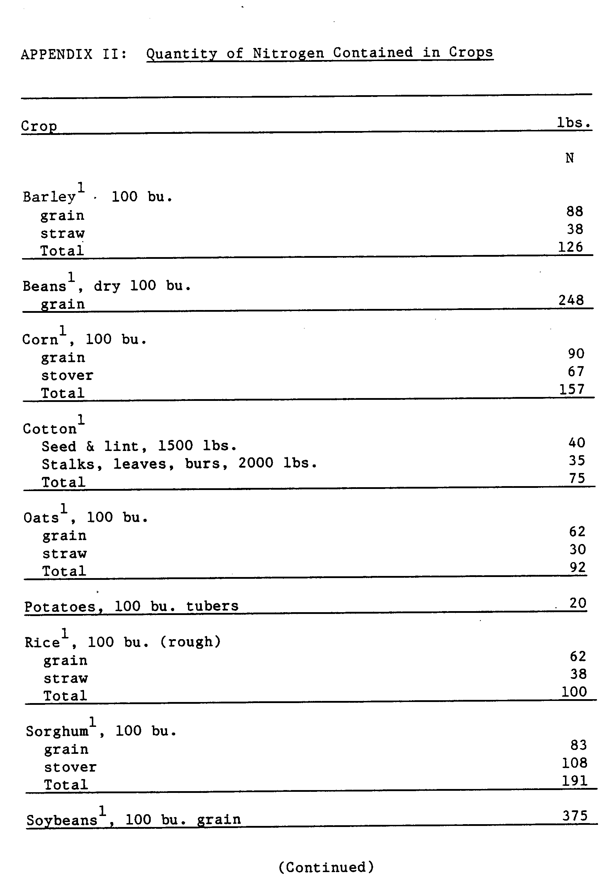
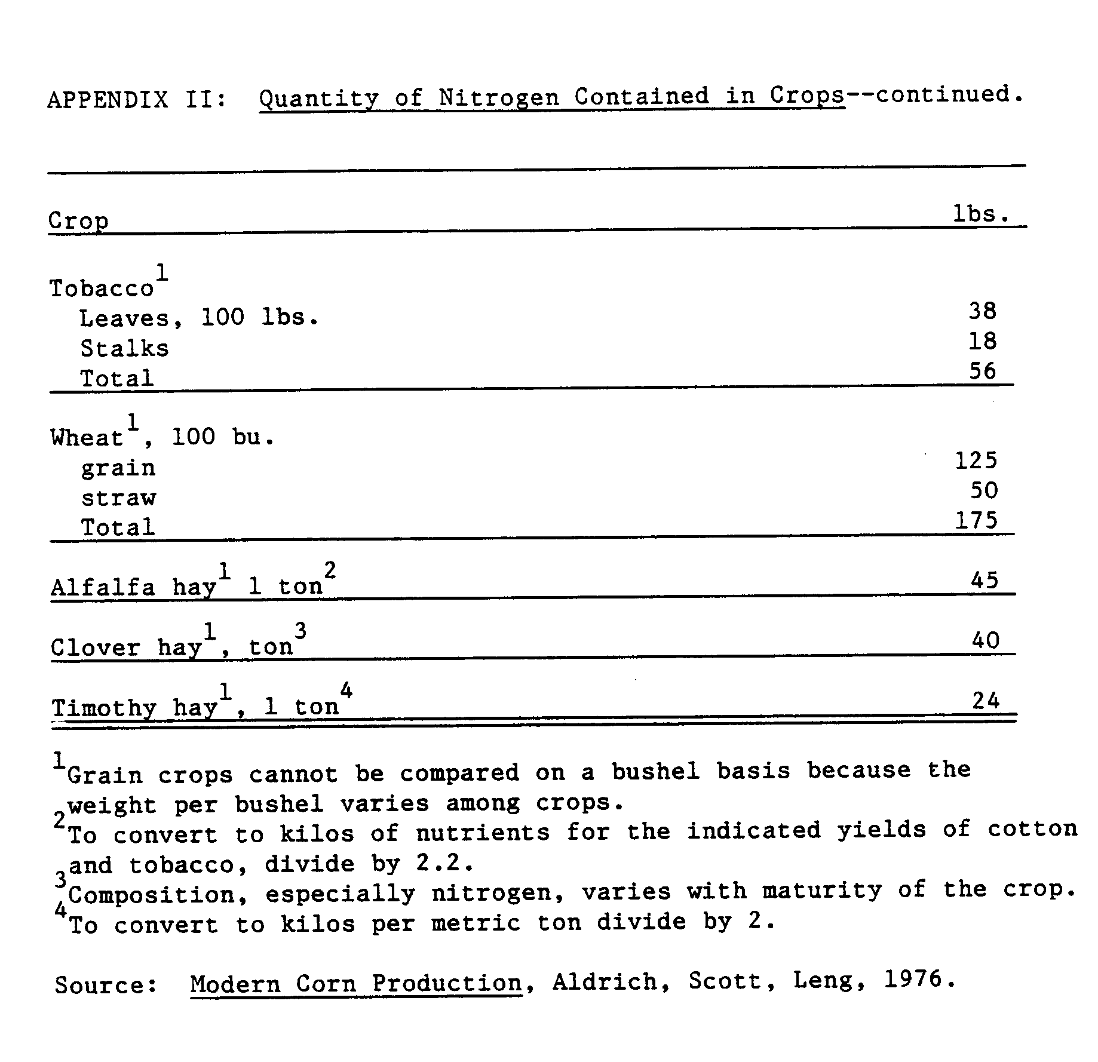
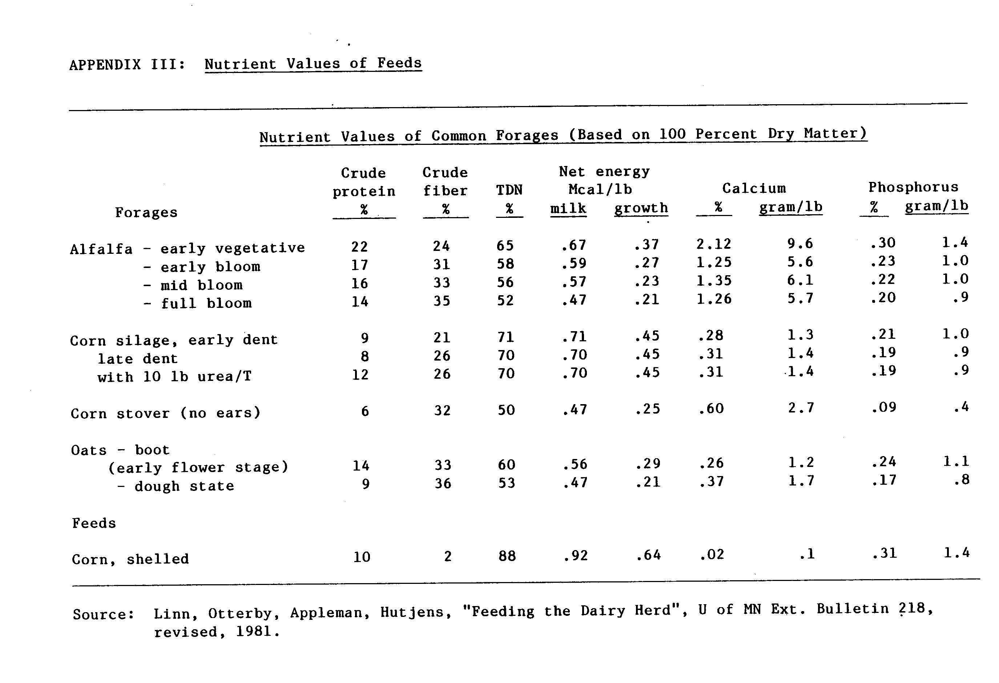
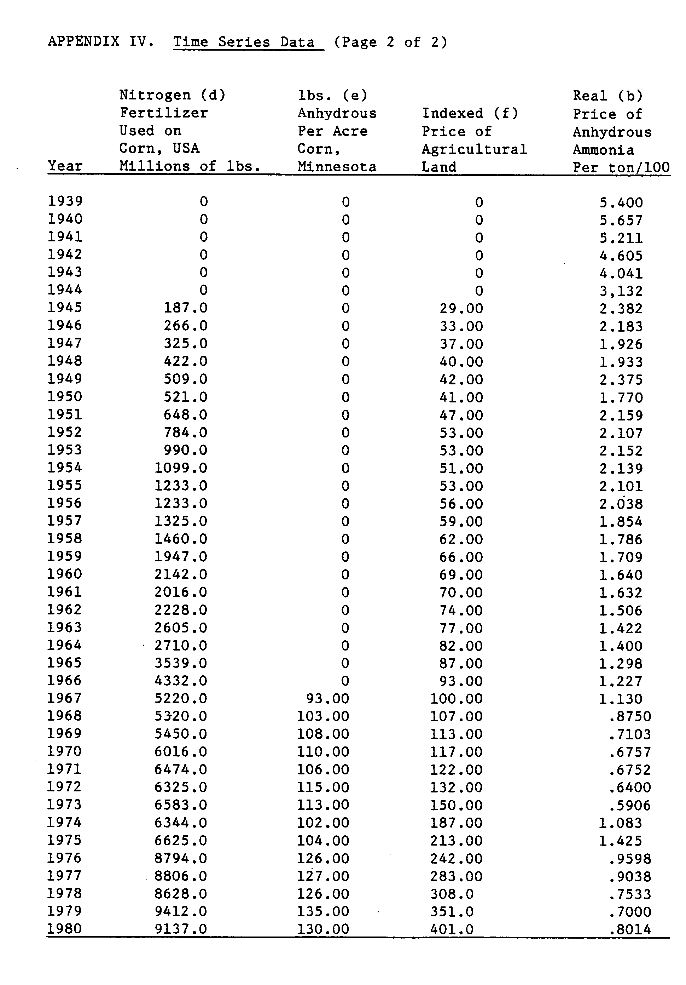
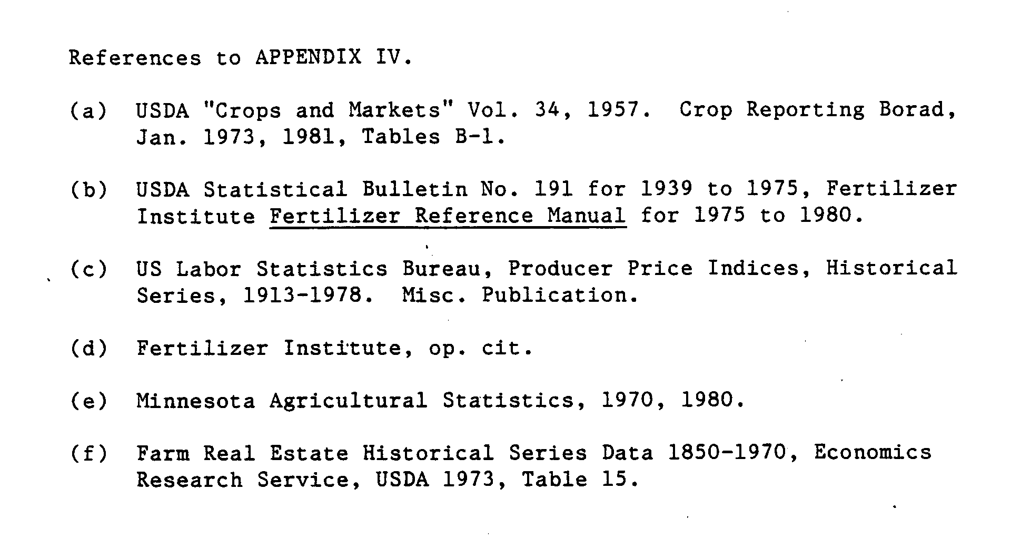
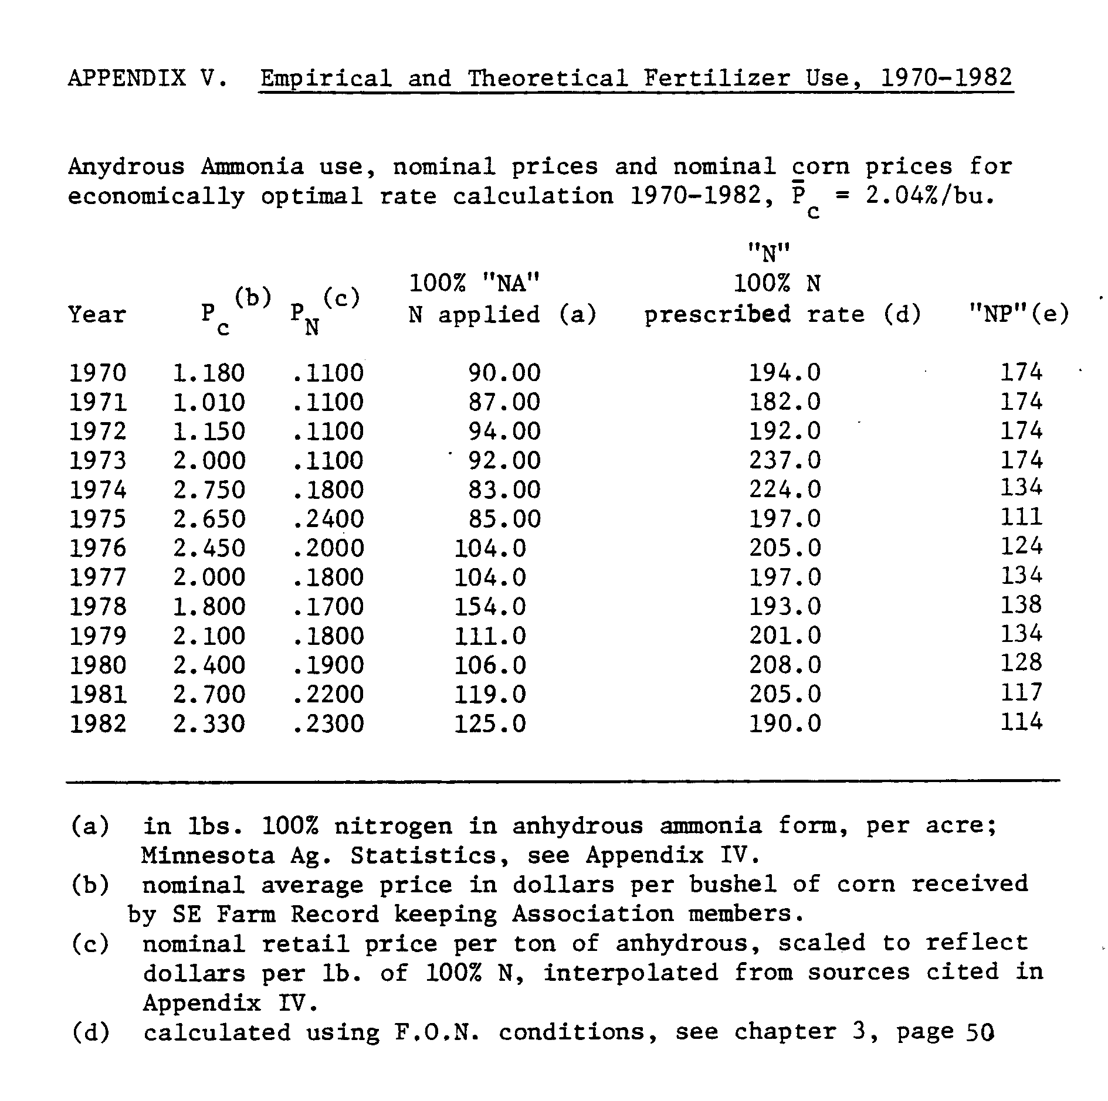
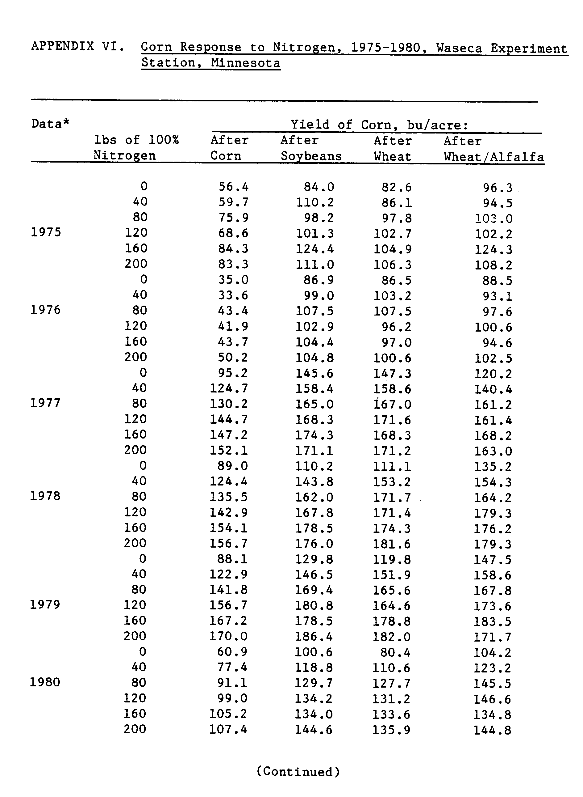
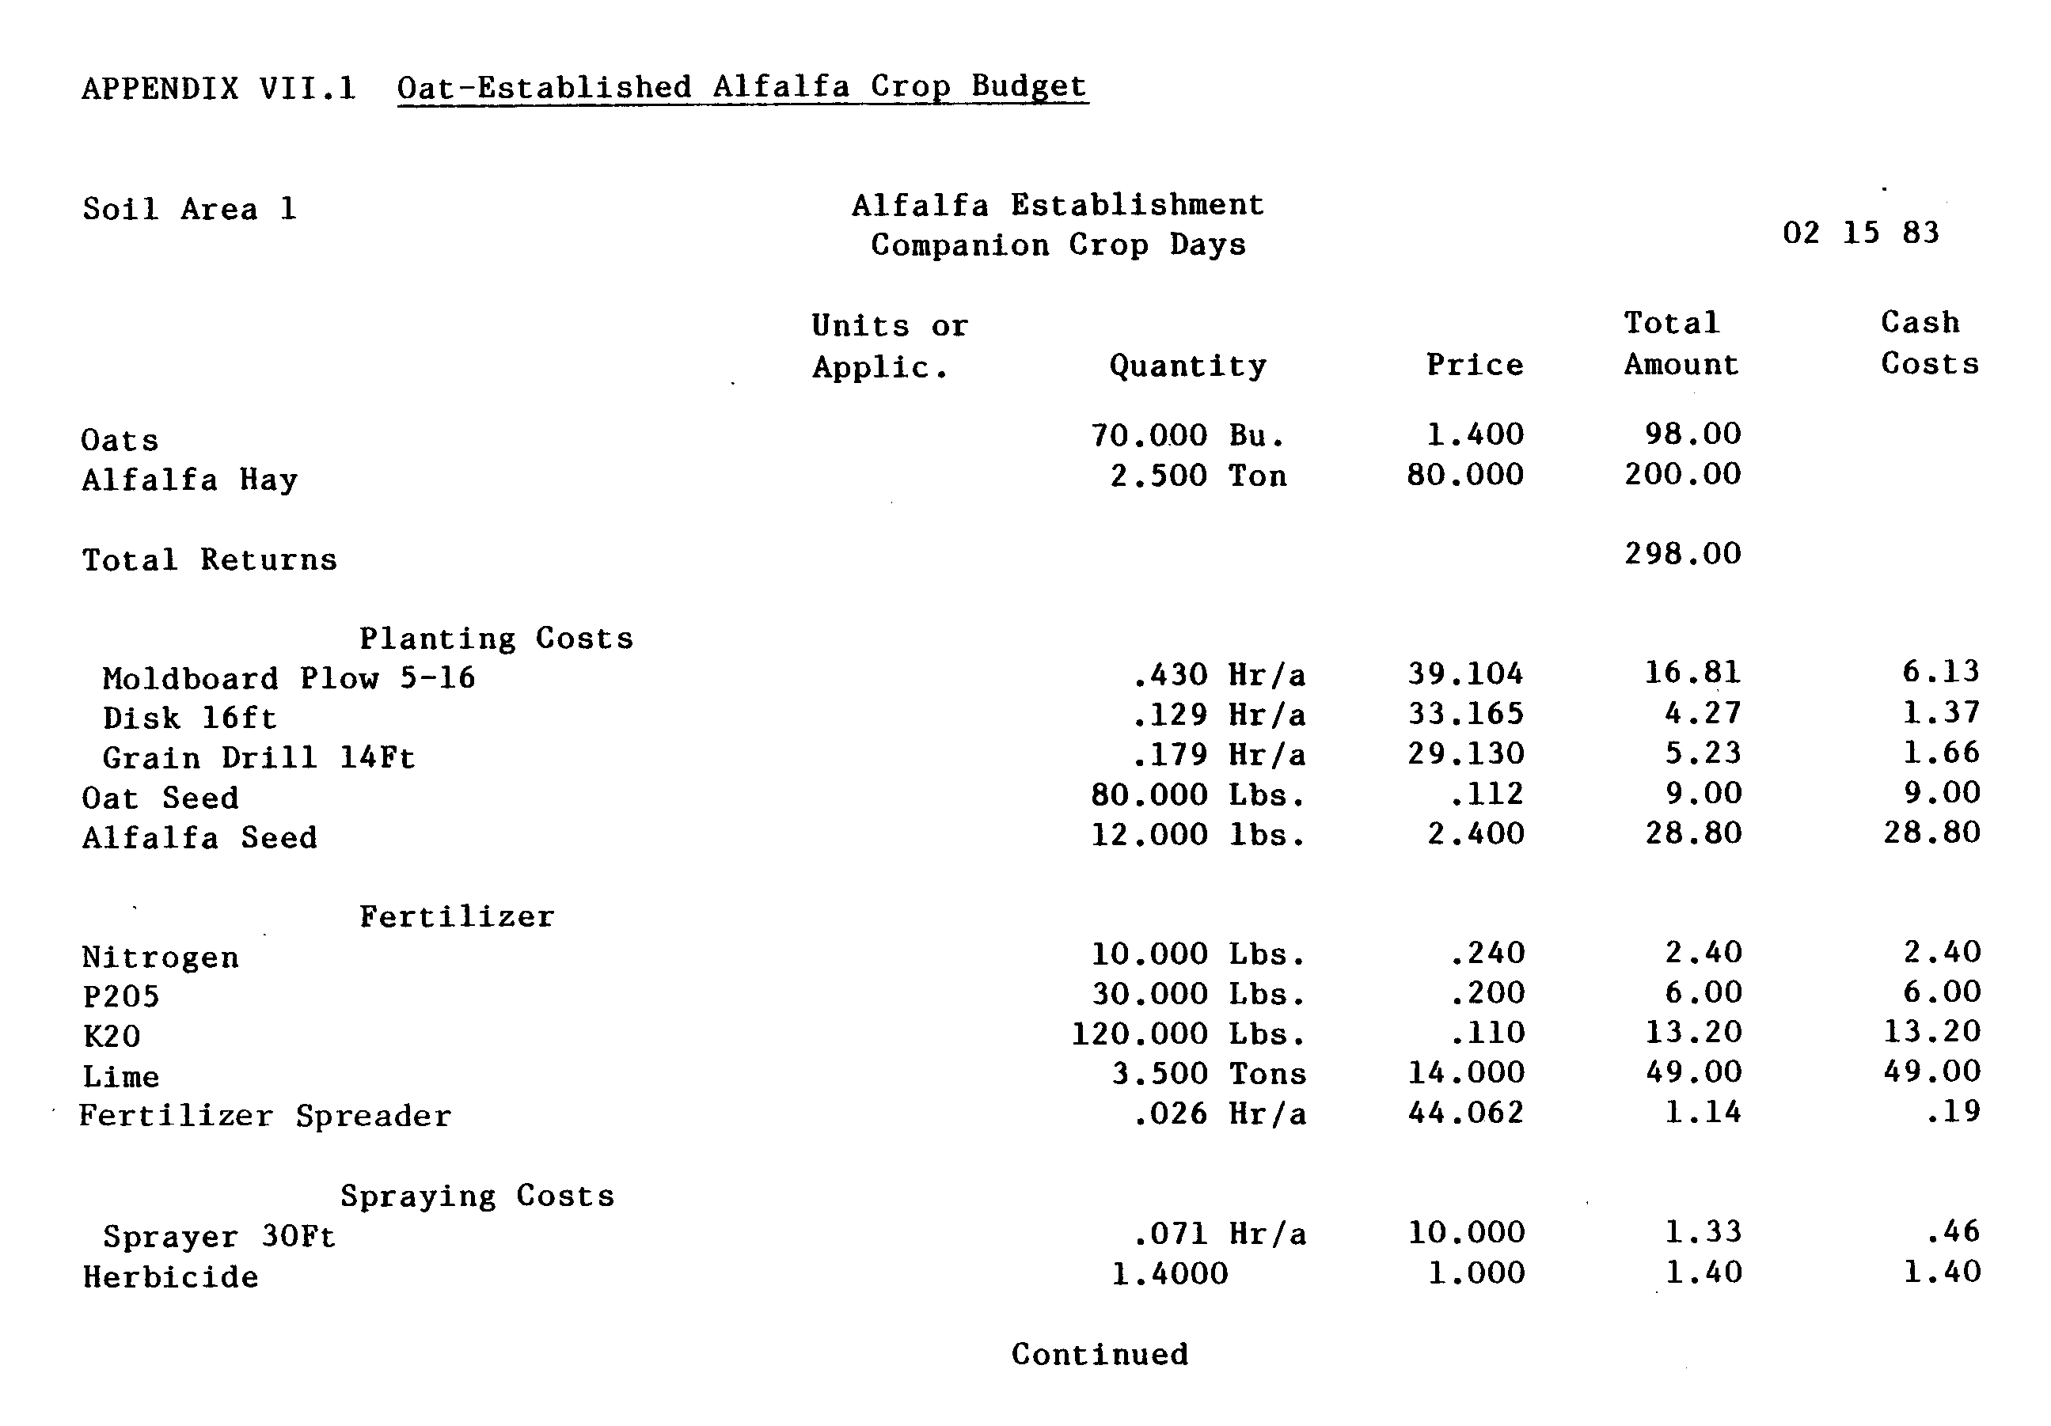
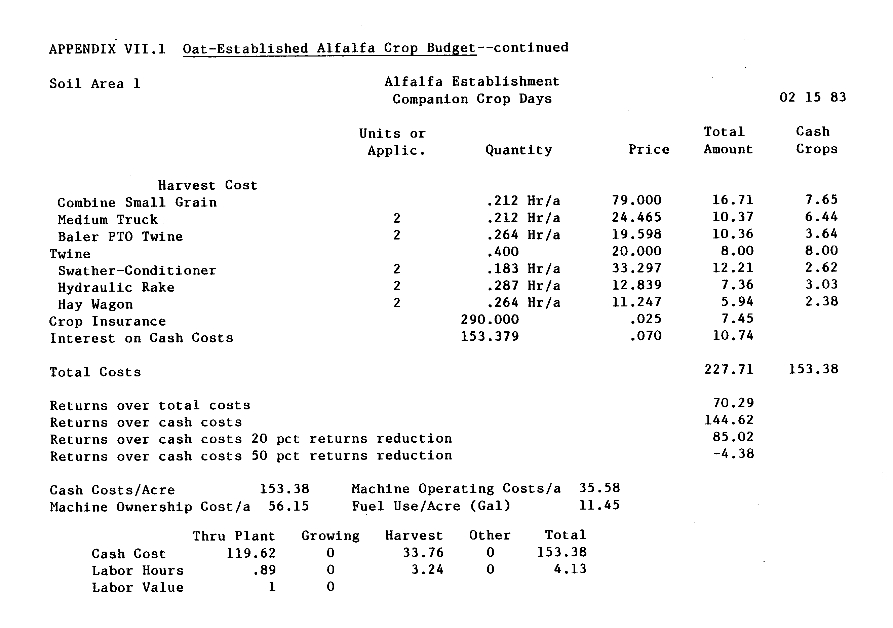
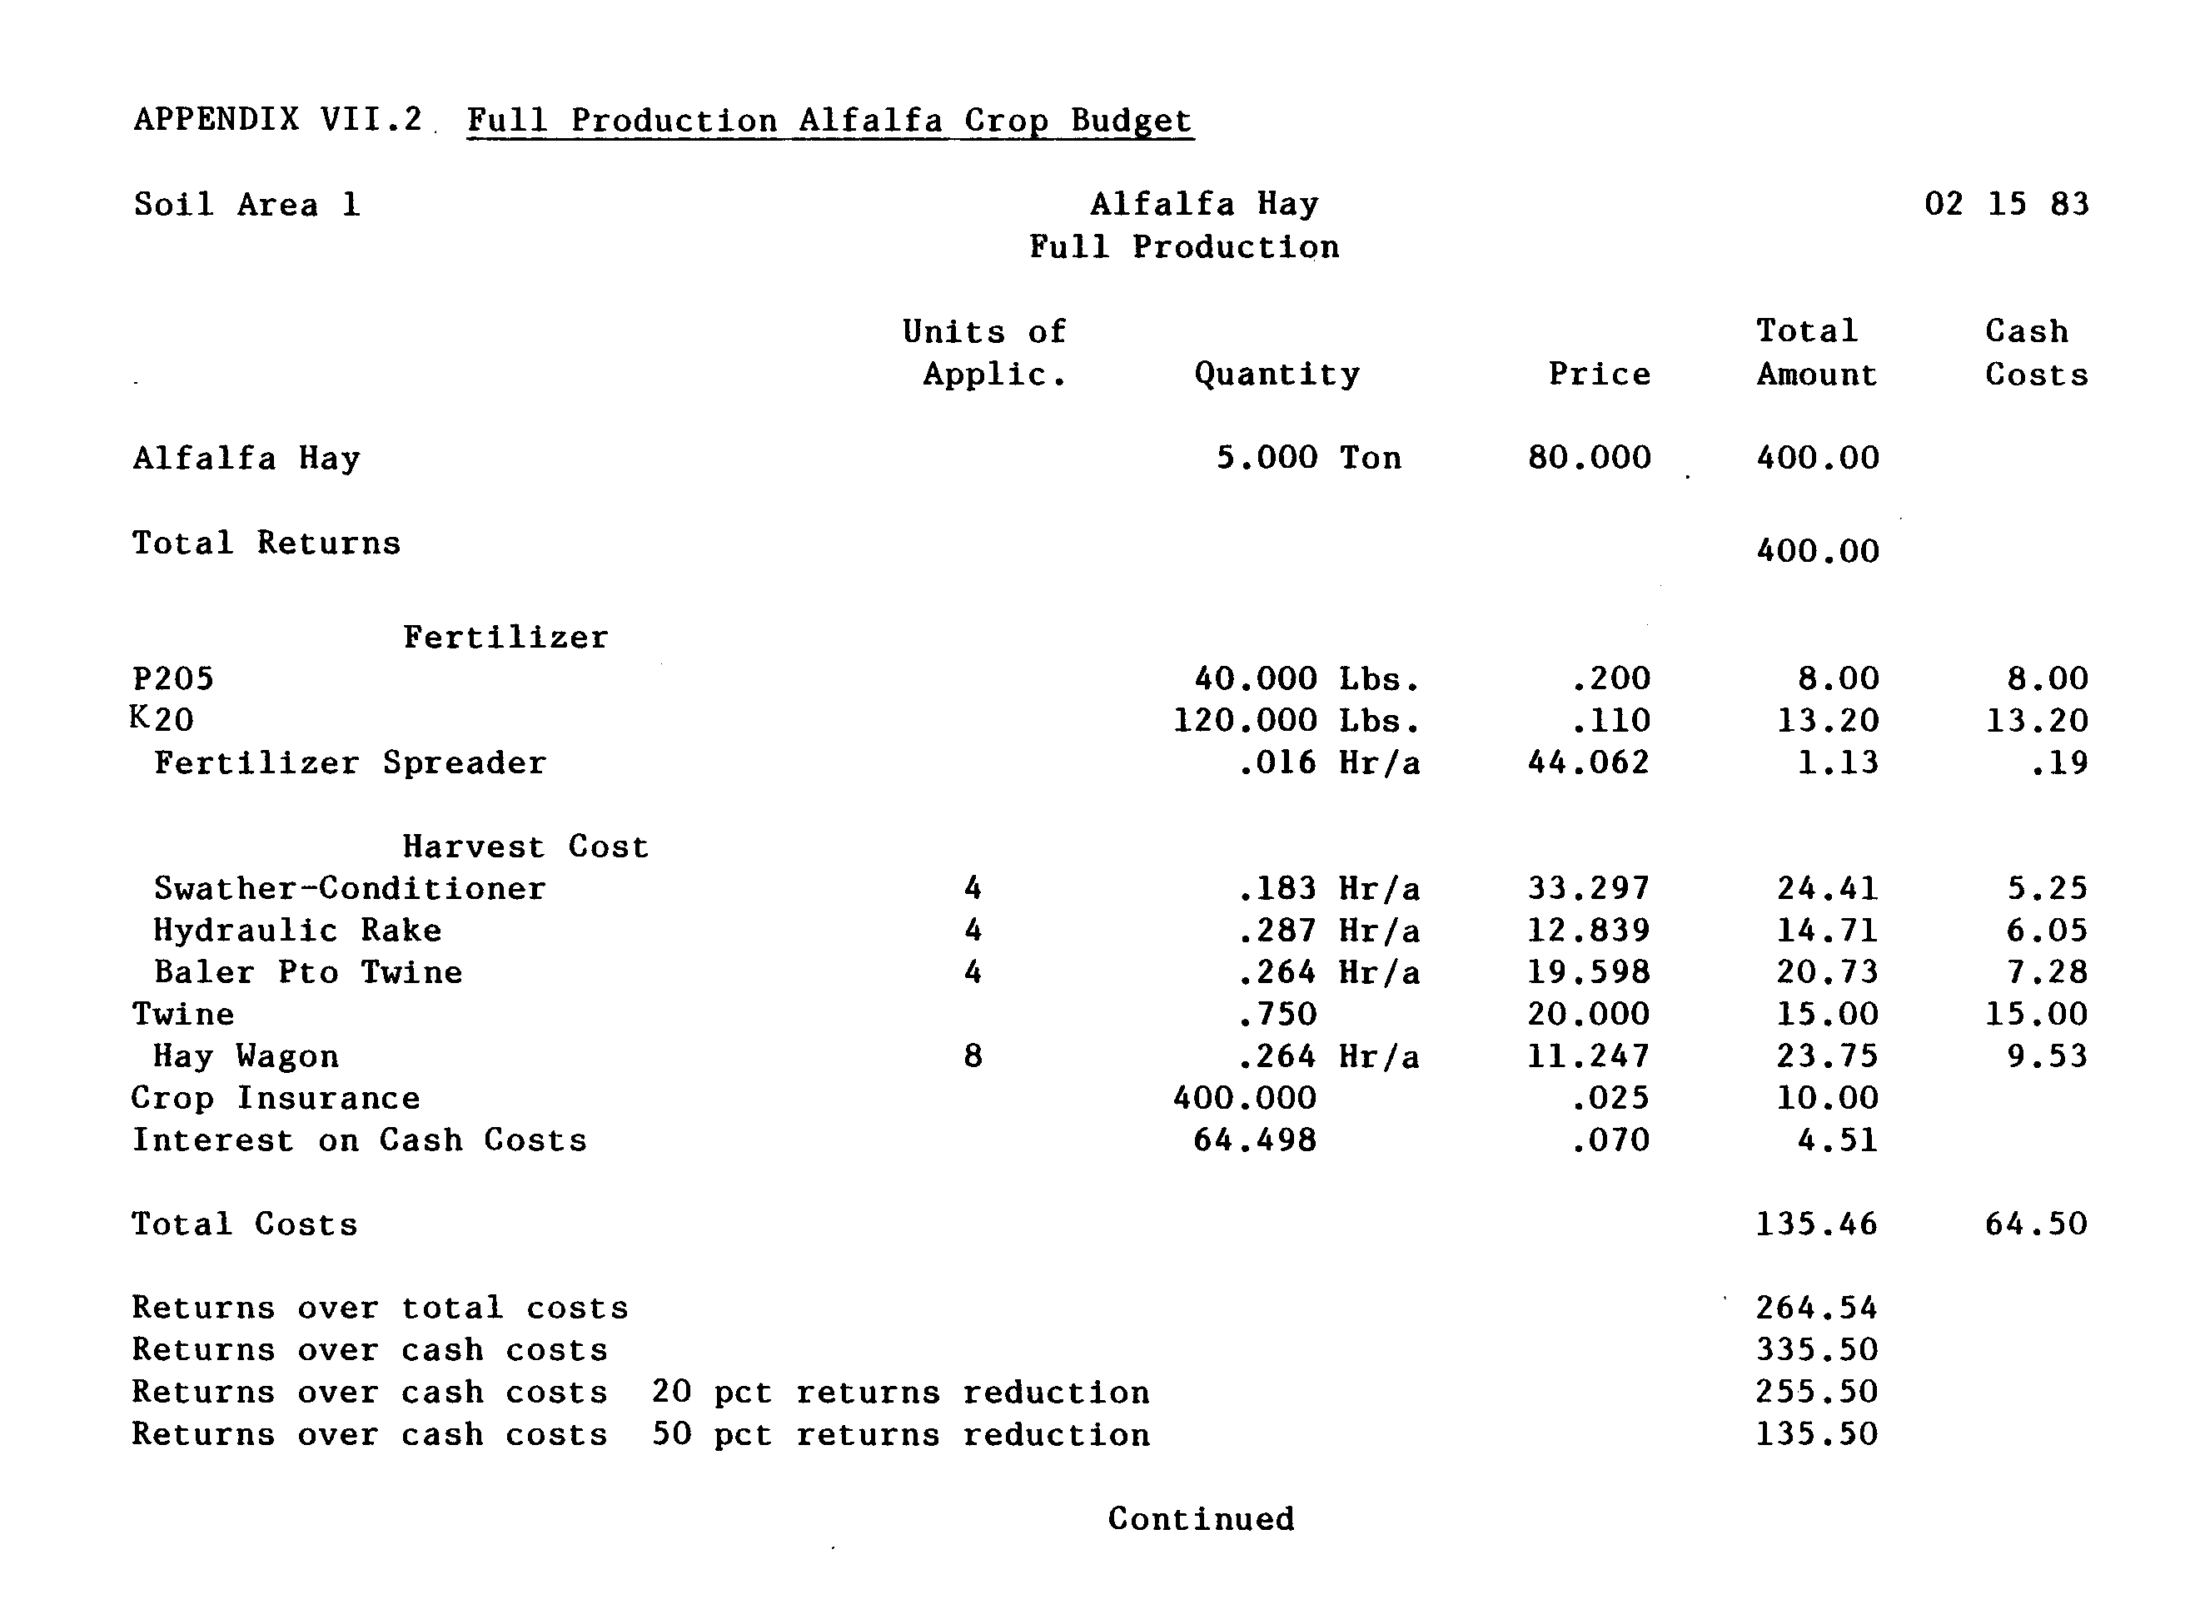
APPENDIX | VIII.1 Time | Disaggregations--Production Periods
Period | First day | Last day
Number | of year | of year | Period
1 | 74 | 87 | March 15 - March 23
2 | 88 | 101 | March 29 - April 11
3 | 102 | 115 | April 12 - April 25
4 | 116 | 129 | April 26 - May 02
5 | 130 | 136 | May 03 - May 09
6 | 137 | 143 | May 10 - May 16
7 | 144 | 150 | May 17 -  May 23
8 | 151 | 158 | May 24 - May 30
9 | 159 | 172 | May 31 - June 13
10 | 173 | 186 | June 14 - June 27
11 | 187 | 200 | June 28 - July 11
12 | 201 | 214 | July 12 - July 25
13 | 215 | 228 | July 25 -  August 08
14 | 229 | 242 | August 09 -  August 22
15 | 243 | 256 | August 23 - September 05
16 | 257 | 270 | September 06 - September 19
17 | 271 | 284 | September 20 - October 3
18 | 285 | 298 | October 04 - October 17
19 | 299 | 312 | October 18 -October 31
20 | 313 | 326 | November 01 - November 14
21 | 327 | 342 | November 15 - November 30

Hours available on good field days
APPENDIX VIII.3 Time Available on Good Field Days, Flow Resources
APPENDIX VIII.4 Planting/Harvest Timing
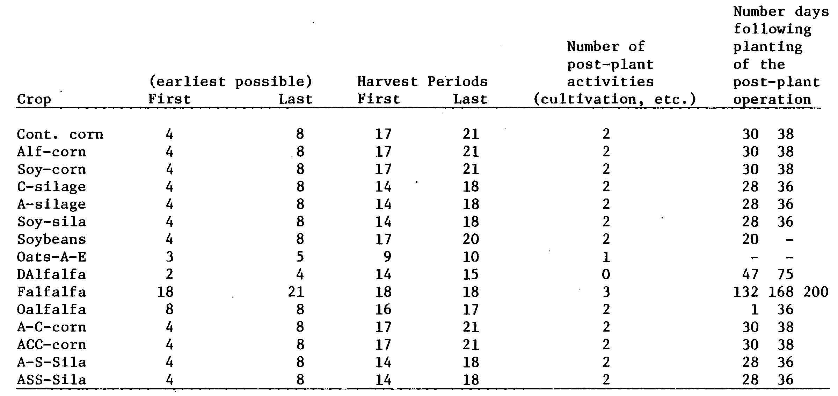
APPENDIX VIII.5 YIELD AND MOISTURE MATRICES, CORN AND SOYBEANS Corn grain
Yield coefficient matrix by planting and harvest dates:
#9 soy acreage must exceed silage or corn in soy rotations

S-corn + S-silage < soybean acreage RHS
+1 +1 -1 ≤ 0

#10 corn rotated with either directly-seeded establishment year alfalfa or full production year alfalfa,cannot exceed the alfalfa acreage

A-corn + A-silage _< D-S alfalfa + full alfalfa
+1 +1 -1 -1 ≤ 0

#11,12 Oats for alfalfa establishment must be equal to alfalfa oat-est.
OEA = oats

+1 -1 ≤ 0
-1 +1 ≤ 0

#13 Full crop alfalfa cannot exceed establishment year alfalfa

FA < OEA + DAlf
+1 -1 -1 ≤ 0

#14 Second year rotated corn cannot exceed first-year rotated corn

ACC + ASS ≤ AS + AC
+1 +1 -1 -1 ≤ 0

Continued
APPENDIX X.2 Dairy Gross Margin
1981 records data: $+2078 gross return per producing cow

$-209 direct costs net of feed per cow

$+340 revenue per head in replacement herd

for 1982 subtract 4% off GM due to government milk penalty of .51¢ a cwt down from $13.42/cwt:
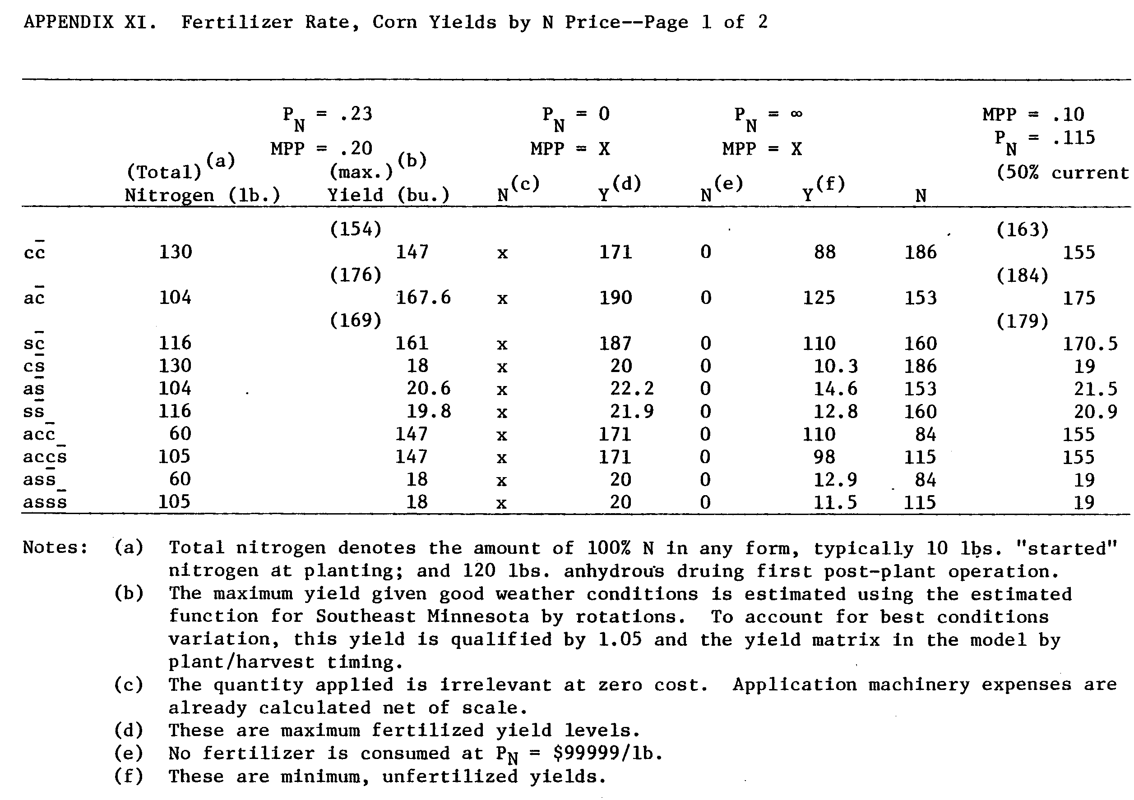
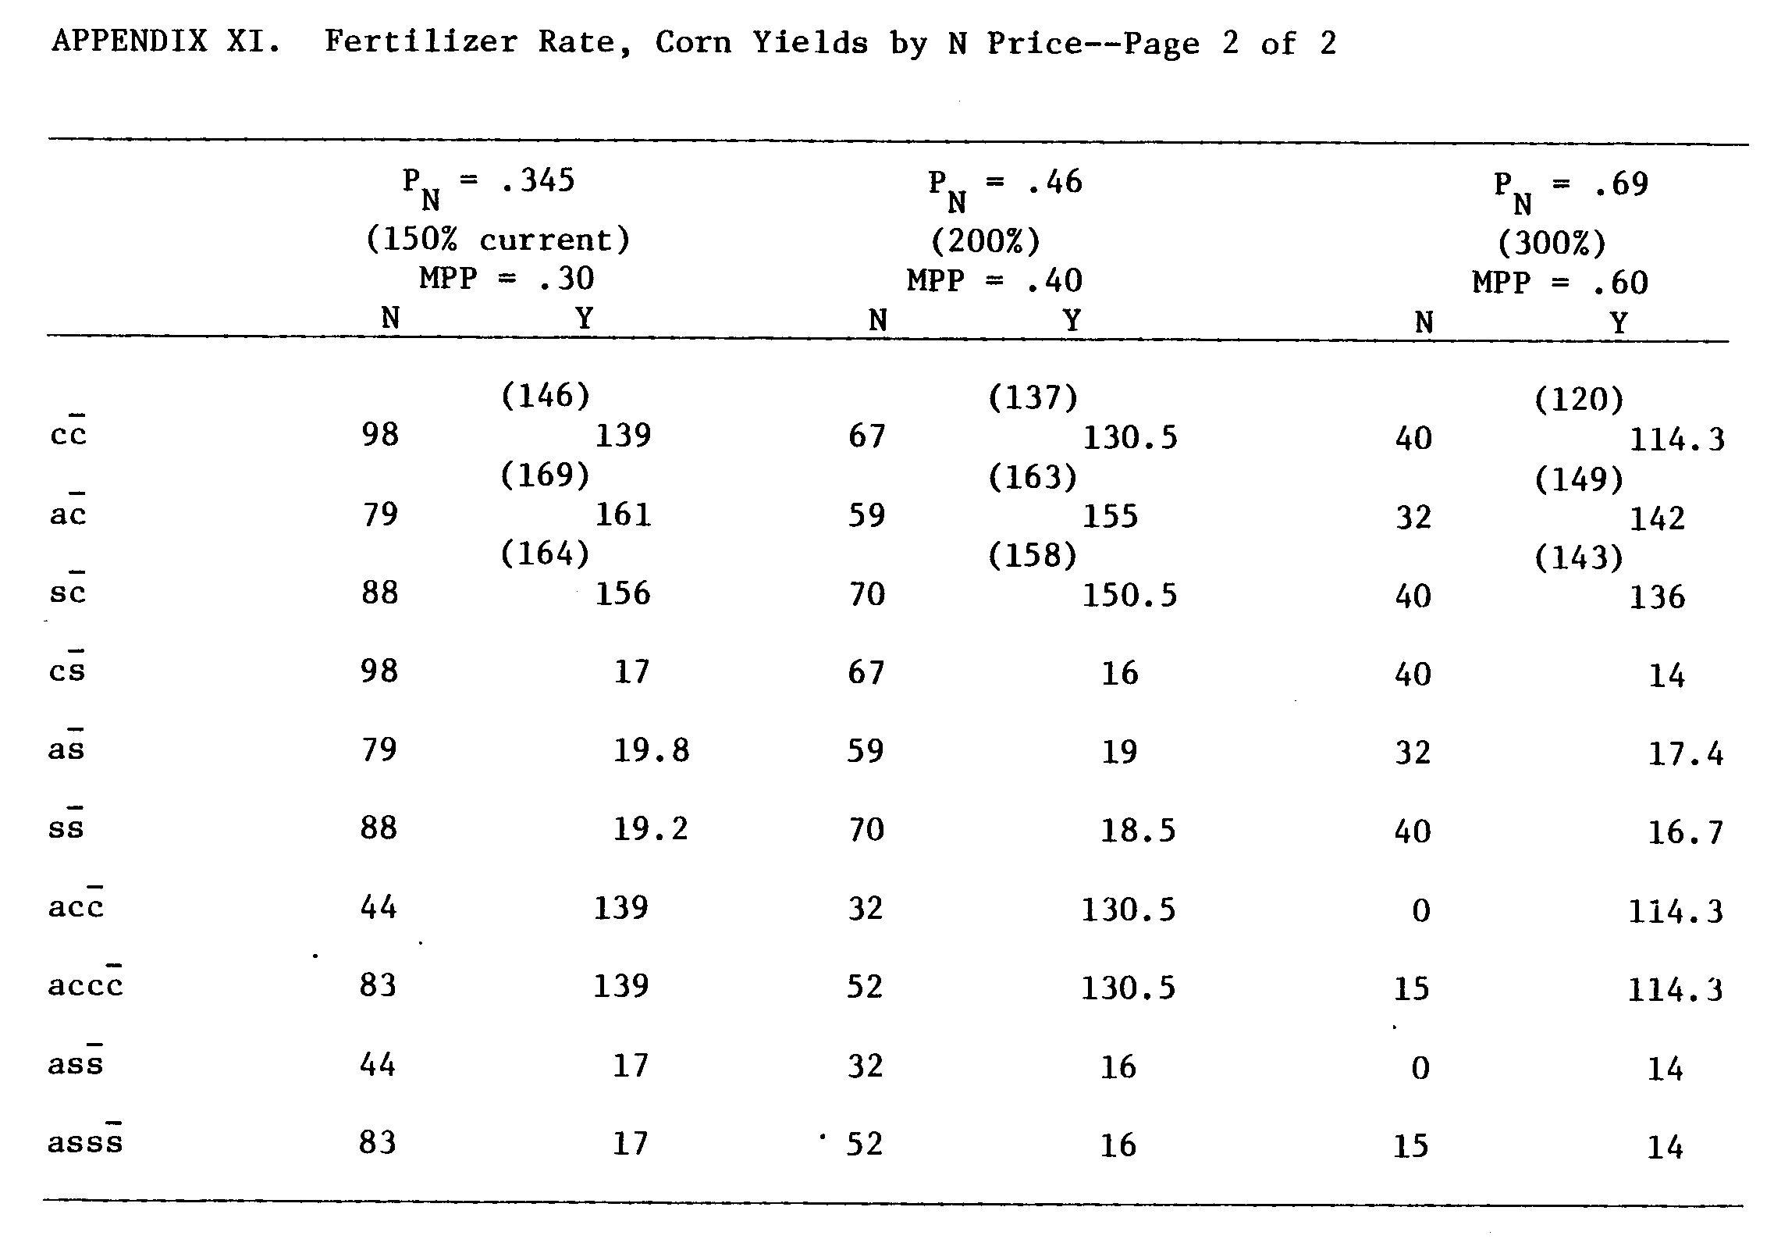
APPENDIX XII. Marginal Physical Product of Nitrogen for Corn

The Marginal Physical Product of Nitrogen for Corn by Rotation

Misterlich - Spillman response function
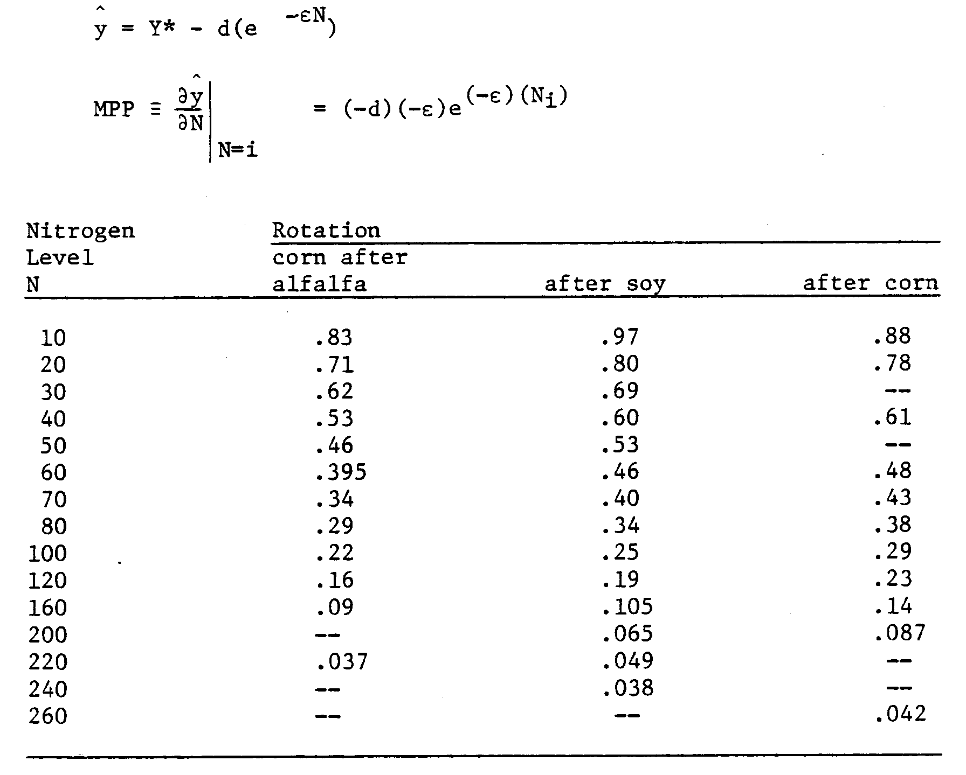
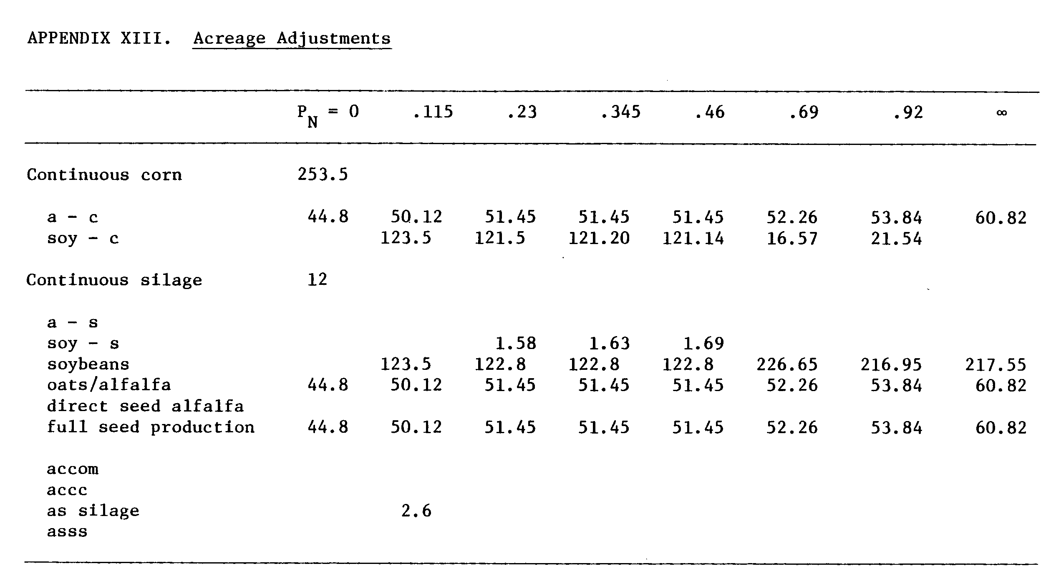
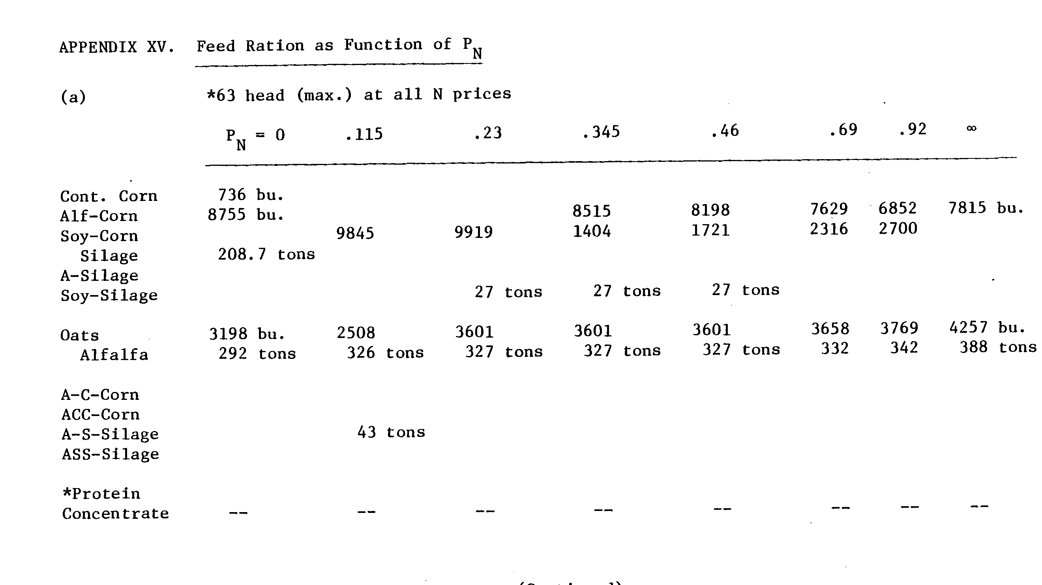
APPENDIX XIV. Total Farm Nitrogen for Corn Production by Source
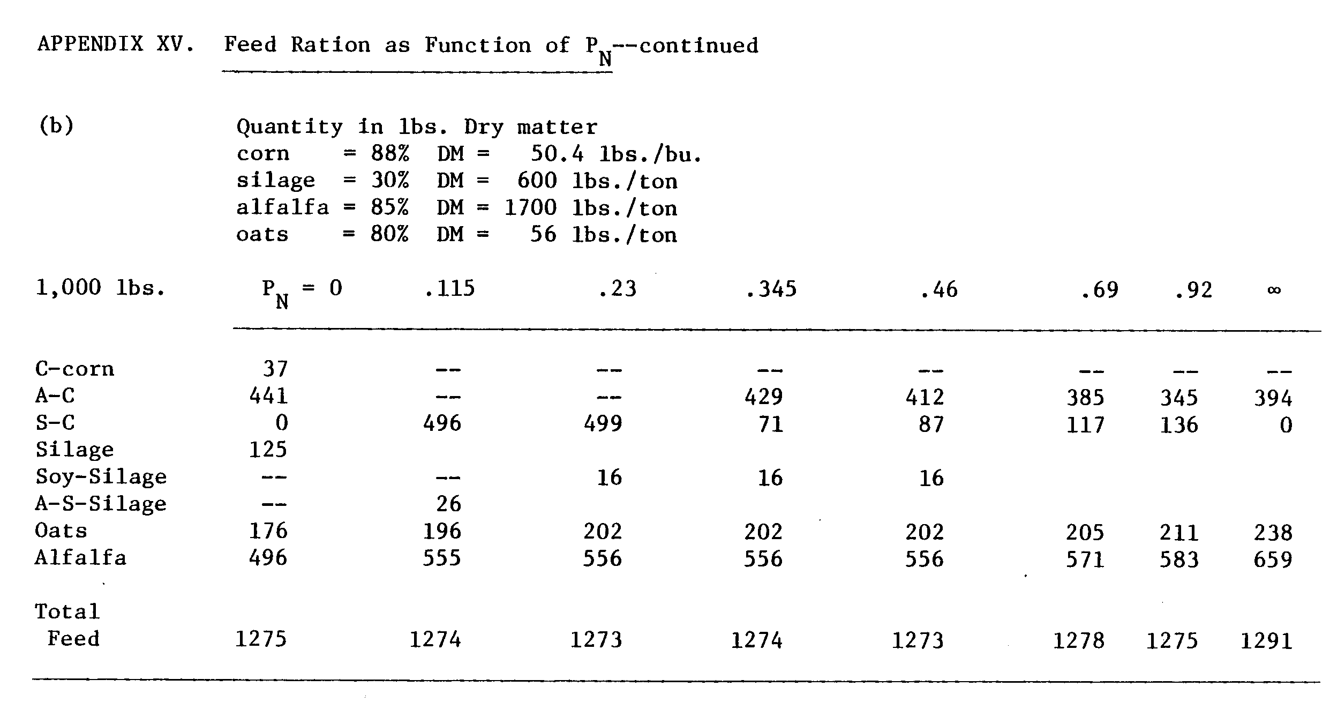
ANNOTATED BIBLIOGRAPHY
Ackoff, R.L. "Systems, Organizations, and Interdisciplinary Research", General Systems Yearbook, Vol. 5 (1960) Society for General Systems Research, pp. 1-8.
see Emery, F.E. for annotation
Ahmed, Saleem. "Projected Nitrogen Needs in the Year 2000 and Alternative Supply Sources." Draft of working paper, East-West Center, 1982. Projects nitrogen needs as a function of food demand, i.e., population growth in terms of global aggregate data, and lists current knowledge of production, distribution, and alternatives-A nice categorization. Highlights BNF as on-point, legume and rice production increasing innovation. No analysis or recommendations.
Allos, H. F., and W. V. Bartholomew. "Replacement of Symbiotic Fixation by Available Nitrogen." Soil Science, 1959, Vol. 87, pp. 61-66, No. 2, February.
The early comparative study using ¹⁵N tracers to determine the effect of inorganic nitrogen on N-fixation. Two postulates which still hold were shown: 1) fertilizer nitrogen resulted in increased growth of the legumes and 2) this stimulated growth and concommittently the need for fixation, but high levels of fertilizer nitrogen replaced the fixation process.
Anderson, J., J. Dillon, and B. Hardacker. Agricultural Decision Analysis.
Apland, J. ROMP-FS1 Documentation. Staff Paper P83-17, August 1983, Department of Agricultural and Applied Economic, St. Paul, MN.
A guide to use and applications of a time disaggregated research oriented mathematical programming model ROMP-FS1. Explains design, structure and includes data format sheets, plus exemplary problem. Terse, yet highly recommended for modelers.
Baker, T. G., and B. A. McCarl. "Representing Farm Resource Availability Over Time in Linear Programs: A Case Study." North Central Journal of Ag. Economics, Vol. 4, No. 1, January 1982, p. 60.
The study explores the consequences of different degrees of time aggregation in L.P.'s on responsiveness to parameter changes in the context of risk. Higher aggregation - more responsive over-exaggerated importance of risk. Time aggregation requires average crop data so obscures and/or eliminate time-related reasons for crop selection and/or diversification, i.e., more crop specialization.
Baldock, Jon 0., R. L. Higgs, W. H. Paulson, J. A. Jakobs, and W. D. Shrader. "Legume and Mineral N Effects on Crop Yields in Several Crop Sequences in the Upper Mississippi Valley," Agronomy Journal, Vol. 73, 1981,
p. 885-890.
What is the unidentified "rotation" affect (or "legume") affect? Over ten years of rotations conducted at Lancaster Wisconsin provide data for estimating the difference between predicted continuous corn yields and rotational corn yields. The nitrogen effect on CCCOA was found to be equivalent to 51 kgN/ha and the legume effect approximately 9.4 quintals/ha.
Banta, G. R. "Information Required to Design and Test for Economic Criteria," in Report of the Cropping Systems Working Group, 4th Cropping Systems Meeting, IRRI, Los Banos, Philippines, 1976.
Short and limited in scope; a simple-prescription of the gross categories of data useful in quantifying some applied economic ' questions about new cropping technologies.

Barber, S. A. "Relation of Weather to the Influence of Hay Crops on Subsequent Corn Yields on a Chalmers Silt Loam," Agronomy Journal, 1972, Vol. 64, pp. 8-10.
Reiterates and adds documentation to positive rotation effect. Relates effect of previous alfalfa crop on corn yield to the weather during corn growth. Continuous corn displayed phytotoxicity under residues, aggravated by higher temperatures, low aeration and infiltration. With lower than average precipitation alfalfa has a more positive rotation effect on corn.

Barker, R., H. E. Kaufman, and R. W. Herdt. "Production Constraints and Priorities for Research." IRRI Agricultural Economics Department Paper No. 75-8, 1975.
Highlights IRRI's rice program, but useful in developing an approach to explain the "yield gap", partitioned among technical, cultural and environmental factors.

Barnes, Gordon. "Insect Control." Part one in series "Crop Rotation vs. Monoculture" in Crops and Soils, Vol. 32, No. 4, p. 15, 1980.
The first in a series of six articles for laymen on the question of rotations. The articles claim inspiration from recent responses to rising energy costs, new environmental laws, product scarcities, and other problems, to take a new look at rotations.

Bauer, F. C. "Nitrogen Problems in the Midwest." Soil Science Society of America, Proceedings, 1942, Volume 7, p. 301-308.
A period piece about nitrogen nutrient maintenance in the corn belt. Historical facts cited: corn and wheat received the largest amounts of N_{f} in the early forties. Yet 72% of the Corn Belt corn crops’ nitrogen needs were met by noncommercial sources: manure and legume nitrogen. To offset impact of wartime shortage, rationing of N_{f} is suggested for hybrid corn and then "starter N" uses. Crop rotation was held in highest regard as the most efficient soil nutrient preserving mechanism. Typical rotations are discussed in detail.

Baum, E. L., E. 0. Heady, J. T. Pesek, and C. G. Hildreth. Economic and Technical Analysis of Fertilizer Innovations and Resource Use. Iowa State University Press, 1957.
Seminar papers for TVA sponsored symposium dedicated to greater fertilizer use efficiency are the content of this primer book. Two vanguard papers by C. Hildreth raise the relevance of soil test analysis and use of LPs, respectively.
Backer, G.S. Economic Theory. Alfred A. Knopf, Inc., 1971.
Intended to serve as a first year graduate text (it has been superceded by more rigorous and less wordy efforts), this book contains a detailed discussion of derived demand for factors of production (in Chapter 8) and substitution among factors. The prose is not esoteric and the maths are basic, therefore it’s recommended to non-economists.
Benson, F. J. "A Comparison of Corn Storage Costs..." 1982, photocopy.
Benson, F. J., and S. Waldorf. "1982 Custom Rate Estimates for Minnesota." Ag. Extension Service, University of Minnesota, Extension Folder 590. Benson, F. J., J. A. True, and C. A. Miller. "Economic Comparisons of Hay Harvesting..." University of Minnesota, Ag. Extension Service, Extension Folder 246. 1976.
Compares various hay systems on basis of costs and losses. Identifies feasible systems for different herd sizes, specifically; approving of conventional hay baling for herds requiring 250 tons of hay per year or less.
Benson, F. J., and S. Waldorf. "Minnesota Farm Machinery Economic Cost Estimates for 1982." Ag. Extension Service, University of Minnesota, Extension Folder 589.
Blake, George R. "Crop Rotation vs. Monoculture: Soil Physical Properties," Crops and Soils, Vol. 32, No. 6, p. 10, March 1980. (Part three in series, see Barges, G.)
Boawn, L. C., J. L. Nelson, and C. L. Crawford. "Residual Nitrogen from NH NO₃ Fertilizer and from Alfalfa Plowed Under," Agronomy Journal, 1993, Vol. 55, pp. 231-325.
Residual legume nitrogen is herein documented to be equivalent to 70-90 lbs./acre of N_{f} commercial for corn.
Boisvert, R. N., and H. R. Jensen. "A Method for Farm Planning Under Uncertain Weather Conditions with Application to Corn-Soybean Farming in Southern Minnesota." Ag. Experiment Station, University of Minnesota, Technical Bulletin 292, 1973.
Includes a method for specification of available field-work days.
Bolton, E. F., V. A. Dirks, and J. W. Aylesworth. "Some Effects of Alfalfa, Fertilizer and Lime on Corn Yields in Rotations on Clay Soil During a Range of Seasonal Moisture Conditions," Canadian Journal of Soil Science, 56, 1976, pp. 21-25.
Documents positive rotation effect over years despite weather variation.
"Consistent response of rotations over years despite variation in seasonal suitability for corn production, indicates the significance of use of rotation in a management program aimed at high yields."
Bolton, Perm, Cooke, Heagler. "Days Suitable for Fieldwork: Mississippi River Delta Cotton Area." Department of Agricultural Economics Research Report 384, Ag. Experiment Station, Louisiana State University, 1968.
Fieldwork days are a function of soil moisture content. Some variables used: rainfall, temperature, soil characteristics, crop type, wind, and relative humidity.
Boulding, K. E., and W. A. Spivey. Linear Programming and the Theory of the Firm. The Macmillan Co., New York, 1960.
A collection of seminar papers covering the mathematical aspects of linear programming and the relationships between theory of the firm and this tool of operations research. Particularly useful is Chapter 4 by Wu and Kwang concerning a comparison of neoclassical theory and math programming. This is a -thinking man's introduction to linear programming firm-level problems.
Bowbrick, P. "The Role of the Economist in Planning Applied Biological Research," Agricultural Administration, Vol. 3, No. 1, January 1976, pp. 11-15. (England)
The author proposes that the agricultural economist involves himself with 1) research priorities, 2) multidisciplinary research, and 3) theoretical research and dissemination of results. Anecdotal.
Brill, W. J. "Biological Nitrogen Fixation," Scientific American, March 1977, Vol. 236, No. 3, p. 68.
Summarizes basic research on mechanisms of BNF. Good background.
Broeshart, H. "Quantitative Measurement of Fertilizer Uptake by Crops," Netherlands Journal of Agricultural Science, 22(1974), p. 245.
Contrasts three methods to assess fertilizer uptake. "Crop yield" is not well justified due to experimental difficulty in obtaining yield curves. The direct methods "difference" and "isotope" are compared, the isotope method preferred because it avoids the incorrect specification of- control due to the defined "priming" effect.
Brown, W. G., and G. H. Arscott. "A Method for Dealing with Time in Determining Optimum Factor Inputs," Journal of Farm Economics, 1958, Vol. 40, No. 1-3, p. 666.
Discusses the application of general rule-of-thumb: the ratios among outputs to be used as inputs in the next period should be equal to the ratio required in that next period.
Brown, W. G., T. L. Jackson, and R. G. Peterson. "A Method for Incorporating Soil Test Measurement into Fertilizer Response Functions," Agronomy Journal, Vol. 54, 1 62, pp. 152-154.
Once the rate of nutrient availability is established and with knowledge of the yield x nutrient yield curve, the optimal fertilizer level can be determined.
Bureau of Agricultural Economics, "Fertilizer Materials: Price per Ton Paid by Farmers, United States, 1923 to Date." p. 37, Agricultural Prices, March 1953, Crop Reporting Board, USDA.
Buttel, F. H., W. Lockerets, M. Strange, and E. C. Terhune. "Energy and Small Farms: A Review of Existing Literature and Suggestions Concerning Further Research." Paper II, National Rural Center, _ Small Farms Project, 1980, Washington, D.C.
Summarizes and reviews empirical studies of 1) effects on production and resource use, 2) conservation recommendations, 3) economic viability of low-input ("organic") farming, and 4) explains recent trends in fertilizer use relative to other factors. Documents that no studies consider possibilities of new production functions-- for example, improved BNF.
Chowdhury, A., Earl Heady, and S. Bhide. "Optimum Crop Production and Resource Use Under Alternative Energy Prices and Agricultural Exports. A Separable Chance-Constrained Programming Analysis." CARD Report 103, Iowa State University, 1981.
A macro-economic quadratic programming model is used to simulate partial equilibrium adjustments in major export grain industries resulting from changing energy situation. Does not look at crop rotations or legumes.
Christensen, D. A., R. J. Schatzer, E. 0. Heady, and B. C. English. "The Effects of Increased Energy Prices on U.S. Agriculture: An Economic Approach." CARD Report 104, Iowa State University, 1981.
An easy to read study report which finds in the fertilizer analysis little change in use of N_{f} if prices increase.
CIMMYT, Planning Technologies Appropriate to Farmers; Concepts and Procedures. CIMMYT, 1980.
A very readable handbook for directing research efforts within F.S.R. framework. Not restricted to any area. F.S.R. begins and ends with farmer as client and farmer as expert.
Conrad, H. R., R. W. Van Keuren, J.W. Hibbs (OARDC, Ohio). Utilization of Alfalfa Protein in Ruminants. Mimeo of 8th Annual Alfalfa Symposium: "Alfalfa: Energy, Protein and Nitrogen." 1978
Provides empirical results of tests with pre-bud alfalfa in dairy rations. Shows excellent performance relative to grains and substitutes.
Cooke, G.W. Fertilizing for Maximum Yield (3rd edition). Granada Publishing Ltd., London, 1982, Macmillan Pub. Co., USA, 1982.
A text that covers the subject from A to Z without becoming a promotional brochure for commercial fertilizers. Each topic includes a brief historical overview documenting the path of innovations. Includes a comprehensive review of various agronomic functional forms to model crop response to nitrogen.
Council for Ag. Science and Technology. Stout, Bill A. (Chairman). Energy Use in Agriculture Now and for the Future. Report No. 68, 1977 August. C.A.S.T.: Iowa State University, Ames, Iowa.)
Discussion section considers the substitution of legume nitrogen for fertilizer nitrogen. Rejects crop rotation on premise of the competitive relation between crops outweighing the complementarity. Proposes intercropping for temperate grain farming without solid empirical justification and naively recommends genetic engineering and nif gene transfer to non-legumes.
Council for Ag. Science and Technology. Energy Conservation in Agriculture. C.A.S.T. Special Publication No. 5, October 1977, Iowa State University, Ames, Iowa.
A collection of short papers mostly addressing policy alternatives. Paper by R. Hoeft discusses energy for crop production, states fertilizer use a major portion (33%) and explicitly recommends corn-soy and grain/legume rotations. Reid 6 White's contribution concerning livestock proposes (1) increase legumes and top grade forages in feeds and extensive livestock production, (2) develop soy substitutes for beef, etc., (3) develop the potential of blue-green algaes, which all depend on BNF which
he does not specifically note. In the discussion section: the issue of non-existing markets for legumes (ex. soybeans) and a discussion of alternatives to commercial nitrogen production.
Cralle, Harry T., and Gary H. Heichel. "Nitrogen Fixation and Vegetative Regrowth of Alfalfa and Birdsfoot Trefoil After Successive Harvests or Floral Debudding." Plant Physiology (1981) 67, 898-905.
Crawford, Eric W. "Farming Systems Research and Agricultural Economics," in Farming Systems Research Group, (Michigan State University), Working Paper No. 1, June 1981, M.S.U.
State of the art definition of terms and methods of R.F.S. (research on farming systems) and F.S.R. (farming systems research): resources function, household goals, cost/returns. Discusses use of L.P.s and the role of agricultural economists.
Curl, E. A. "Control of Plant Diseases by Crop Rotation." Botannical Review, Vol. 29 (1963), pp. 413-479.
Dart, P. J. "Biological Nitrogen Fixation." Development Digest, Vol. XIII, No. 4, October 1979, pp. 18-28.
Well-integrated overview about BNF, not limited to discussion of tropical systems. Contains misleading calculation of the "economic value" of N-fixed.
Dent, J. B., and M. J. Blackie. Systems Simulation in Agriculture, 1979, Applied Science Publications: London.
The first text concerned with methods of system research of agricultural systems where biological, social, economic components interact. Designed primarily for agricultural researchers without model-building experience; covers conception, construction, implementation, validation and use of computer-based ag-system models.
Dillon, J. L. The Analysis of Response in Crop and Livestock Production. Pergammon Press: London, 1968.
A "principles" handbook for analyzing crop-fertilizer and livestock-feed responses. Concise chapters include examples of each topic, summarizes with the common shortcomings in agricultural response research.
Dillon, J. L. "Economic Considerations in the design and analysis of agricultural experiments." (Australian) Review of Marketing and Agricultural Economics, 1966, Vol. 34, pp. 64-75.
Contrasts dichotomous experiments (requiring functional analysis of variance) with "levels" research, (requiring OLS regress on estimation) and concentrates on the "how much" experiment design and analysis. Mode of analysis should be considered before experiments designed. Discuss complete and fractional, factorial, central composite and rotatable designs.
Doering, Otto C. III "Agriculture and Energy Use in the Year 2000." AJAE, Vol. 59, No. 5, December 1977, p. 1067.
Identifying the relationships characterizing energy use in Agriculture: relative price changes among energy, substituting inputs and final goods, shortages -most likely. Projects anhydrous may climb to $275/ton reflecting costs (recall demand price of $400/ton 1974). Nevertheless, chemical fertilizer use would probably NOT decline.
Doering, 0. C., III, and R. M. Peart. "Evaluating Alternative Energy Technologies in Agriculture." NSF/RA-77Ul24. Purdue University Ag. Experiment Station, Indiana, 1977.
Doll, J. P. "A Comparison of Annual vs. Average Optima for Fertilizer Experiments," American Journal of Agricultural Economics. Vol. 54, No. 2, 1972, p. 226.
On the question of estimating response functions, Doll argues against the wide range of levels experiments ala Heady and Pesek by showing the insensitivity of average profit over years of experiments to variations in fertilizer levels. The price of nitrogen is as important as the level applied, in determining profitability.
Dovring, Folks, and D. R. McDowell. "Energy Used for Fertilizers." Illinois Ag. Economics Staff Paper 80-E-102, February 1980.
Estimates BTUs of energy consumed for fertilizer use and production in the U.S.A.
Duncan, Marvin, and Kerry Webb. "Energy and American Agriculture." Kansas City Federal Reserve Bank, 1980.
A macroeconomic study highlighting elasticity of substitution among input categories of labor and mechanical versus chemical energy. Crop rotation/legume nitrogen not explicitly considered.
Dvoskin, D., and E. 0. Heady. "U.S. Agricultural Production Under Limited Energy Supplies, High Energy Prices, and Expanding Agricultural Exports." CARD Report 69, Ames, Iowa, 1976.
Models nationwide agricultural adjustments to energy constraints. This is an interesting study that (along with others) concludes crop rotation will assume greater importance as energy is constrained. Nitrogen fertilizer can be supplied by manure and from legumes in the rotation qualified by tillage and crop management.
Edwards, Everett, Jefferson and Agriculture. USDA, Bureau of Agricultural Economics, Agricultural History Series, No. 7, 1943.
A review of the historical documents of Thomas Jefferson c. 1780-1820 that contains transcripts of his writings on crop rotations with alfalfa and clover to maintain soil fertility, along the lines of the European techniques. He lists crop rotation research at the top of agronomy priorities.
Eidman, Vernon R. "Agricultural Energy Modeling: Discussion of Linear Programming Models." American Journal of Agricultural Economics, Vol. 59, p. 1081, No. 5, Dec. 197⁻7.
Acknowledgement that linear programming models are useful, but they should be developed with (1) sufficient detail in specifying alternatives, (2) deal with adjustments over time, and (9) consider embodied energy when evaluating alternative technologies. A call is made for investigating new technologies x energy price scenarios.
Eidman, Vernon R., Editor. Agricultural Production Systems Simulation. Oklahoma State University, May 1977.
A discussion of simulation modeling--contains general introduction to simulation that classifies management techniques as 1) budgeting, 2) functional analysis, 3) activity analysis, 4) simulation, 5) management gaming, compares them and details a specific firm simulator.
Eidman, Vernon R. "Enterprise Budgets - Economic Concepts and Computational Procedures." Mimeo. University of Minnesota, Department of Agricultural and Applied Economics. Sept. 1977.
Discusses economic concepts important for developing enterprise budgets: Fixed vs. Variable Costs as a function of timing, concepts of diminishing marginal returns, input substitution. 'Computing procedures and examples are included. Highly recommended also
for non-economists.
Emery, F.E., editor. Systems Thinking. Penguin Books, Inc. 1969.
An introductory anthology concerning the philosophical and mechanical fundamentals of system thinking. Contains chapters by class
of system (open, physical, behavioral, goal oriented, etc.). Papers are reprinted from the major proponents in the field. Esoteric vocabulary is introduced.
Engelstad, 0. P., and G. L. Terman. "Fertilizer Nitrogen: Its Role in Determining Crop Yield Levels." Agronomy Journal, Vol. 58, No. 5, 1966, p. 536.
The relative immobility of K and P in soils, especially in humid regions is why applied fertilizer N generally sets the yield level of non-legume crops. The response curves for N are far greater in magnitude than curves for P or K. Also, in contrast to P and K, crop N response is highly dependent on seasonal moisture and other yield limiting factors.
Evans, H. J., and Lynn Barber. "Biological Nitrogen Fixation for Food and Fiber Production. What are some immediately feasible possibilities." Science, 22 July 1977, Vol. 197, p. 332.
Overview article on major aspects of BNF applications to future world needs. Concludes that research on nodulating legumes and algae systems has greatest probability of producing "economic" (not derived) benefits to society in the short run.
Evans, Harold J., Editor. Enhancing Biological Nitrogen Fixation. Proceedings of Workshop: Energy Related General Research, N.S.F., June 1974. Published in June 1975.
Ewald, Ursula. Recent Developments of the World Fertilizer Market: A Statistical Analysis. Institut fur Weltwirtschaft, Universitat Kiel.
Fertilizer Institute. Fertilizer Reference Manual. Fertilizer Institute, Washington, D.C., May 1980.
Contains world production and consumption data, U.S. capacity, production, imports and exports; consumption of fertilizers by type, from late 1960's to 1979.
Food and Agriculture Organization. "Current World Fertilzer Situation and Outlook, 1980/81-1985/86." FAO/UNIDO/World Bank Working Group on Fertilizer, 7th Session, Rome, 1981.
Forecasts supply and demand of fertilizers up to 1986. Data shows LDC nitrogen fertilizer consumption growing fast. Relates nitrogenous fertilizer supply to surplus ammonia (not natural gas) availability, i.e., fertilizer production is not assumed a number of priority and supply will be in deficit soon. (This is debatable.)
Francis, C. A., and J. H. Sanders. "Economic Analysis of Bean and Maize Systems: Monoculture versus Associated Cropping." Field Crops Research, 1(1978), p. 319-335 (Elserier-Amsterdam).
Twenty trials of bean-maize analyzed-associated cropping compared with monoculture in yields, returns, average risk, evaluated over price ratios from 1:1 to 8:1. Methodology is very straightforward and can be used by agronomists in the field.
Frank, Gary G. USDA E.R.S. A Guide to Energy Savings for the Dairy Farmer. USDA, FEA, June 1977.
Freeman, M. L. "1982 Crop Production: Cash Costs...S.E. Minnesota." photocopy (corn, soybeans, alfalfa)
Fribourg, H. A., and W. V. Bartholomew. "Availability of Nitrogen from Crop Residues During the First and Second Seasons after Application."
Soil Science Amer. Proceedings 20:505-508, 1956.
Compares green manure crops, ranking alfalfa above soy or clover straws. Oat hulls actually depressed subsequent corn yields. Calculated availability rate: year after full crop alfalfa 43% of alfalfa nitrogen available from two tons of alfalfa tops/acre; yield: 108 bu. corn.
Fried, Maurice, and L. A. Dean. "A Concept Concerning the Measurement of Available Soil Nutrients." USDA, 1951.
From the concept that a plant will absorbs nutrients from different "sources" in direct proportion to the amounts available. A mathematical expression for determining the amounts available is derived (A= B (1-Y)₎
Y
Fried, M., and H. B. Broeshart. "An I dependent Measurement of the Amount of of Nitrogen Fixed by a Legume Crop." Plant and Soil, Vol. 43, 1975.
N_{sy} is calculated by A values x % N_{f} utilization by legume crop.
Frissel, M. J. and J. A. van Veen. "Simulation of Nitrogen Behavior of Soil-Plant Systems: Models for Nitrogen in Soil and Uptake by Plants." Papers from workshop. Wageningen Publications: Netherlands, 1980, 1981.
Fuller, Earl I., Dale Nordquist, and Tony L. Groble. "User's Guide for FACILITY: An Investment Cost and Labor Requirement Generator for Livestock System." University of Minnesota, Department of Agricultural and Applied Economics and Agricultural Extension Service, January 1980. Mimeo.
Can be used to develop estimates of costs and labor requirements for various dairy facility systems.
Ghodake, R. D., and J. B. Hardaker. "Whole Farm Modeling for the Assessment of Dryland Technology." ICRISAT, Economic Report No. 29, December 1981.
FSR for technology assessment considers the social structure, the institutions, extension, markets, farm resources, current technologies, skills, attitudes (eg: towards risk) and objectives, in the farm context. An assessment consists of projected farm income, output, and the associated riskiness of the new technology. It identifies limiting factors and key constraints. Technology and/or policy revisions can then be suggested that alleviate those constraints.
Ghodake, R. D. "The Potential of Mathematical Programming for the Analysis of Yield Gaps in Semi-Arid Tropical Agriculture." ICRISAT, Economics Report No. 24, September 1981.
Allocative (or price) efficiency and technical efficiency are two components of overall economic efficiency. Technical efficiency - Management (controllable), physical and social (uncontrollable). Price (allocative): suboptimal input combinations.
Gibson, A. H. "The Influence of the Environment and Managerial Practices on the Legume-Rhizobium Symbiosis." Chapter II in Section IV of A Treatise on Dinitrogen Fixation. by R.W.F. Hardy and A. Gibson, Editors, Wiley S Sons, 1977.
The most comprehensive discussion on the subject encountered by this author, to include: influences of temperature, light, moisture, oxygen and carbon dioxide, pathogens, defolication, nutrition, sowing, mulching, lime, starter nitrogen, transplantation, photosynthesis, timing, irrigation and more.
Giddens, Joel, S. Arsjad, and T. H. Rogers. "Effect of Nitrogen and Green Manures on Corn Yield and Properties of a Cecil Soil," Agronomy Journal, Vol. 57, No. 5, 1965, p. 466.
Will a rye crop turned under as green manure supply the fertilizer N it absorbed to a subsequent crop? This experiment evidenced that organic nitrogen cannot be built up to the same level that inorganic fertilizer directly applied can. Green manuring this non-legume conserved soil N but crop recovery was only 60% as high as recovery from fertilizer applied.
Green, J. T., et. al. "Inoculation of Forage Legumes." North Carolina Agricultural Extension Service, 8-79-5M, AG-226.
Greenberg, Edward, Christopher T. Hill, and David J. Newbar. Regulation, Market Prices and Process Innovation: The Case of the Ammonia Industry. Westview Press: Boulder, CO 1
Guar, Y. D., A. N. San, and N. S. Subba Rao. "Improved Legume-Rhizobium Synthesis by Inoculating Preceding Cereal Crop with Rhizobium." Plant and Soil. Vol. 54, No. 2, 1980, p. 313-316.
Gustafson, C. R. "Optimum Production Adjustments of a Southern Minnesota Cash Grain Farm to Changing Energy Supplies." M.S. Thesis, University of Minnesota, Department of Agricultural and Applied Economics, 1980.
The bulk of the L.P. model used to identify farm adjustments to various fuel price scenarios. The author discusses other adjustments with some unsubstantiated summaries to conclude timing and tillage alterations are the major focus of production adjustments. Does contrast continuous with rotated corn and beans.
Halsey, Clifton F. "The Universal Soil Loss Equation and Its Use in Agriculture." University of Minnesota, Agricultural Extension Service, Extension Folder 546, 1980.
A useful summary of the U.S.L.E. and guide to quick computation. Unfortunately, rainfall erosion index data and computations cannot be made without the original U.S.L.E. USDA Ag. Handbook 537.
Hardin, Lowell S., and Glenn L. Johnson. "Economics of Forage Evaluation." Journal of Farm Economics, Vol. 37, p. 1457.
Correct economic evaluation of forages require (1) pricing as an input in livestock feed, (2) with feed ration balancing between farm production and market purchasing, (3) pricing as output, and (4) comparative budgeting relative to other alternative crops.
Hargett, Norman L. 1974 Fertilizer Summary Data. N.F.D.C., T.V.A., Bulletin Y-86, January 1975.
Haynes, J. L. and L. E. Thatcher. "Crop Rotations and Soil Nitrogen," Soil Science Society of American Proceedings, 1955, Vol. 19, p. 324-327.
To test the notion that legume rotations are "soil building," 39 years of rotation experiments were examined to show long-term cummulative trends in soil fertility. Results: rotations maintained a high level of fertility but did not cause continual amelioration. Continuous corn caused long run downward trend in soil productivity.
Heady, E.O., and W. Chandler. Linear Programming Methods. Iowa State Press, 1958.
An early discussion of the variety of farm problems and L.P. formats that can be encountered. It is proposed that exogeneous (by hand) calculation is an alternative to L.P. calculation of optimal fertilizer with only a few discrete fertilizer rate alternative processes.
Heady, E. 0., and J. Dillon. Agricultural Production Functions. Iowa State University Press, 1961.
Heady, E. 0., and H. R. Jensen. "The Economics of Crop Rotations and Land Use." Agricultural Experiment Station Research Bulletin 383, August 1951. Iowa State College, Ames, Iowa.
An elaboration of the neo-classical approach of enterprise complementarity applied to determination of optimum rotations and livestock ration. Reasons for complementarity between forage legumes and grain include: (1) the accretion of nitrogen, (2) pest reduction, (3) tilth, and (4) erosion control.
Heady, E. 0. "The Economics of Rotations with Farm and Production Policy Applications," Journal of Farm Economics, Vol. 30, 1948, p. 645. Employing the basic product-product production relations with assumption of diminishing marginal complementarity between forage legumes and grain, Heady details the iso-revenue= isocost determination of optimal rotation.
Heady, E. 0., and H. Jensen. Farm Management Economics. Prentice-Hall: New Jersey, 1954.
A primer on farm management economics of historical interest,. i.e., how crop rotation was analyzed in terms of the many benefits of rotation and the complementarity among legume and grain crops. Livestock feed requirements are also considered.
Heady, E. 0., J. T. Pesek, and V. Y. Rao. "Fertilizer Production Functions from Experimental Data with Associated Supply and Demand Relationships," Ag. and Home Ec. Experiment Station, Iowa State University, Ames, Iowa, Research Bulletin No. 543, :!arch 1966.
Production function regression analysis used to derive single nutrient response curves. Includes static analyses of corn supply and fertilizer demands, relating various price scenarios to "optimum" fertilizer use. Results should be interpreted with extreme caution.
Heady, E. 0., J. A. Schuittker, N. L. Jacobson, and S. Bloom. "Milk Production Functions. Hay/Grain Substitution Rates and Economic Optima in Dairy Cow Rations," Agricultural Experiment Station, Iowa State College, Research Bulletin No. 444, October 1956, Ames, Iowa.
Strong production economics presentation of the substitutability of hay and grain, grossly defined in dairy cow rations. This study concerns wide range of hay in ration, but does not define hay or grain according to quality or nutrient content.

Heady, E. 0., N. L. Jacobson, J. P. Madden, and A. E. Freeman. "Milk Production Functions in Relation to Feed Inputs, Cow Characteristics and Environmental Conditions," Ag. and Home Ec. Experiment Station, Iowa State University, Ames, Iowa, Research Bulletin No. 529, July 1964.
Presents regression models for economic optima in ration specification, and milk isoclines and isoquants, exogenously determined prices, and cow characteristics. The data consists of experimental points on the production surface. Does not include a wide range of hay feeding or quality levels.

Heichel, G. H. "Breeding Alfalfa for Improved Nitrogen Fixation: A Physiological Perspective." Photocopy of submitted article, October 1981.
Of high value in the thick of research, but soon to be superceded. This paper explains results of two cycles of bidirectional selection vis a vis enhancing nitrogen fixation considering other characteristics, management, dormancy of alfalfa; in cropping systems. Outlook: positive!

Heichel, G. H. "Energy Analysis of Alfalfa Production." USDA-Minnesota Agricultural Experiment Station Scientific Journal Series Paper No. 1U, 176 (1978a).
Alfalfa and forages account for 73% of feed fed to ruminants and alfalfa provides nitrogen in crop rotations. The crude oil equivalents of energy required for seed processing, distribution, and cropping and harvesting are audited. Minnesota alfalfa production is the most energy efficient modern cropping system!
Heichel, G. H., D. K. Barnes, and C. P. Vance. "Nitrogen Fixation of Alfalfa in the Seeding Year," Crop Science, Vol. 20, March 19811 p. 330.
During the seeding year of alfalfa, 43% of their nitrogen needs were supplied by symbiosis. This paper also contains a good description of the N-method. Fixation performance over four harvests shows best fixation harvest during intervals 2 and 3.
Heichel, G. H., and C. P. Vance. "Nitrate-N and Rhizobium Strain Roles
in Alfalfa Seedling Modulation and Growth," Crop Science, Vol. 19, July-August 1979, p. 512-518.
Heichel, G. H. "Stabilizing Agricultural Energy Needs: Role of Forages, Rotations and Nitrogen Fixation," Journal of Soil and Water Conservation, Nov.-Dec. 1978b, Vol. 33, No. 6, p. 279-282.
Compares energy requirements for major crops. Estimates the savings in terms of fossil energy flux if crop rotations are better exploited.
Heichel, G. H., D. K. Barnes, and C. P. Vance. "Nitrogen Fixation by Forage Legumes and Benefits to the Cropping System," in Proceedings, Sixth Annual Symposium, Minnesota Forage and Grassland Council, St. Paul, Minnesota, 1981.
Reports comparisons of yield and nitrogen fixation patterns for alfalfa, trefoil and red clover. Alfalfa harvest management
and plowing effects benefits to system. Late summer incorporation into soil may add significant amounts of nitrogen to soil.
Hera, C. "Effects of Management Practice of Dinitrogen Fixation in Temperate Regions," IAEA-AG-92/12.
Nice background article by member of Romanian cereal and industrial crops research institute about how fixation works and how temperate agricultural management can effect fixation by non-symbiotic organisms and also legume symbiotic systems.
Hicks, D. R., S. D. Evans, J. H. Ford, W.⁻E. Lueschen, W. W. Nelson, C. J. Overdahl, R. H. Peterson, G. W. Randall, and D. D. Warnes. "Corn Management Studies 1973-75." University of Minnesota Ag. Exp. Station, Misc.
Report 149, 1977.
Higgs, R. L., W. H. Paulson, J. W. Pendelton, A. F. Peterson, J. A. Jackobs, W. D. Schrader. "Crop Rotations and Nitrogen. Crop Sequence Comparison on Soils of the Driftless Area of S.W. Wisconsin, 1967-74." University of Wisconsin, Madison, College of Ag. 6 Life Science Bulletin hoR2761. 1976.
Eight years crop rotation studies show:
- first year corn after legumes needs no N_{f} to equal 150N_{f} corn yield.
- legume N available for corn depends on amount of legume in the field.
- hay yields are not affected by rotation or fertilizer.
- the year x rotation positive effect on corn was significant to 1% significance level.
Hildreth, C. G. Chapter 16 "Possible Models for Agronomic-Economic Research", and Chapter 21 "Some Problems and Possibilities of Farm Programming".
in Baum, et al, Economic and Technical Analysis of Fertilizer Innovations and Resource Use, Iowa State U. Press, 1957.
Holt, R. F. "Crop Residue, Soil Erosion, and Plant Nutrient Relationships." Journal of Soil and Water Conservation, Vol. 34, No. 2, March-April 1979, p. 97.
Compares plant nutrients associated with crop residues by state with commercial fertilizers. In Minnesota, 60% of the commercial nitrogen is in residues.
Hughes, H. and Scott Pearson. "Principle Issues Facing the World Fertilizer Economy." Ag. Development Council, RTN, Seminar Report, 1974.
Concise and readable. Explicitly identifies BNF and inoculation as a principal analytical question regarding world fertilizer supply.
Hutjens, M. F. "Alfalfa in the Ration: Pros and Cons." in 8th Annual Alfalfa Symposium, Alfalfa: Energy, Protein, and Nitrogen. March 1978.
Pros: nutrient content, protein solubility: is high for immature, feed intake: is highest for immature hay, milk production: excellent, buffering capacity.
Cons: dry matter losses, carmelization, chop length; dry cow rations.
International Fertilizer Development Center, UNIDO. Fertilizer Manual. IFDC-UNIDO, 1979.
A reference source on fertilizer production technology and economics for developing countries. Part one contains brief historical overview on U.S. fertilizer trends (no data). Part two includes "economies of fertilizer use" ale Heady and John Anderson. Chapter RI discusses choosing among nitrogen fertilizers from all perspectives. Phosphate and potash fertilizers are also considered.
Jacobs, J. E., and J. A. Stricker. "Economic Comparisons of Legume Nitrogen and Fertilizer Nitrogen in Pastures," in Stelly, M., Editor, Biological Nitrogen Fixation in Forage-Livestock Systems. A.S.A., No. 28, 1
Missouri Beef Cow-Forage systems experiment economic analysis compares legume-grass forages with no legume + nitrogen fixation forage. Legume-grass is shown superior. Includes an interesting six-point guideline for designing agronomic research for economic analysis.
Jensen, D., and J. T. Pesek. "Generalization of Yield Equations in Two or More Variables," Ag. Journal, No. 51, 1959, p. 255.
Jokela, W. E., W. E. Fenster, C. J. Overdahl, C. A. Simkins, and J. Grave. "Guide to Computer Programmed Soil Test Recommendations for Field Crops in Minnesota." University of Minnesota, Agricultural Extension Bulletin No. 416, revised 1981.
Provides fertilizer (N, P, K) and lime recommendations based on soil test analyses for maximum "economic" yields. Nitrogen .fertilizer recommendations are explicitly a function of the crop rotation course for almost all crops.
Kim, Y. J. "Multiple-Crop Diversification: A Macro-Economic View."ASPAC, Food and Fertilizer Technology Center, Extension Bulletin No. 158, March 1981.
Argues extent/how crop diversification provides advantages of reduced risk, increased whole-farm efficiency, and improved farm income.
Klepper, R., W. Lockeretz, B. Commoner, M. Gertler, S. Fast, D. O'Leary, and R. Blobaum. "Economic Performance and Energy Intensiveness on Organic and Conventional Farms in the Corn Belt: A Preliminary Comparison," American Journal of Agricultural Economics, Vol 59, No. 1, February 1977, p. 1-12.
Paired comparison study of existing livestock and grain farms of Iowa, Illinois, Minnesota, Missouri, and Nebraska. "Organic" methods include use of legume green manures and crop rotation. In fact, rotations were found to be the only main distinguishing feature. Yield comparisons show little difference in bad weather years. Profitability per acre was found very similar!
Kliebenstein, J. B., and J. P. Chaves. "Adjustments of Midwest Grain Farm Business in Response to Increases in Petroleum Energy Prices," Southern Journal of . Economics, December 1977, p. 143.
Ties prices of fuel, propane, chemicals, and fertilizers to fossil fuel energy price changes equally. As with other studies, no-till plus high chemicals is preferred to a point, then conventional tillage and low chemical technology is preferable. Model is not sensitive to legume nitrogen since rotation nitrogen does not appear.
Koopmans, T. Activity Analysis of Production and Allocation. Wiley, 1951. Lanzer, Edgar A., and Q. Paris. "A New Analytical Framework for the Fertilization Problem," American Journal of Agricutlural Economics, Vol. 63, No. 1, 1981, p. 93.
Fertility carry-over is like money in the bank, and therefore it must be considered part of fertilizer economics. The two main thrusts of this paper are (1) explaining the linear response and plateau function "LRP" which is based on von Liebig's Law of the Minimum and Misterlich's relative yield theory, and
(2) showing how this model can improve on the P and K recommendations from the quadratic model.
Larson, W. E. "Crop Residues: Energy Production or Erosion Control?", Journal of Soil and Water Conservation, March-April 1979, Vol. 34(2).
2.2 metric tons hectare (approximately 1 ton/acre of residue) on the soil surface reduces water-erosion soil loss by 65%. Residue removal means loss of plant nutrients and increased loss by erosion.
Linn, J. G., and R. D. Appleman. "Feed Inventory for Inventory for Dairy Cattle." University of Minnesota, Agricultural Extension Service, Extension Folder No. 545, 1980.
Feed inventories can be used to balance rations on nutritional bases for a dairy herd and therefore plan other farm adjustments. Costs and economic optima are not considered.
Linn, J. G., D. E. Otterby, R. D. Appleman, and M. F. Hutjens. "Feeding the Dairy Herd." University of Minnesota, Agricultural Extension Service, Bulletin 218, revised 1981.
State-of-the-art overview of dairy herd nutrition. Details and summarizes requirements, functions, and rations for all parts of herd.
Litsinger, James A., and K. Moody. "Integrated Pest Management in Multiple Cropping Systems," Chapter 15 in Multi le Cro in , 1976, Papeadick, et. al., (Editors), ASA Special Publication
Discusses pest control implications of most cropping management systems. Crop rotation vs. perennial crop pest management is compared on the general level. Rotation is effective in lowering soil-borne diseases and interrupting pest buildup. Biocontrol of insects is more successful with perennial cropping.
Lofgren, John. "Insect Control of Forage Crops." University of Minnesota, Agricultural Extension Service, Entomology Fact Sheet No. 4, 1979.
Loomis, Ralph A. "Effect of Weight-Period Selection on Measurement of Agricultural Inputs," Agricultural Economics Research, Vol. IX, No. 4, October 1957, USDA, Ag. Mkt. Service, Ag. Research Service.
Lyon, T. L., and J. A. Bizzell. "Nitrogen Accumulation in Soil as Influenced by the Cropping System." Journal of the American Society of Agronomy, Vol. 25, 1933, p. 266-272.
An early modern account of the accretion of soil nitrogen due to alfalfa cropping. Without legumes the nitrogen accretion appeared to be about 25 lbs./acre/year.
Lyon and Bizzell. "A Comparison of Several Legumes with Respect to Nitrogen Production." Journal of the American Society of Agronomy, Vol. 26, 1934, p. 651-666.
Great "why alfalfa BNF?", similar to previous Lyon article.

Malzer, G. L. "Nitrate Nitrogen Soil Test for Corn." Mimeo, Fall 1982.
Algorithm for calculating available soil nitrogen as function of position in soil profile, moisture, organic matter (mineralization) and non-nitrogen effects on yields.
Markham, J. W. The Fertilizer Industry: Study of An Imperfect Market. Greenwood Press, Pubs.: New York, 1958.
Study by Princeton economist focusing mainly on phosphate and mixed fertilizer industries--the effects of government policies, enforcement of antitrust controls and regulations. Fundamental question: how can the industry keep charging inflated prices over the value of the nutrients? Includes some historical data: fertilizer in 1876, replacement of soil nutrients by fertilizer in 1949, and governmental disposal in 1950's.
Markowitz. "Portfolio Selection, Efficient Diversification of Investments." Cowles Foundation Monograph No. 16, 1959.
Marten, John F. "Can Farmers Afford Thirty Cent N?" Fertilizer Solutions, Vol. 19, No. 2, March-April 1975, p. 30, N.S.F.A.
Building on the principle that fertilizer should continue to be applied until the rate of added returns no longer exceeds the cost of additional units, considering the diminishing affect of N on corn after 200 lbs./acre, this ag. economist from Purdue concludes that under most conditions and wide range of N prices, added returns exceed additional costs; no reduction of use is implied if N prices increased. Also, it is demonstrated that under rationing constraints it is more profitable to equally allocate N (due to the high rate of response under lower application levels) than to concentrate application on a few plots and leave the rest unfertilized.
Martin, Neal P. "Growing, Harvesting and Storing Alfalfa in S.E. Minnesota." Presentation at 1982 Dairy-Forage Forum, Jan. 1982, Owatonna & Rochester, Minnesota.
Shows management methods of top Minnesota alfalfa producers and uses crop budgets to express the revenue of that system.

Martin, N. P. "Managing Alfalfa for Higher Yields." Photocopy: Paper presented at 4th Annual Minnesota Forage S Grassland Council Symposium, Rochester, Minnesota, February 1979.
Neal Martin's recipe for 6-9 ton/acre top producers: 1) use productive soil, 2) choose a persistent disease-resistant variety, 3) buy certified (pre-inoculated)seed, 4) lime the soil - if required, 5) establish 15-20 plants/sq. ft. (thick), recommends direct-seeding, EARLY, 6) top dress with K₂0 and P₂0₅, and 7) cut "close" but "not frequent" 30-35 days.
Martin, N. P., F. Benson, J. Linn, and R. Arthaud. "Profitable Preservation and Feeding of Quality Silage." University of Minnesota, Agricultural Extension Service, Special Report 81, 1979-80, Silage Clinics.
Concise articles summarizing recent U of M research on silage and forage crop silage "economical" management, storage, and use.

McVickar, Malcolm, W. P. Martin, I. E. Miles, and H. H. Tucker, (Editors). Agricultural Anhydrous Ammonia Technology and Use. Agricultural Ammonia Institute, American Society of Agronomy, Soil Science Society of America, Publishers 1966.
Proceedings of symposium: from production to consumption of nitrogen fertilizers. Chapter 4 by J. R. Douglas, Jr., and S. A. Cogswell
on trends takes input-substitution perspective. Chapter 16 on profitability by B. B. Tucker and G. B. Crowe reviews agrononometric work on fertilizer response and partial budgeting for inter-comparisons among types of fertilizer forms. Best for historical data.
Mehring, A. L., J. R. Adams, and K. D. Jacobs. "Statistics on Fertilizers and Liming Materials in the United States." Statistical Bulletin No. 191, USDA, April 1957.
The most comprehensive and consistent source of data on state and national consumption, prices, production, and use trends of nitrogenous fertilizers as well as organic substitutes. Excellent historical reference.
Menegay, M. R. "Farm Management Research on Cropping Systems." ASPAC Food and Fertilizer Technology Center, April 1977, Technical Bulletin No. 35.
Comparison and recommendation of methods to measure multiple-cropping outputs. Describes the crop intensity index and its applications to define homogeneous recommendation domains.
Minnesota Forage and Grassland Council. Proceedings of the 7th Annual Forage Day. "Fantastic Forages--Feed, Fiber, or Fuel." February 1 82.
Useful papers include D. G. Johnson's "Alfalfa Yield and Quality as Affected by Forage Harvesting Systems," where conventional hay baling earns a low rank; and "Potential for Alfalfa Production in Minnesota" by Shaeffer and Barnes which identifies varieties and management practices best suited to Minnesota.
Miranowski, John A. "Effects of Energy Price Rises, Energy Constraints, and Energy Minimization of Crop and Livestock Production Activities." North Central Journal of Agricultural Economics, Vol. One #1, January 1979.
An L.P. model focusing on 3 main energy-reducing alternatives: (1) methane-generated electricity; (2) crop residue and/or livestock excreta as livestock feed; (3) manure and legume nitrogen for fertilizer is used to assess 1.25x to l0x energy price changes. Although the modeled farm is insensitive up to 5x, increased rotation occurs as nitrogen price reaches 5x.
Moncrief, John. "Corn-Soybean Rotations Sensible for Conservation Tillage." NEWS for County Agents, University of Minnesota, Agricultural Extension Service, August 1982.
Mooers, C. A. "The Effects of Various Legumes on the Yield of Corn." Tennessee Agricultural Experiment Station, Bulletin No. 142, College Station, Tennessee, February 1930.
This article is a classic, but the "data" is quite out of date about rotations among corn and various legumes turned under for green manure ... experiments from 1908 showed that sweet clover enriched soil nitrogen levels enough to provide a 21-bushel/acre advantage over continuous corn in a 5-year rotation. Other experiments showed corn rotated with alfalfa gave over 50 bu. more corn over five years than from continuous corn. Average corn yields: 41 bu./acre/year.
Mudahar, Mohinder S. "Needed Information and Economic Analysis for Fertilizer Policy Formation." A.D.C. No. 24, 1980.
Addresses basis for policy formulation concerning commercial fertilizers. Suggests framework for analysis of alternatives.
Mukhopadhysy, Sudhin. "Demand Functions for Fertilzers: A Methodological Survey." IFDC, August 1975, Mimeo.
A thought-provoking study developing a framework to explain fertilizer consumption and adjustments under changing production, distribution, and pricing.
Mundlak_{I} Y. "Transcendental Multiproduct Production Functions." International Economic Review, Vol. 5, No. 3, 1964, p. 273-284.
Munson, R. D. (Potash/Phosphate Institute, Minnesota) "The Influence of Alfalfa on Subsequent Crops." Paper presented at 8th Annual Alfalfa Symposium: "Alfalfa: Energy, Protein, and Nitrogen." 1978, Minnesota.
The best succinct assessment of alfalfa and legume nitrogen available. Documents from the most respectable rotation studies to support 4-point list: (1) nitrogen fixation, (2) high phosphate and potassium sink, (3) moisture depletion, and (4) growth substances (triacontanol).
National Fertilizer Development Center. Directory of Fertilizer Research in the U.S. Agronomic, Economic, Marketing. T.V.A. Bulletin Y-164, April 1981.
This directory lists 1425 recent and current fertilizer projects concerned with agronomic, economic, and marketing research in the United States, Puerto Rico, and the Virgin Islands. The directory provides the names and addresses of the project leaders, the titles of the projects, and at least three key words or phrases that describe each project. The objective is to provide a guide to professional workers at national, university, commercial, and other organizations that are developing new information about fertilizers. An analysis of the project listings shows the importance of environmental concerns, energy conservation, and enhanced fertilizer efficiency. Nitrogen was the nutrient element receiving most attention, with it being involved in 832 projects; 12 other nutrients also were investigated. Very few fertilizer projects are conducted in the economics (34 projects) and marketing (81 projects) areas.
National Fertilizer Development Center. "Effects of Increased Energy Costs on Fertilizer Production Costs and Technology." Bulletin Y-84, November 1974, Tennessee Valley Authority.
Identifying the natural gas feedstock and fuel high energy requirements to produce nitrogen fertilizers, this paper concludes that despite the inseparable link between oil price and gas price increases, no process substitution could occur for ten years. Also, despite nitrogen fertilizer price increases, demand was stable and profits went up.
National Fertilizer Development Center. Fertilizer Abstracts. T.V.A. 1968 through present, annual volumes.
Abstracts of all fertilizer related scientific journal research including topics on nitrogen fixation, crop rotations, sources of fertility for corn, energy conservation, and economics. Also includes publications from foreign countries. (This should inspire all those on nitrogen fixation to choose key words that will insure the abstract is included here.)
National Fertilizer Development Center. "High Yielding Cereals and Fertilizer Demand." Tennessee Valley Authority, 1970, Bulletin Y-4.
.Taylor, T.R. "The Theory of the Firm: A Comparison of Marginal Analysis and Linear Programming". The Southern Economic Journal, Vol. 32, Jan. 1966, No. 3, p. 263.
Discusses rigorously the differences between marginal analysis and linear programming approaches to theory of the firm. The principle difference: how the production function is handled, lack of analogy for input substitution analytical results in L.P. analysis.
Nicol, K. J., and E. 0. Heady. "A Model for Regional Agricultural Analysis of Land and Water Use, Agricultural Structure, and the Environment:
A Documentation." CARD, Iowa State University, Ames, Iowa, September 1975. Detailed description of national crop-production cost minimization model, (L.P.) used in most of the CARD studies on energy impacts
on U.S. agriculture. Nitrogen fertilizer can be supplied by legumes in rotation, manure or commercial fertilizers. No soil, tillage, weather, or other factors interact with fertilizer requirements. Includes schematic tableau and the determination of coefficients.
Norman, D. W. "The Farming Systems Approach: Relevance for the Small Farmer." MSU Rural Development Paper No. 5, Department of Agricultural Economics, Michigan State University, 1980.
Excellent overview on farming systems research. Concise, readable; from historical to current applications by one of the well-known practitioners of FSR/X.
Oelke, E. A., and R. L. Thompson. "Seeding Dates for Small Grains and Flax." University of Minnesota, Agricultural Extension Service, Agronomy
Fact Sheet No. 26, 1973.
Olson, R. 0. "The Economics of Forage Production and Utilization." Journal of Farm Economics, Vol. 37, 1955, p. 1440.
Discusses analytical models directing research regarding optimum production of forage legumes on grain-livestock farms. Structure should allow for increasing marginal rates of transformation between forages and grain in rotations, diminishing marginal rates of substitution between legume and other feeds, and to determine optimal feeding and production of forages simultaneously.
Olson, K. D., E. 0. Ready, C. C. Chen, and A. D. Meister. "Estimated Impacts
of Two Environmental Alternatives in Agriculture: A Quadratic Programming Analysis." CARD Report 72, Iowa State University, Ames, Iowa, 1977.
The two alternatives are restrictions on insecticides and constraints on use of nitrogen fertilizers to control nitrite pollution and illustrate effect on agricultural product prices of constrained natural gas availability. Legume nitrogen is not modeled as a substitute per-se. Soybean production does become the major crop under nitrogen limits, and its price drops as surpluses are grown.
Overdahl, C. J., W. E. Fenster, and C. A. Simkins. "Fertilizing Corn." Soils Fact Sheet No. 24, revised 1976.
Overdahl, C. J., and G. E. Ham. "Fertilizing Soybeans." University of Minnesota, Agricultural Extension Service, Soils Fact Sheet No. 26, 1976.
Overdahl, C. J., C. A. Simkins, and W. E. Jokela. "Nitrogen for Minnesota Soils." University of Minnesota, Agricultural Extension Service, Extension Folder No. 516, 1980.
Papendick, R. I., and L. F. Elliot. "Tillage and Cropping Systems for Soil Erosion Control and Efficient Nutrient Utilization." Agronomy Abstracts, 1981, p. 166.
Recommends to avoid moldboard plowing to reduce erosion, and have legumes in your rotation.
Papendick, R. I., Sanchez and Triplett, (Editors) Multiple Cropping. 1977 American Society of Agronomy, 1977, Madison, Wisconsin.
Paul, Duane, and Richard Kilmer, "The Manufacturing and Marketing of Nitrogen Fertilizers in the United States." Economic Research Service, USDA, Report 390.
A documented general overview about the current situation from actual original data obtained to define the characteristics of firms in the industry. From information about current trends, a few projections are made: despite more energy efficient production, costs are rising. Certainty of supply of intrastate gas (no curtailments) influences location of plants.
Perrin, Richard IC.. "The Value of Information and the Value of Theoretical Models in Crop Response Research," American Journal of Agricultural Economics, Vol. 58 (1976), No. 1, p. 54.
In the context of economics of information which states that: information should be sought to the point where the additional value earned due to having the information is just met by the marginal cost of acquiring the information; the questions concerning the choice of functional forms and soil test measurements are addressed. Expected payoff provides the estimate for the value
of information. The LRP model (see Lanzer) is chosen to model crop responses to fertilizer.
Perrin, R. K., D. L. Winkleman, E. R. Moscardi, and J. R. Anderson. From Agronomic Data to Farmer Recommendations: An Economic Training Manual. CIMMYT, Information Bulletin No. 27, 1976.
Designed for agronomists, yet particularly useful for economists engaged in agronomic research design. Defines new terminology for target groups: "recommendation domain." Assuming "net benefit" approach mirrors farmers' decision rule, explains the partial budgeting approach and net benefit curves. Discusses risk and sensitivity analysis, and where to get "correct" prices and costs data.
Peterson, Arthur G. "Price Administration, Priorities, and Conservation of Supplies Affecting Agriculture, United States, in 1917-18." USDA, Bureau of Agric. Economics, Agric. History Series No. 3, November 1941. Includes discussion of policy adjustments concerning fertilizer nitrogen during WWI and WWII.
Robinson, R. G. "Pulse or Grain Legume Crops for Minnesota." University of Minnesota, Agricultural Experiment Station Bulletin No. 513, 1975.
Rohweder, D. A., and J. E. Baylor. "New Forage Analyses Offer New Horizons for Hay Grading-Marketing, Evaluating Forages." Forage and Grassland Progress, Vol. XX, Winter 1980.
Describes the "Two-fiber Technique" and, proposes revamped grading of grasses and hay. Finds that early cut alfalfa (pre-bloom) at 40-50% leaves by weight has approximately 40% higher feed value than other headed grasses or full-bloom alfalfa.
Sanders, John K. "Definition of the Relevant Constraints for Research Resource Allocation in Crop Breeding Programs." CIAT, Mimeo, November 1980, Cali, Colombia.
A rare and useful pragmatic approach to the definition of the agricultural economist's mandate in a crop program. Has guidelines for choice between vertical and horizontal strategies of plant pathogen resistance. Agro-economic estimates of problem magnitude are done by multiple regressions using production function data.
Schienbein, Allen (USDA ERS) "A Guide to Energy Savings for the Field Crops Producer." USDA FEA, June 1977.
Contains section on fertilizer use that accounts for use and waste. ⁻Recommends fertilizing on soil test basis and use of manure, but overlooks relevance of crop rotations. Includes BTU accounting algorithm.
Schmid, A. R., A. C. Caldwell, and R. A. Briggs. "Effects of Various Meadow Crops, Soybeans and Grains on the Crops Which Follow." Agronomy Journal, . Vol. 51, p. 160-162.
Scott, J. T., Jr. "The Economics of Corn Conditioning and Storage Alternatives for Farmers." aerr #98, Department of Agricultural Economics, Ag. Experiment Station, University of Illiniois, January 1969.
Shrader, W. D., W. A. Fuller, and F. B. Cady. "Estimation of a Common Nitrogen Response Function for Corn (zea mays) in different crop Rotations," Agronomy Journal, Vol. 58, 1966, p. 397-404.
Supports the hypothesis that legume nitrogen can be expressed as a fertilizer nitrogen equivalent (defined). Also found equivalents were the same regardless of the age of the meadow stand for the first year of corn, but longer stands had higher nitrogen equivalents for second year corn.
Shrader, W. D., and R. D. Voss. "Crop Rotation vs. Monoculture: Soil Fertility," Crops and Soils, Vol. 32, No. 8, p. 15, June-July 1980, (part four of series, see Barnes, G.)
Smith, D. "Influence of Fall Cutting in the Seeding Year on the Dry Matter and Nitrogen Yields of Legumes," Agronomy Journal, Vol. 58, 1956,
p. 236.
Root-rot confounds the results of experiments this paper is based upon - superceeded by research of Heichel, Shaeffer, et.
Snedecor, George W. Statistical Methods Applied to Experiments in Agriculture and Biology.
Stengel, Dr. Paul J. (IFDC) "Market Trends and Agronomic Suitability of Key Fertilizers Commonly Sold in World Trade." Paper mimeo from seminar, "Optimizing Agricultural Production Under Limited Availability of
Fertilizers." Sponsored by Fertilizer Assoc. of India, New Delhi, December 1974. FAI-FAD.
Good descriptive reference on popular fertilizers and their usefulness and characteristics.
Stelly, Mathias (Editor in Chief). Biological Nitrogen Fixation in Forage-Livestock Systems, American Society of Agronomy, Special Publication No. 28, 1976.
Stelly, M. (Editor in Chief). Multiple Cropping. American Society of Agronomy, Special Publication No. 27, 1976
Stickler, F. C., W. D. Shrader, and I. J. Johnson. "Comparative Value of Legume and Fertilizer Nitrogen for Corn Production," Agronomy Journal, Vol. 51, 1959, p. 157-160.
Rather unclear presentation on "efficiency" of legume nitrogen, in summary that it ranges 16% to 92% as "effective" as inorganic nitrogen. (Consideration of rates of mineralization information would have been an improvement.) Year one: 150 lb/A N_{f} equiv. Year two: 78 lb/A N_{f} equiv.
Stinchfield, Joseph: "Impacts of Energy Uncertainties on the Food System in the Upper Midwest." Upper Midwest Council, Federal Reserve Bank, Minneapolis, MN, May 1977.
Strand, 0. E., and N. P. Martin. "Roundup Use for Interseeding Alfalfa." Minnesota Forage Update, Vol. VI, Winter 1981.
Prescribes method of herbicide establishment of alfalfa when other grasses are also cultivated.
Subba, Rao. "Nitrogen Deficiency As A World-Wide Problem." Chapter 1 in Global Impacts of Applied Microbiology, W. R. Stanton and E. J. Da Silva, Editors, Kuala Lumpur, UNEP UNESCO ICO, University of Malaysia Press, 1978.
A provocative essay of current wisdom relating BNF to meeting world food and energy needs. Summary discusses potentials, points to reducing rhizobial hydrogenase to increase N_{sy} efficiency.
Subba Rao, N. S. Recent Advances in Biological Nitrogen Fixation. Arnold Press: London, 1980.
Sundquist, B., Ken M. Manz, and C. F. Neumeyer. "A Technology Assessment of Commercial Corn Production in the United States." University of Minnesota, Agricultural Experiment Station, Station Bulletin No. 546, 1982. Chapters-on. fertilizer technology and rotations reflect current thinking about "yield plateau" relative to nitrogen and with current prices. Nitrogen chapter contains very informative statistics and trend analyses. Rotation chapter looks at the more than 48% of U.S. corn acreage which is grown following soybeans.
Sutherland, W. N., W. D. Shrader, and J. T. Pesek. "Efficiency of Legume Residue Nitrogen and Inorganic Nitrogen in Corn Production," Agronomy Journal, Vol. 53, 1961, p. 339-342.
Estimates nitrogen production by meadow crop between 123-200 pounds per acre in first corn year, 54-83 pounds per acre for second year corn.. Excessively wet conditions disadvantageous to rotation corn. Does not fin3 evidence of a non-nitrogen "rotation effect." Organic matter for rotated plots at intermediate level between check plots and highly fertilized plots.
Swan, J. B., and J. A. True. "Management Considerations in Primary Tillage for Corn and Soybeans." University of Minnesota, Agricultural Extension Service, Extension Folder 428, 1977.
A good discussion on choice of tillage operations. Highlights corn-soy rotation with chisel vs. moldboard plows recommends less costly practice which gives equivalent yields.
Swan, J. B., W. W. Nelson, and R. R. Allmaras. "Soil Management by Fall Tillage for Corn." University of Minnesota, Agricultural Extension Service, Extension Folder 264, 1972.
Swanson, Earl R. Cropping Systems: Economic Considerations. Illinois Agricultural Economics Staff Paper, Series E, March 1981, No. 81-E-155. A write-up of remarks presented at a crop protection workshop: focuses on principal components of the expected level of income from corn and soybean farming, the risk, cash availability x pests - for Illinois counties.
Swanson, Earl R., C.R. Taylor, and P.J. Van Blokland. Economic Effects of Controls on Nitrogen Fertilizer. Agricultural Experiment Station Bulletin No. 57, College of Agriculture, University of Illinois Urbana-Champaign, April 1978.
Simulation of effects of (six) different methods of policy corresponding to controls on use of nitrogen fertilizer: (1) Education,
(2) Per-acre use limit, (3) Excise tax, (4) Market for rights,
(5) Restricted nitrate concentration in the watershed, (6) Restrictions on nitrogen balance at farm level. Used L.P. for modeling; see
M.E. Walker 1974 reference for further discussion of (6).
Swanson, Earl R., C.R. Taylor, and L.F. Welch. "Economically Optimal Levels of Nitrogen Fertilizer for Corn: An Analysis Based on Experimental Data." Illinois Agricultural Economics, Vol. 1 (2), p. 16-25.
Swanson, Earl R., and E.S. Tyner. "Influence of Moisture Regime on Optimum Nitrogen level and Plant Population for Corn: A Game Theoretic Analysis." Agronomy Journal, Vol. 57, 1965, p. 361-364.
Taylor, C. R., K. K. Frohberg, and W. D. Seitz. "Potential Erosion and Fertilizer Controls in the Corn Belt: An Economic Analysis," Journal of Soil and Water Conservation, Vol. 33, No. 4, 1978, p. 173.
The welfare effects of erosion controls and nitrogen controls are investigated using an L. P. model. Looking at the impact of N-restrictions: soybeans replace corn acreage. Due to the model's specification that the N-restriction applies to legume N also, rotations do not appear technologically superior. This study incorporates restrictions that seem too severe and this reflects poorly on the validity of the conclusions.
Taylor, C. R., and K. K. Frohberg. "The Welfare Effects of Erosion Controls, Banning Pesticides and Limiting Fertilizer Applications in the Corn Belt," American Journal of Agricultural Economics, Vol. 59(1) 1977, p. 25-36. see also next reference)
The L.P. developed for this model does not tie the nitrogen available from legumes to the land on which the legumes were cropped. The fertilizer restriction also amounts to a restriction on all soil fertility, organic or inorganic. The propriety of these restrictions is dubious.
Tang, Paul S. "Validation of Computer Models of Plant Disease Epidemics:a Review of Philosophy and Methodology." Journal of Plant Diseases and Protection, Vol. 88, No. 1, pg. 49-63, 1981.
A compact, comprehensive overview of modeling/simulation building as it is related to and improved by the process of validation. It is liberally referenced - serves as an abstract on systems research and model validation.
Tennessee Valley Authority. Fertilizer Marketing in a Changing Agriculture. Fertilizer Production 6 Marketing Conference, Memphis 1969, T.V.A. 1970.
Collection of seminar reports sponsored by T.V.A.- Market research and analysis chapter by G.C. Sweeney Jr. covers concept of "shifting yield curves." J. Mahan's article "Fertilizer Use Reports" is well documented, but the sources cited can lead one on a wild goose chase. "Role of Technology is expanding Fertilizer Markets," by W.E. O'Brien covers advent of granulation, bulk blending and scale increase effects of industry and costs. See also Gleason article on fertilizer aid to L.D.C's.
Tennessee Valley Authority. Nutrition of Maize and 1970-73 Supplement to Nutrition of Maize, T.V.A. Bulletins Y-26 and Y-98, May 1971 and September 1975, rasp.
Abstracts of allagronometric studies on nutrition of corn, from around the world over two decades.
Tennessee Valley Authority - 1FDC. World Fertilizer Situation and Outlook T.V.A., 1979.
Major overview that supercedes all others in detail, clarity, and accessibility. Identifies current situation as in oversupply due to overbuilding of world ammonia capacity.
Tennessee Valley Authority-International Fertilizer Development Center, 1981, "Suggested Fertilizer-Related Policies for Government and International Agencies."
Surprising lack of emphasis on alternatives to fertilizer support policies. Only one buried acknowledgement re: BNF in terms of improving fertilizer use efficiency. A good example of the lack of encouragement towards national BNF programs.
Triplett, G. B., Jr., F. Haghiri, and D. M. Van Doren, Jr. "Plowing Effect on Corn Yield Response to N Following Alfalfa," Agronomy Journal, Vol. 71, No. 5, 1979, p. 801.
The study was initiated to compare the additional N required for continuous corn versus rotated corn with alfalfa under no-till. Results: tillage was not necessary to release the organic nitrogen. The legumes under either tillage method were able to supply all of the corn's nitrogen needs.
USDA. "Crops and Markets." Vol. 34, 1957, Economics and Statistics.
USDA. Crop Production. 1963 January, 1973 January, 1981 January - All Annual Summaries. Statistical Reporting Service.
For historical data on acreage, yields and indices of production of various field crops.
USDA. 1980 Fertilizer Situation, December 1979.
U.S. Department of Labor. Productivity Trends 1900 to 1950 Agriculture. Bureau of Labor Statistics, March 1952.
Vance, C. P. "Nitrogen Fixation in Alfalfa: An Overview." Paper presented at 8th Annual Alfalfa Symposium, Minnesota 1978. "Alfalfa: Energy, Protein, Nitrogen."
Beautiful all-inclusive overview relevant for laymen. Discusses the mechanisms involved in BNF of alfalfa/rhizobia system and effecting factors. Contains interesting accounting of "natural gas equivalents" for N_{sy} of legumes.
Vance, C. P., G. H. Heichel, D. K. Barnes, J. W. Bryan, and L. E. Johnson. "Nitrogen Fixation, Nodule Development, and Vegetative Regrowth of Alfalfa Following Harvest," Plant Physiology, (1979) 64, 1-8.
Vance, C.P., and L. E. B. Johnson. "Modulation: A Plant Disease Perspective." Plant Disease, Vol. 65, No. 2, 1981, p. 118.
Voss, R. D., and W. D. Shrader. "Crop Rotations: Effects on Yields and Response to Nitrogen." Iowa State University, Cooperative Extension Service, Ames, Iowa, PM905, August 1979.
"The response to fertilizer nitrogen by corn following a forage legume is primarily a function of the legume yield." Summarizes 25 years of crop rotation studies: good legumes provide 100-160 lbs/a nitrogen to corn. One year full crop is as good as two, years of meadow. The more continuous years of corn, the lower the corn yield. A greater frequency of high yields of corn are obtained in rotation.
Voss, R., and J. T. Pesek. "Estimation of Effect Coefficients Relating Soil Test Values and Units of Added Fertilizer," Agronomy Journal, Vol. 54, 1962b, p. 339-341.
To resolve the dissimilarity of the coefficients in yield functions o£ soil nitrogen and of fertilizer nitrogen, regression estimates were evaluated. Soil nitrifiable nitrogen provides .7665 of the estimated effect coefficients of fertilizer nitrogen.
Waggoner, P. E., and W. A. Norvell. "Fitting the Law of the Minimum to Fertilizer Applications and crop Yields," Agronomy Journal, Vol. 71, March-April 1979, p. 352.
Application of Liebig's Law of the Minimum to identify nutrients in corn, clover, and alfalfa production as opposed to regression analysis a'la' Heady.
Walker, M. E., and E. R. Swanson. "Economic Effects of a Total Farm Nitroge Balance Approach to Reduction of Potential Nitrate Pollution." Illinois Agricultural Economist, July 1974.
Very interesting paper -- linear programming assessment of a subset of oir-farm adjustments to controls on nitrate pollution of waters. Includes good nitrogen balance chart on page 22. Rotations are highlighted, and under both nitrogen constraints a corn--soy rotation is optimal. The model farm is a cash grain farm and, therefore, legumes are merely a fallow crop. No price variation scenarios are considered either. Conclusions include: when commercial nitrogen fertilizer is controlled at low levels concurrently with a constraint to maintain higher levels of soil nitrogen balance: more soy, small grain, and alfalfa production occurs.
Walker, N. Soil Microbiology, 1975, Halsted Press.
A very low combining rate (less than 0.6%) of DNA from soybeans and from R. japonicum is such that any transfer of genetic material would be quite unstable.
Walters, H. J. "Disease Control." (Part two of series, see Barnes, G.) Crops and Soils, Vol. 32, No. 7, p. 1980.
Welch, L. F. "Nitrogen Use and Behavior in Crop Production," University of Illinois, Agricultural Experiment Station, Bulletin 761, February 1979, p. 43-52.
Excellent, readable to layman overview of nitrogen cycle; use of manure; use of commercial nitrogen fertilizer; (w/ref to Illinois) nitrogen content and N_{sy} content in plants; corn-nitrogen price ratios. "Rotation effects management practices effecting nitrogen economy."
Welch, L. F. "The Morrow Plots - Hundred Years of Research." Annales Agronues, 1976, Vol. 27, 5-6 p. 881-890.
Over 100 years of crop rotations and experiments that reflect the innovations and management practice changes in USA are summarized. Results are variations of the first two "facts" established: the
highly fertile prairie soil could be depleted with cropping; and depletion could be postponed by rotating grains with legumes.

Welsch, D., and Lorin Westman, 1980: Pfeifer, H. B. 1980, 1981 Annual Report of the S.E. Minnesota Farm Management Association. Economic Report ER81-2 and E 2-2, Department of Agricultural and Applied Economics, University of Minnesota, March 1981 and March 1982.

Welsch, D. "Economic Analysis of Biological Nitrogen Fixation". pg 675 in Graham, P.H., and S.C. Harris, editors, Biological Nitrogen Fixation for Tropical Agriculture, CIAT, Cali, Columbia, 1981.
Whittlesey, N. K., and W. R. Butcher. "Energy Research Opportunities for Agricultural Economists," American Journal of Agricultural Economics, Vol. 56, No. 5, December 1974, p. 89 7.
Yates, F. "The Analysis of Experiments Containing Different Crop Rotations," BIOMETRICS, September 1954, p. 324.
Deals exclusively of analysis of crop rotation experiments. Leads with a very useful glossary of rotation terminology.

